Leveraging GLAM Assets in Library-Museum Collaboration
User Experience Research Report

Table of Contents
_Toc82982989
Executive Summary 4
Introduction 5
About the UO GLAM Alliance 5
UX Research Goal and Research Questions 5
Methodology 6
Selection of the Digital Projects for UX Research 6
Research Methods 7
Personas 9
Recruitment 9
Study Participants 10
Testing Setup and Moderation 11
Limitations of the Study 12
Data Collection and Analysis 13
Data collection 13
Data analysis 13
Findings & Recommendations 17
“Tekagami and Kyogire” Findings 17
“Tekagami and Kyogire” Recommendations 26
“The Artful Fabric of Collecting” Findings 27
“The Artful Fabric of Collecting” Recommendations 39
“The March” Findings 41
“The March” Recommendations 42
Conclusions 44
References 46
Appendix A - “Tekagami and Kyogire” Participant Handout 47
Appendix B - “The Artful Fabric of Collecting” Participant Handout 49
Appendix C – System Usability Scale 51
Appendix D – Card and Categories for Card Sort 52
Appendix E – Navigation Tree and Tasks for Tree Test 53
Appendix F – User Persona 54
Appendix G – Consent Agreement 55
Appendix H – Categories Analysis from Card Sort 59
Appendix J – Standartization Grid from Card Sort 61

Executive Summary

This report details a User Experience (UX) Research conducted by the University of Oregon Libraries Digital Scholarship Services Department of the digital projects built in the frames of UO GLAM Alliance, a creative partnership between the Jordan Schnitzer Museum of Art and the University of Oregon Libraries.
The User Experience of digital projects was assessed using the combination of UX methods, such as Usability Testing, Card Sorting, and Tree Testing. The findings from the research were used to form a list of recommendations to be implemented for enhancing user experience.
While digital projects reviewed in this research have different scholarly focuses and are built on different platforms, they share some common challenges for visitors. These challenges include findability and discoverability of the content, navigating complex and content-rich digital exhibits, and engaging with digital objects through interactive viewers and metadata.
The primary overarching recommendations are to:
1. Evaluate the information architecture of the digital projects, including reassessing the organizational structure, content categories, and labels. Improving information architecture will help users to find and discover content more easily.
2. Provide more support to visitors in utilizing Search and Advanced Search Functionality. Highlight these features on the websites, and include some tips or examples on how to effectively perform the search. Limit the number of metadata standards visitors are exposed to when using the Advanced Search.
3. Adapt scholarly content to the realities of the web. Users engage with digital projects differently than they would with a research paper. The written content needs to follow the best practices of writing for the web. Using meaningful headings and subheadings, shorter paragraphs, lists, bullet points, and white space can increase readability and support users in locating necessary information quicker.
These and other recommendations available in the report are designed to improve the overall user experience of existing digital projects. The finding and recommendations are also to be used during the development of the new digital projects.

Introduction

About the UO GLAM Alliance
In 2016, the UO Libraries and the Jordan Schnitzer Museum of Art (JSMA) formed a creative partnership, the UO GLAM (Galleries, Libraries, Archives, and Museums) Alliance.
Between 2018 and 2020, with the $300,000 grant from the Andrew W. Mellon Foundation, UO GLAM Alliance developed six digital projects highlighting important museum and library collections. Each digital project was developed from the University of Oregon faculty research and teaching and with the expertise of Mellon post-doctoral scholars, graduate research fellows, curators and archivists from the art museum and library special collections and archives, museum asset specialists, and digitally orientated librarians and technology specialists.
Operating under a Creative Commons license, the digital projects are meant to be reused by a variety of educators in schools, libraries, museums, as well as accessed by the general public.
In 2021, the User Experience (UX) Research was designed and implemented.

UX Research Goal and Research Questions
The goal of this User Experience (UX) Research was to examine and understand how the GLAM community perceives and navigates publicly available digital projects built with WordPress and Omeka S in frames of UO GLAM Alliance.

Based on the results of the User Experience Research the strategies for enhancement of the user experience were recommended for further implementation.

The User Experience Research was designed to answer the following research questions:
1. How do users feel about digital projects?
2. What are the areas of friction that users face while interacting with digital projects?
3. What are the opportunities to improve the user experience of the digital projects?

Methodology

Selection of the Digital Projects for UX Research
To address the time and capacity constraints, the comparative analysis of six digital projects was performed to select digital projects for the UX Research.

The following criteria were used to compare the digital projects:

- complexity, which includes the number of pages, and amount of written and visual content.
- information architecture, that includes organizational structure, labeling, navigation, and search systems
- type of the digital platform that hosts the project (WordPress vs Omeka S)

Besides selecting the digital projects for the UX Research, the comparative analysis also allowed researchers to generate assumptions about the pain points that visitors might experience while interacting with digital projects.

The digital projects “Madness Outside In” and “United Collection” were not selected for further UX Research since they have a narrow thematic focus. They contain the least amount of content and the least amount of pages. The content is logically organized into few categories that have meaningful labels that don’t require specific knowledge on the subject.

For example, “Madness Outside In” has a Main Navigation that includes such labels as About, Listen, Read, Teach, Create. These labels have limited numbers of meanings attached to them. Before clicking the navigation label visitors can have a more precise idea of what they are going to see on the page.

The “United Collections” has smaller Navigation Menu, which consists of the pages Home, Modules, and About. There are four modules, which also have clear names, such as Building Collections, Accessing Collections, Caring for Collections, Digitizing Collections. The modules are accompanied by information on how to use the modules and what elements the modules contain. This helps new visitors to be more confident in using the digital project.

Additionally, both “Madness Outside In” and “United Collections” were built on WordPress and function as websites with a hierarchical structure that is familiar to the majority of internet users.

Another project not selected for the UX Research was a digital exhibit “Yokai Senjafuda” built in Omeka S. This project is a digital exhibit that includes the browsing option, thus bringing more complexity to the website. It also has a lot of written content and more than 300 digital items, the majority of which are votive slips. However, this digital exhibit has a single focus, that is clearly stated on the Home page in the short introductory paragraph.

Three digital projects that were selected for further research are:
- The Artful Fabric of Collecting
- The March
- Tekagami and Kyogire
“The Artful Fabric of Collecting” and “Tekagami and Kyogire” are both digital exhibits that are built with Omeka S. This brings more complexity to those projects since not all visitors might be aware of how digital exhibits operate and what functionality is available to them.
“The Artful Fabric of Collecting” and “Tekagami and Kyogire” include a wealth of written content and a large number of digital objects. Moreover, both digital exhibits present visitors with multiple themes.
For example, “The Artful Fabric of Collecting” which is dedicated to the collection of Chinese textiles housed in the Jordan Schnitzer Museum of Art collected by Gertrude Bass Warner, has numerous accompanying topics. It is not only highlighting the textile pieces present in the museum but features information about silk collectors, silk production, weaving, and embroidery, collecting scroll paintings that depict different scenes of agriculture and sericulture, and so on.
The structure of the digital exhibits has elements of both hierarchical and sequential structure, making it more complex. Labeling of the pages contains a lot of subject-specific words.
“The March” was built in WordPress. It has mostly written content, accompanied with the stills from the documentary, audio recordings, and digitized documents. The website has a hierarchical structure. It has a main navigation menu and a sidebar menu. The pages’ labels allow for multiple interpretations.

Research Methods
Based on the research goals and taking into consideration the characteristics of the selected digital project and potential challenges, the combination of three research methods was selected.

Usability Testing
Usability Testing was done for two digital exhibits – “Tekagami and Kyogire” and “The Artful Fabric of Collecting”.
Usability testing is a method of testing the functionality of a website by observing real people as they complete the typical tasks on it. The goal of usability testing is to understand how people navigate and feel about the website, to reveal areas of confusion, as well as identify opportunities to improve the overall user experience.
Usability Testing for “Tekagami and Kyogire” included four short scenarios that would describe typical needs of people for using the digital exhibits. The 4 scenarios were broken down into 11 smaller tasks. The list of scenarios and tasks was included in the Participant Handout, and is available in Appendix A.

Usability Testing for “The Artful Fabric of Collecting” consisted of 5 scenarios and 15 tasks.
The list of scenarios and tasks was included in the Participant Handout, and is available in the Appendix B.
System Usability Scale
System Usability Scale (SUS) was administered at the end of the Usability Testing sessions using Qualtics. The SUS consists of ten questions and five responses ranging from “strongly agree” to “strongly disagree The SUS was used as a supplemental tool for usability testing since it allows to translate the subjective perceptions of the usability into a bigger quantitative picture.
The SUS Questionnaire is available in Appendix C.
Card Sorting
The Card sorting method was used to evaluate the information architecture of “The Artful Fabric of Collecting’. This method helped to:
- discover users’ mental models, that reflect how users think
- understand how concepts relate to each other in the mind of the user and the hierarchy of them
- uncover definitions, terms, or ideas that might be missing or misunderstood
During the card sorting session, participants organized content topics into categories that made sense to them. During the sessions, participants used 20 cards that have names of the pages or sections of the pages with distinct headings assigned to them. Participants sorted the cards into 4 Categories that represented the main navigation menu from the website.

For this study, the Hybrid Card Sorting variant was utilized, which allowed users to organize the website content into 4 predefined categories as well as to create their own categories if none of the pre-defined categories were suitable in their opinion.

The full list of Cards and initial Categories is available in Appendix D.

Tree Testing
The tree Testing method was used to evaluate findability in the navigation menu of “The March” digital project. This method helps to understand if the menu labels make sense to people and if people can find the information they need easily.

The study participants were given a set of tasks of finding information in the hierarchical category structure or tree, that was created after the actual Navigation Menu on the website.

The scheme of the tree navigation as well as tree testing tasks is available in Appendix E.

Personas
After selecting the digital projects for the UX Research and identifying the research methods, the set of Personas was developed to aid in the recruitment process and in the design of scenarios and tasks for UX Research sessions.

User Personas are fictional representations of the real audience of the digital project. Personas represent the goals and needs of larger groups of users.

Personas for this study were built using the Hydra-in-a-Box Personas template. It includes a short description of the persona and their motivation, and a scenario of using the digital project, and specific goals they want to accomplish.

Six different personas were developed for this UX Research. All of them represent the members of the GLAM community who use digital projects for their research and teaching:

- Curator Persona
- Digital Humanities Researcher Persona
- Graduate Employee Teaching Assistant Persona
- Librarian/Archivist Persona
- Teaching Faculty Persona
- Undergraduate Student Persona

The example of the Persona is available in Appendix F.

Recruitment
Outreach was done via promoting the call for participation in UX Research study through the University of Oregon Libraries website and list serve, through listserves of such organizations as Jordan Schnitzer Museum of Art, Digital Library Federation, Society of American Archivists, Northwest Archivist, Visual Resources Association, Oregon Museum Association, Western Museums Association, The Association of Art Museum Curators, American Library Association.

The call for participation included a screening survey that interested in participation people were asked to fill in.

The selection of participants for the study was done via non-probability purposive sampling. The developed Personas were used as a basis for the selection. The following criteria for selection were applied:
- The participant needs to be a representative of the GLAM community that would use digital projects in their research and teaching (graduate or undergraduate students, curators, scholars, librarians, teaching faculty);
- Members of either academic or public institutions, such as universities, museums, libraries and, archives.
- The area of studies, research, or expertise of the participant should include Art History, Asian Studies, or History.

Study Participants
Based on the timeline of the project, scope of work, and available budget, the aim was to recruit 15 participants. 14 participants were recruited, four of them affiliated with University of Oregon, and ten represent other institutions, such as other universities, public and academic libraries and museums.

The selected participants were distributed almost evenly across different roles. There was a slight lack of participants who would represent the museum’s educational staff.

Figure 1 – Distribution of participants by their roles

Majority of selected participants had a specialization in Art History.

Figure 2 – Distribution of participants by their specialization

Testing Setup and Moderation
Before participating in the UX Research session all participants received and signed the Consent Agreement, which provided the information about the research, privacy, data confidentiality, and outlined roles and responsibilities of participants. The Consent Agreement example is available in Appendix G.

The UX Research sessions were done in two formats:

1. Usability Testing session. A day before the session, participants received a Participant Handout (available in Appendices A and B) that briefly explained the nature of the usability testing. It also listed scenarios and tasks participants will be asked to do during the session.

The Usability Testing session lasted 1,5 hours. It was done directly on the digital project website (either on “Tekagami and Kyogire” or “The Artful Fabric of Collecting”). After completing the Usability Testing participants were asked to fill in the SUS survey.

2. Tree Testing and Card Sorting session. The session lasted for 1 hour and included two different activities, done one after another. Tree Testing was done for “The March” digital project. Card Soring was done for “The Artful Fabric of Collecting”. Before the start of each activity, participants were shown the digital exhibit to provide the context for the tasks. However, all the tasks for Tree Testing and Card Sorting were done without interaction with the digital project in specialized UX software – UXtweak.

After the tree testing, the facilitator asked a question “On the scale from 1-5, with 5 being completely agree, how much do you agree with the following statement? I felt confident while completing these tasks.”

After the card sorting activities participants were asked the following questions:
- Were any items especially easy or difficult to place?
- Did any items seem to belong in two or more groups?
- What thoughts do you have about the items left unsorted (if any)?

Sessions of both formats were held via Zoom and video recorded for further analysis. The video recordings were stored on secure university-owned Dropbox storage and deleted after the completion of this report.

The research team for the UX Research sessions consisted of Facilitator and Observer.

Limitations of the Study
This UX Research Study had several limitations that influenced the design and implementation of the research. The majority of the study timeline, including recruitment and study sessions, had fallen on the summer term, that limited the availability of students and teaching faculty. There was a limited amount of funds available for recruitment and participants’ compensation.
The recruitment was done by the research team in between other full-time job responsibilities heavily relying on reaching out to familiar professional networks. The research team didn’t utilize any UX recruitment services, which limited the outreach to prospective participants that would more precisely correspond to selection criteria. The research team had a specific amount of funds that can be spent on the participants’ compensation, thus also influencing the opportunity to recruit more people for the research study.

Data Collection and Analysis

Data collection
The following data was collected during the Usability Testing:
- Participants’ comments and impressions (via think out loud method)
- Screen recordings of participants’ interactions with the website
- Collected metrics on the number of errors and time to complete
- Answers to the SUS Survey at the end of the usability testing
For collecting the quantitative information about the number of errors and time to complete tasks, a measurement range for each question was developed.

For the error metrics the range was the following:
0 – Fail because of errors
1 – Many errors
2 – Some errors
3 – Few or no errors
To measure how long participants took to perform a task the following range was developed:
0 – Fail
1 – Succeed very slowly in a roundabout way
2 – Succeed a little slowly
3 – Succeed quickly

The following data was collected during the Card Sorting and Tree Testing:
- Screen recordings of participants performing tasks in UXtweak
- Participants’ comments
- Observer’s notes
- Participants’ answers to the post-study questions

Data analysis
Usability Testing Analysis
Analyzing Participants’ Performance. The first step of the Usability Testing analysis was to build a table for each participant that would consist of metrics on errors and time to complete the scenario. These metrics reflect the overall performance of each participant. Scenario 1 was not included in the analysis, because it asked for a subjective opinion and didn’t contain any success criteria.
Table 1 demonstrates the scenario performance of one of the participants.

Table 1 – Participant 1 Scenario Performance
Scenario | Errors | Time to complete
2 | 3 | 3
3 | 2.57 | 2.57
4 | 3 | 1
Key | 0 – Fail because of errors  1 – Many errors  2 – some errors  3 – Few or no errors | 0 – Fail  1 – Succeed very slowly in a roundabout way  2 – Succeed a little slowly  3 – Succeed quickly

Then, a table for each metric summarizing the experience of the whole participant’s group was developed. The average score for each scenario was calculated. Although the averages are not meaningful in absolute context, they provided a way to compare the scenarios to each other.

Identifying patterns. The second step in the analysis was to organize the qualitative data in the form of participants’ comments, impressions, and observer notes. The data from all the Usability Testing sessions were consolidated into one excel sheet and then assessed to for the presence of repeated concerns, similar observations or comments. Based on this the trends were identified.

SUS Analysis. As the final step, the data collected through SUS was analyzed. The following numeric values were assigned to the choice text:

Strongly disagree – 1
Somewhat disagree – 2
Neither agree nor disagree – 3
Somewhat agree – 4
Strongly agree – 5

Then the odd questions were scored 0-4 based on the 1-5 selection, where a selection of 1 equals 0 points, a selection of 2 equals 1 point, and so on. Even questions were scored 4-0 based on the 1-5 selection where a selection of 1 equals 4 points, a selection of 2 equals 3 points, and so on. Scores for all ten questions were added for a total score between 0-40 points. This total was multiplied by 2.5 to generate a SUS score for each participant between 0-100 points.

SUS scores are not percentages and need to be normalized to a percentile ranking. Based on an analysis of 500 studies with 5000 user scores, the average SUS score is 68, which is in the 50th percentile (Sauro, 2011a). The SUS scores were translated into letter grades based on the Curved grading scale interpretations of SUS scores. SUS score of 68 is in the center of the range for grade C (Klung, 2017).

Table 2 - Curved Grading Scale Interpretations of SUS Scores.
Letter Grade | Numerical Score Range
A + | 84.1–100
A | 80.8–84.0
A - | 78.9–80.7
B + | 77.2–78.8
B | 74.1–77.1
B - | 72.6–74.0
C + | 71.1-72.5
C | 65.0–71.0
C- | 62.7–64.9
D | 51.7–62.6
F | 0–51.6

Card Sorting Analysis
Card sorting analysis was done in specialized UX software – UXweak, which allows for analysis automation and provides a number of dashboards that represent the results visually. For the purposes of this study, the Categories Analysis and Standardization Greed functions of UXtweak were utilized. The analysis in UXtweak was followed by assessing qualitative information in a form of participants’ comments.
Categories Analysis. The listings of all cards into categories by all participants were accumulated in one table. The number of unique cards that were sorted into each category, the number of respondents who used this category, and the agreement score were calculated.
In addition to four pre-defined categories, participants created ten more categories:

- Tapestry and Embroidery
- About
- Things you make out of silk
- Everything Else
- Not sorted
- Types of silk attire
- Ceremonial stuff
- Robes
- Badges
- Ceremonial Clothing

The newly created categories and cards that were sorted in them were assessed for similarities and overlaps. Categories “Things you make out of silk”, “Types of silk attire” and “Ceremonial clothing” significantly overlapped and were standardized into one category with an agreement score of 80%. The 80% agreement score means that standardization is a good representation of the original categories. The Agreement score expresses how the respondents who created the original categories agree with the contents of the standardized category.
The Agreement score was calculated as the average of the percentages of respondents who placed each unique card into the original categories. (e.g. when standardizing two categories from two different people, if these categories contain one same card but also one different card each, the Agreement score would be (100 + 50 + 50) / 3 = 66)
Standardization Greed. Sums up how many times a specific card was sorted into each category.
During Card Sorting Analysis the results for both high-agreement cards and low agreement cards were assessed. Low agreement cards signal about the content that participants didn’t understand or about content that could belong to several categories.

Tree Testing Analysis
Tree Testing analysis was also done in UXtweak. For the purposes of this study, the Tasks Statistics and Destinations dashboards from UXtweak were utilized. Later, comments from participants were assessed to identify patterns.
Task Statistics. For each task, the task statistics were calculated which includes a breakdown of success and directness.
- Direct success - the respondent went directly for the correct answer
- Indirect success - the respondent took a different path and backtracked before going for the correct answer
- Direct failure - the respondent went directly for a wrong answer
- Indirect failure - the respondent took a different path and backtracked before going for a wrong answer
Destinations. A breakdown of where the participants ended up for each task. The destinations with a significant percentage of nominations represent common ways of navigating the tree.
Identifying patterns. Comments that participants had during the Tree Testing session were compiled together and assessed for the presence of similarities to identify the trend

Findings & Recommendations
In the following section, the major findings and recommendations are presented for enhancing “Tekagami and Kyogire”, “The Artful Fabric of Collecting” and “The March” digital exhibits. The quotes from participants are included to illustrate the findings.

“Tekagami and Kyogire” Findings
Participants’ Scenario Performance
Tables 3 and 4 present summaries of the participants’ group performance in accomplishing scenarios. The average scores do not have meaning in absolute context, but they provide a way to compare the scenarios to each other.

Table 3 – Scenario Performance Summary
Scenario | Pax 1 | Pax 2 | Pax 3 | Pax 4 | Pax 5 | Avg.
Scenario | Graduate Student | Teaching Faculty 1 | Teaching Faculty 2 | Librarian | Museum Curator | Avg.
2 | 3 | 1.5 | 3 | 3 | 1.5 | 2.4
3 | 2.57 | 0.43 | 2.14 | 2.57 | 2.14 | 1.97
4 | 3 | 0 | 0 | 3 | 0 | 1.2
Key | 0 – Fail because of errors  1 – Many errors  2 – some errors  3 – Few or no errors

Table 4 – Completion Time Summary
Scenario | Pax 1 | Pax 2 | Pax 3 | Pax 4 | Pax 5 | Avg.
2 | 3 | 1 | 2 | 3 | 1.5 | 2.1
3 | 2.57 | 0.29 | 1.86 | 2.57 | 2 | 1.86
4 | 3 | 0 | 0 | 3 | 0 | 1.2
Key | 0 – Fail  1 – Succeed very slowly in a roundabout way  2 – Succeed a little slowly  3 – Succeed quickly

Based on the data from the above tables, scenario 4 has the highest number of incompletes. This scenario was based on using the Advanced Search to locate a number of items that correspond to specific criteria, such as style/period. A more detailed explanation about this finding is provided in Key Trends from the Usability Testing, under Utilizing Search/Advanced Search Functions.
Scenario 3, which also has a lower rate of completion and higher times to accomplish the scenario, included the task of finding the copyright information for the digital object. None of the participants was able to accomplish this task, which resulted in a decrease in the overall performance score for scenario 3. A more detailed explanation about this finding is provided in the section Inconsistencies Metadata fields on the Item pages.

Key Trends from the Usability Testing
1. Utilizing Search/Advanced Search Functions
Scenario 4 in the Usability Testing was based on using the Advanced Search to locate a number of items that correspond to specific criteria, such as style/period. Participants who were able to quickly accomplish the scenario were a Graduate Student, who studies Library Sciences in addition to Art History, and a Librarian. The rest of the participants didn’t look for and didn’t utilize the Search and/or Advanced Search option. This might signal lower awareness about the Advanced Search functions among visitors who do not have Librarians expertise.

Such an outcome might also signal the low discoverability of Search/Advanced Search options on the website of the digital exhibit. For example, one of the participants, although exhibiting the correct for this scenario logic, were not able to accomplish the scenario:

“I am looking for a specific listing of the Kyogire items, which I don’t seem to find on the Browse page. [Goes back to Navigation Menu and explores other pages.] … It would require me to do more digging to find if that information [about style/period] is actually provided somewhere else. It would require checking individual items one by one. If I go to Browse and click on each item to open it, I would see style/period. Individual items have that information. I would just need to go through them if I can't find a more efficient way to do it.”

Another participant, who accomplished scenario 4 through utilizing the Advanced Search was familiar with the concept of the Advanced Search. However, the participant was overwhelmed by the amount of metadata standards available as a dropdown list in the search fields.

“I am going to do a search by value and search for style property. There is a lot of metadata anthologies available here! Why there are so many? Part of me is getting bored scrolling through all of them.”

The Advanced Search in Omeka S contains 12 different metadata formats, that are presented as a long drop-down list. Moreover, different metadata formats have overlapping/similar property names. All of this creates additional challenges for visitors in finding the necessary information.

2. Inconsistencies in Metadata fields on the Item pages
Scenario 3 contained the tasks of locating copyright information for the Mirror of Hands Albums’ images. All participants, when asked to complete the task, were expecting to find the necessary information in the metadata fields. They were checking all the metadata fields available on the page as well as metadata available through the Universal Viewer under the More Information tab. Not being able to locate any information on the copyright of the specific item, participants pointed to the Licensing information on the digital exhibit in the footer, as the only source of similar information.
“I just see the Licensing; I don’t see anything else. And this would be public domain giving the age of the item. The photograph thought… I think licensing information would work.”
“I don’t see copyright. I would think it is under Licensing because I don’t see any other possibility.”
“I am assuming the Licensing would be my copyright, but it’s not really copyright – it is licensing.”
“I think Licensing is related to the whole site, I don’t think it’s going to relate to the image.”
Participants were not able to locate the copyright information for the Mirror of Hands Album’s image because of the design flaw. Such metadata fields as Rights, Rights Holder, Institution, Repository are not included on the item pages for the complex digital objects (such as pages from the Mirror of Hands Album), that include smaller fragments. However, these metadata fields are available on the item pages of the simple digital objects. To discover the copyright information, the visitor would need to check the related items that are listed in the metadata, find their copyright information and make sure it is the same for all the fragments that compose the complex digital object.

3. Complex, content-rich digital exhibit
All participants commented on the digital project being complex, having a lot of information and specifically being rich in written content. Participants noted that the website is nicely organized.
“It is a very detailed website, very dense, a lot of information.”
“It looks like there is a wealth of information to explore in a pretty easy-to-use way, so I can see myself spending a lot of time going though these curated paths for Tekagami and Kyogire. And once I am done with that then I can also browse for specific things if I want to see more of a particular keyword.”
“A lot of information, but it seems to be nicely organized and defined for people who don’t know what these things are.”
At the same time, majority of participants noted that pages have too much written content that is presented in big blocks of text.
“A lot of prose. I doubt very much that people will read a lot of text at once.”
“Way too much text, I would probably just skip over it because it is too much to read.”
“I feel like I am reading a research paper, which it probably is.”
Several participants said they would appreciate it if the text was broken down into smaller sections.
“There is a lot of text, maybe it would be nice to break up the text box.”
Three out of five participants appreciated that each term’s definition also included Japanese equivalent and translation.
“I like that it is written in Japanese and also in English letters and that there are translations provided.”
However, one of the participants noted the inconsistency in how the terms are defined:
“I like how Kohitsu is defined - word and then explanation. But then with "mirror of hands" – Tekagami - it is the opposite. That's confusing with those two there. Because I am used to reading the word and then the description and not the description and then the word.”

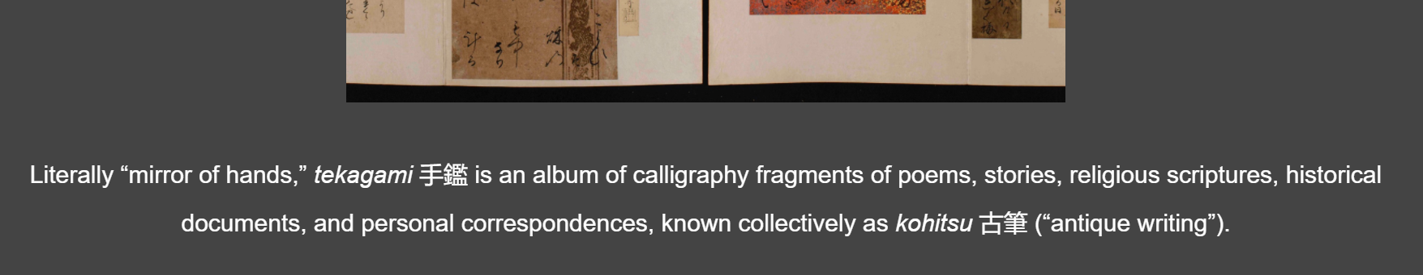
Figure 3 - Definitions of Tekagami and Kohitsu on the Home Page

4. Look and feel of the digital exhibit
Participants appreciated the images that were featured on the Home page and other pages.
“I do really enjoy the images, really beautiful.”
“Really pretty images, colorful.”
However, several participants made observations that on the number of pages the images are placed at the bottom of the page, after the long text.
“When the pictures are shown at the bottom, I wish they were somewhere in the middle. They can be put earlier - to break the prose and as an illustration of something in the text.”
Additionally, participants noted that those images at the bottom of the page are too small.
“The images are too small; I would put bigger images to break up the text.”
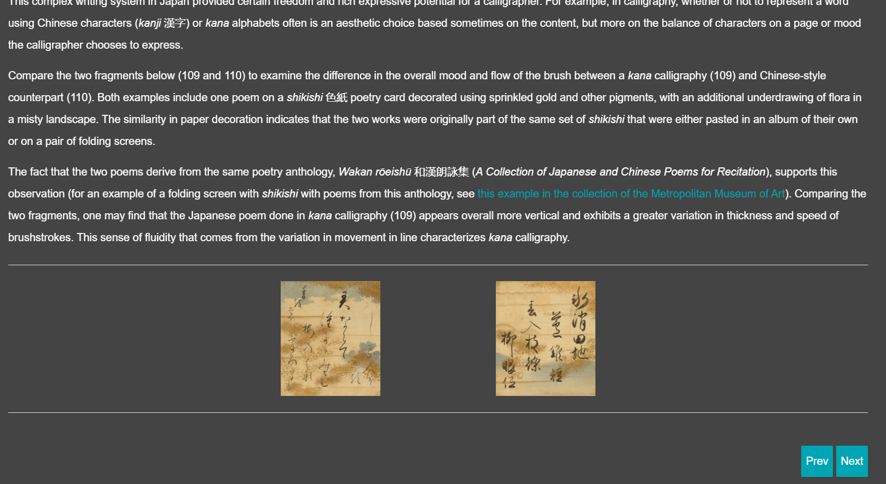
Figure 4 - Images at the bottom of the Writing in Japan page

The text and background colors received mixed reactions from participants. While some said the white text on a dark background was easy to read and that muted neutral background helped to bring focus to visual elements, others said that it was hard to read white on grey.
“It looks like the focus is on the visual materials. I like the more muted neutral background. It seems easy to read - the white text on dark background. The font used for the text is easy to read, it is clear, sans serif. Muted dark grey makes images pop which is nice. I like the look of the site.”
“I am not really sure about the grey background - it is hard to read white text on the grey. Big blocks of text – it is a lot...it starts getting all weird after looking at it for a while. I am not focusing, I am kind of jumping around, I don’t want to focus on the words.”
Participants also were not sure about the visual style of the links.
“The blue is weird for the link. Maybe the underlining would be better to let me know it is a link.”

5. Universal Viewer Functionality
Functionality. All participants appreciated the functionality of the Universal Viewer, specifically the ability to go full screen, zoom in and out, and move to different areas of the image. Four out of five participants noted the high quality of the images. For example, participants said:
“It is cool you can zoom in so much, almost down to the character.”
“Really clear images, I can zoom in very closely.”
“It is a very clear image, lots of great details, high quality, not pixelated”.
One of the participants noted that the images lose a bit of definition, but not significantly.
Two out of five participants expressed initial difficulty in starting to use the Universal viewer since it wasn’t clear at the beginning what is the functionality of the viewer, despite having the tooltips.
“I don’t know how to make the image full screen.”
“I would need to play around to know the viewer can do that [full-screen mode]. People younger than me are probably fine with this, people older than me are probably not fine with this.”
Design of pop-up windows. The majority of participants had difficulties utilizing the download and embed functions of the Universal Viewer due to the insufficient contrast of the text and background. In the Download pop-up window, the text next to the radio buttons is white on white background. Thus participants were confused about seemingly empty radio buttons in the download window. Participants also said it is hard to see the embed code because it is in white letters on a very light background. The settings pop-up window on the top right also contains white text on white background.

6. Navigation challenges
The Navigation Menu. The menu contains a lot of pages, which surprised some of the participants. At the same time, participants said the menu organization seemed consistent.
“Oh wow, that’s a lot here! There are a lot of headings with a lot of different subheadings - list of pages I am guessing.”
“I see the dropdown menu - you have an outline of what this is going to contain and you seem to be consistent in the format of what each of those sections of the website contains.”
The first line of headings [in bold] in the dropdown menu often wasn’t perceived as links to the separate pages.
“It is a little confusing - I really notice that it is a link when I am hovering over it. I just thought it is a title, not a link.”

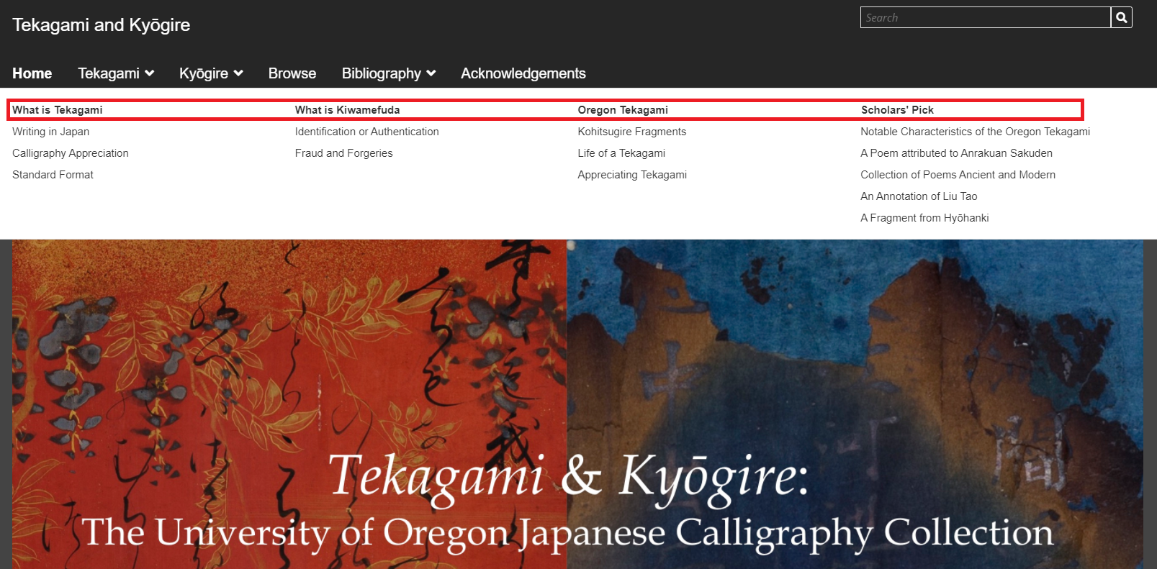
Figure 5 - Main navigation with revealed drop down menu

One of the participants experienced difficulties selecting pages in the drop-down menu.
“Oh, I don't like that dropdown, sometimes I can get to where I want and sometimes I can't if I don't hit it just right. It seems very sensitive. I was trying to get down to something and the bar would go away. That is very frustrating.”
One of the participants didn’t notice the navigation menu until later in the usability session. They said they wish the information from the menu was also available in other places.
“I don’t know if there should be a second area for that [navigation menu] …some redundancy a little bit for some people. Because some people would know to look up there and some would not.”
Image Links on the Home Page. Besides the Navigation Menu that is available across the website, the Home Page contains two images that serve as links to the two parts of the digital exhibit – about Tekagami and about Kyogire. However, they are not immediately perceived as links.
“I think it is a little bit confusing…I really only noticed it was a link by hovering over it. Because it almost looks the same as the header image, but smaller, my first instinct was that those images are just sort of titles and not links.”

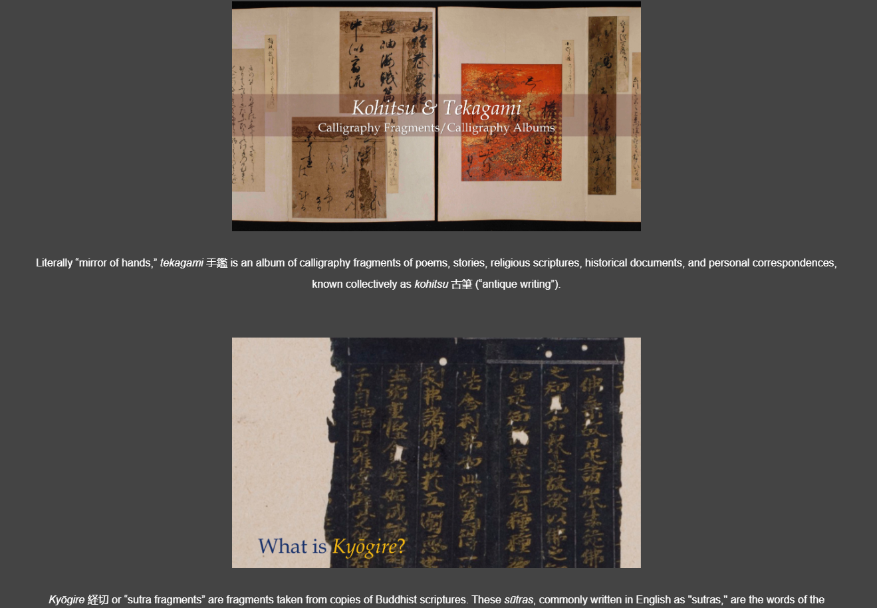
Figure 6 –Image links on the Home page

The “Next” button. Several participants were not sure about the purpose of the “Next” buttons and how they work in the relation to the Navigation Menu.
“The Next button is confusing.”
“I am curious what the Next button does. I am not sure how the best go through the exhibit, or what creators prefer me to do. Is there a prescribed order? Why then do we have those links? [refers to the images on the home page with the links to Tekagami and Kyogire pages].”
“I am not sure where I should be going or what I should be doing.”
One of the participants while exploring the exhibit decided to use the “Previous” button. The participant, pressing the “Previous” button, navigated in the following way:
Introduction to Buddhism in Japan → What is Kyogire → A Fragment from Hyohanki (in Scholars’ Picks).
The Participant was confused of where they ended up on the website because it didn’t align with their expectations.
“You have those navigation buttons at the bottom [Next and Previous buttons] - I am not sure... I am just gonna go back to see what I've missed here in the previous ones… I thought they would take me back Home. And what it seems to be doing is taking me to the series of Scholars' Picks. So it is taking me through specific work rather than through the structure of the website.”

7. Bibliography
Two out of five participants made remarks on how the bibliography was nicely organized and that it was good it contained resources both in English and in Japanese. One of the participants wondered if any of those resources were available online and said it would be nice to have the links to those resources available.

System Usability Scale Results
Subjective usability scores gathered through the administering of System Usability Scale (SUS) survey in the end of the Usability Testing session are presented in the Figure 7. The average SUS score for the “Tekagami and Kyogire” is C- (63 points). That means that this digital exhibit performs a bit below average (68 points). The digital exhibit received an A+ from the Archivist. It is important to remember that prior experience with interface tends to increase SUS scores (Sauro, 2011b).

Figure 7 – SUS Results for the “Tekagami and Kyogire” digital exhibit

“Tekagami and Kyogire” Recommendations
1. Search and Advance Search. The majority of participants didn’t utilize Search and Advance Search functionality, which might signal their low discoverability. It is recommended to make these functions to be more prominent on the website. Moreover, Advanced Search for the digital exhibits that are built with Omeka S utilizes a big number of metadata standards which overwhelms and confuses users. It is recommended to limit the number of different metadata standards if possible. It is recommended to include tips and examples on how to effectively use the Advanced Search.
To increase the findability and discoverability of digital objects it is recommended to add another section in the digital exhibit that would feature the item sets. The digital exhibit also might have a navigation structure, that would contain two options – Browse All Items and Browse Item Sets.
2. Metadata fields for compound objects. It is recommended to add such fields as Rights, Rights Holder, Institution, Repository to the compound objects (such as Mirror of Hands pages).
3. Look and Feel. Since the digital exhibit is rich in written content it is recommended to break the big blocks of written content using subheadings and inserting images. While some of the pages already follow this practice, other pages might need restructuring.
It is recommended to increase the size of individual images in the image sets across the pages.
It is necessary to further evaluate the color contrast for text color, link color, buttons, and background.
4. Universal Viewer. It is necessary to change the color of the text in the pop-up windows of the Universal Viewer to ensure sufficient contrast. It might be helpful to feature more prominent tooltips or instructions on how to use the Universal Viewer.
6. Navigation. It is recommended to review the design of the Main Menu. In particular, it is worth considering a redesign of the drop-down menu to be vertical, instead of spanning across the whole width of the page. It is recommended to change the look of the first line of menu links in the dropdown menu (that are currently in bold) to make them more perceivable as links. The color of links on hover should be different from the inactive link color.
Image links on the Home page are not discoverable. It is necessary to redesign them to ensure that they are perceived as links to other parts of the digital exhibit. Including action verbs in the text on the image might be helpful.
It is advisable to review the use of the Next button and to clarify how users might navigate through the digital exhibit.

“The Artful Fabric of Collecting” Findings
Participants’ Scenario Performance
Tables 5 and 6 present summaries of the participants’ group performance in accomplishing scenarios. The average scores do not have meaning in absolute context, but they provide a way to compare the scenarios to each other.

Table 5 – Scenario Performance Summary
Scenario | Pax 1 | Pax 2 | Pax 3 | Pax 4 | Pax 5 | Avg.
Scenario | Library Curator | Archivist | Graduate Student 1 | Graduate Student 2 | Museum Educational Staff | Avg.
2 | 3 | 2 | 2.5 | 3 | 2.5 | 2.6
3 | 3 | 3 | 3 | 3 | 3 | 3
4 | 3 | 3 | 3 | 3 | 2.75 | 2.95
5 | 3 | 2 | 1 | 3 | 3 | 2.4
Key | 0 – Fail because of errors  1 – Many errors  2 – some errors  3 – Few or no errors

Table 6 – Completion Time Summary
Scenario | Pax 1 | Pax 2 | Pax 3 | Pax 4 | Pax 5 | Avg.
2 | 3 | 2 | 2.33 | 3 | 2.33 | 2.53
3 | 3 | 3 | 3 | 3 | 3 | 3
4 | 2 | 3 | 3 | 2.75 | 3 | 2.75
5 | 2 | 1 | 1 | 1 | 3 | 1.6
Key | 0 – Fail  1 – Succeed very slowly in a roundabout way  2 – Succeed a little slowly  3 – Succeed quickly

Based on the data from the above tables, participants were able to accomplish all the tasks. Scenario 5 has the lowest success rate. This scenario asked participants to find all the images of Daoist Robes. There were several ways to accomplish this task. 2 out of 5 participants during performing the task took the wrong “turns” in their search and needed to start again. This scenario also has the longest time to complete, because for the majority of participants succeeded slowly in a roundabout way.
Scenario 2 also has a lower rate of success because 3 out of 5 participants weren’t able to accomplish one of the tasks (finding a specific digital object) in the scenario. The time to complete was also longer for this scenario because participants spent more times trying to locate the object.
A more detailed explanation is provided in the Key Trends from the Usability Study, under Content Findability Challenges.

Key Trends from the Usability Testing
1. Loading issues for compound objects in the Universal Viewer
All research participants appreciated the functionality of the Universal Viewer and the quality of images available in the collection.
“I especially like that I can interact with a photograph, manipulate it, zoom in and out, look at certain details, move it around, and it’s not getting pixelated.”
“This is my favorite part - to zoom in really closely and see the details. And I like the optional tab to show more information about the image.”
One of the participants expected more images to appear in the universal viewer as a sequence:
“How would I get to the next image? So I have to go back? Ok, I thought it would be more sequential”.
During the usability testing it was discovered that some items consisting of several images, such as Gertrude Bass Warner’s letters Escape from Peking/three Japanese letters dated November 9, 1924 or Ink Cakes with Scenes of Tilling and Weaving are displayed in the Universal Viewer as a sequence, meaning the user can navigate between pages using arrows.
However, usability testing revealed that items, containing multiple images (compound objects), take a long time to load. There is no loading indicator or message that would inform the user that the image is loading. This resulted in participants being confused when they tried to interact with the Viewer or access its different functions while the images were still loading.
Participants also experience a number of loading errors, such as the More Information tab doesn’t display information, one of the Navigation Errors disappear, the empty tab on the left side appears, images are not scaling up properly etc.
“I see More Information tab. I click that, and it doesn’t look there is any more information - no metadata or anything like that. I’ve got a message that the page is unresponsive. I will refresh the page and try to do it again. I am waiting for reload. I am clicking, and it doesn’t do anything. I would just download the image and use my own image viewer to zoom in.”
“I am trying to look for an arrow, but I can’t see it the in other corner, I don't know why”. [Exists the full screen - the arrow appears on the right. Enters the full screen again - arrow disappears]. “I have this banner with More Information, but it’s empty.”
“I am not sure what is this for [empty tab on the left side] Maybe it would be nice to have little thumbnails for the whole document.”
The empty tab on the left side is only visible in the Universal Viewer, embedded into the Gertrude Bass Warner, Collector page. The empty tab disappears is the item is accessed through the Browse page.
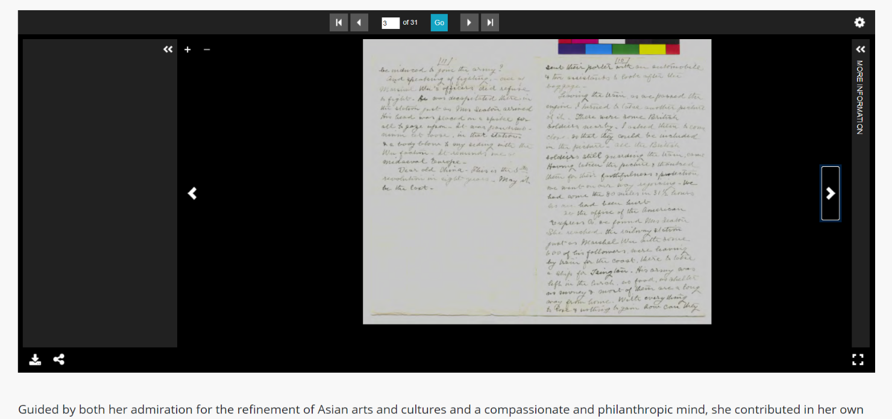
Figure 8 - Escape from Peking/three Japanese letters dated November 9, 1924 displayed in the Universal Viewer with an empty tab on the left side.

The functionality of the Universal Viewer while displaying single vs multiple images also differs. The manipulation of the image (zoom and navigating to different parts of the image) via mouse is not accessible, however it works for the single images. This inconsistency within the same viewer is confusing for the users.
“When I click on the image itself it doesn't do anything”.
“I am trying to zoom in with the mouse, but I can't, so I am going to use "+". I am not sure what is this for [empty tab on the left side] Maybe it would be nice to have little thumbnails for the whole document.
“I am using the “+” icon and I can move around with the scroll bar. Normally I navigate with my mouse but it doesn’t work here.
This might be due to the fact, that Settings options differ for the Universal Viewer displaying a single image and the Universal Viewer, displaying multiple images.
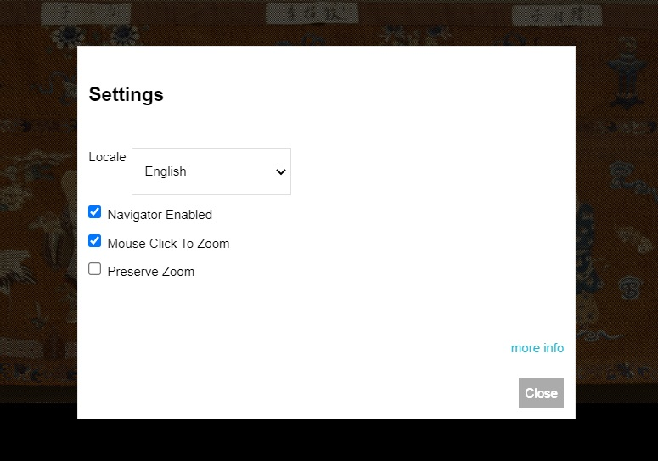
Figure 9 – Settings window in the Universal Viewer displaying single image

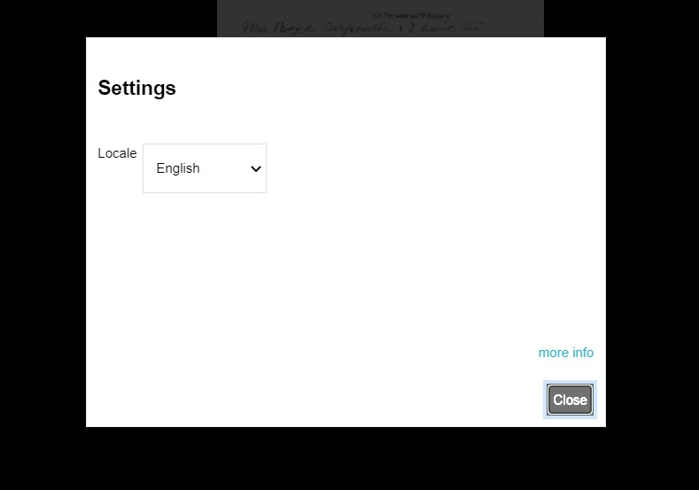
Figure 10 – Settings window in the Universal Viewer displaying multiple images

2. Poor User Experience of Internet Archive Viewer
In addition to the universal Viewer, which is used to display items on the Browse page, and throughout some other pages, this digital exhibit also utilizes Internet Archive Viewer for displaying items on the Collecting “Pictures of Tilling and Weaving” page.
After using the Universal Viewer, all participants experienced difficulties while engaging with the Internet Archive Viewer because it functions differently.
Although there is a full-screen icon available, it doesn’t function the way participants expected. The full-screen mode doesn’t make the image full screen, and the viewport stays the same size.
“I am going to look at how to make this bigger first. Maybe Zoom? No. I am trying to see how to make the frame bigger, but I don't know if you can do that. [Clicks on the icon of the Internet Archive - the video starts playing]. That doesn’t seem right.”
“I am not necessarily getting… I am trying to make it larger so I can see. I wish it was larger. And I am not sure if I should be scrolling down to see images. It is a little difficult to navigate.”
Because participants couldn’t make the image full screen using the full-screen icon, in order to see the image better they tried other solutions, such as scaling browser windows, using the zoom function of the browser, or abandoning the viewer altogether.
“I wish the viewer was a little bit bigger on the page. I have this window on my screen expanded to be the full size of my screen and I was a little surprised the viewer itself didn’t scale to the size of the page because I wish it did. Or that there was a way to drag it out to make it a little bit bigger”.
“I want go in the full-screen mode, but I can't. I want to see them [the images] bigger. I am zooming my browser”.
Another participant left the page with Internet Archive Viewer and used the Search function in the Navigation to search for the same image. The participant was able to locate the same item, but displayed in the Universal Viewer. Thus the same digital objects (images of Ink Cakes) are duplicated in different interactive viewers.
Besides the full-screen icon, participants also experienced difficulties with other parts of the Internet Archive Viewer’s interface. For example, participants were not sure about the meaning of the magnifying glass icon, because it carries several meanings:
“I thought it is Zoom or Detailed View, but it is Search, which is weird. What could I be looking for in here?”
“It makes me think it is a magnifying glass.”
To access the essential zoom function, participants needed to navigate a long path. They need to click on the icon with three dots on the left-hand side of the viewer, then click Visual Adjustments, which revealed the pop-up window with Zoom options. The pop up window takes half of the viewport when activated, and obstructs the view. Users need to go back and forth between the image and the zoom function in order to calibrate the image.
“It would have been nice if at least the zoom function was right on the actual page of the viewer itself. Because if have I not been searching through the viewer I probably would not have found that option”.

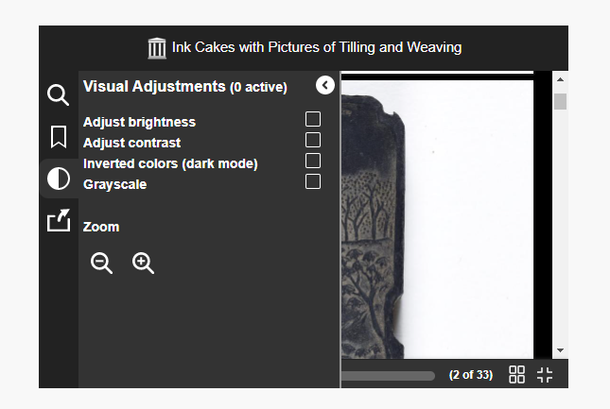
Figure 11 – Zoom Function in the Internet Archive Viewer

3. Content Findability challenges
While performing usability tasks on locating specific objects, such as Gertrude Bass Warner’s letter about her departure from Peking or Daoist Robes, participants most often started with using Search function. However, typing “letter departure”, "gertrude bass letter" or "gertrude bass correspondence" in the Search bar didn’t return any results. Searching “robes” or “daoist robes” didn’t provide any results, or provided 2 irrelevant results. Since the initial search would not work, participants spend more time and effort trying other ways to locate information.
One of the participants noted, “I am not sure what the search function searches.”
Participants assumed that they need to search for a letter written by Gertrude Bass Warner on the page with the name “Gertrude Bass Warner, Collector”. And although the Universal Viewer displaying the letter was indeed embedded into this page, the majority of participants were scrolling through it multiple times without being able to locate it. This is due to the low findability of this object. This digital object doesn’t have any caption or title and is placed in the middle of a long block of text. Additionally, the first displayed page of the letter is blank.
“It’s not looking like a letter, just like a blank page. It’s not a good a cover page because it is so pale, I would choose a second page as a cover.”
“This is not clear at all, because this is in the middle of the text, so I would need at least to review the whole text, read it. Maybe a caption below or above would help”.
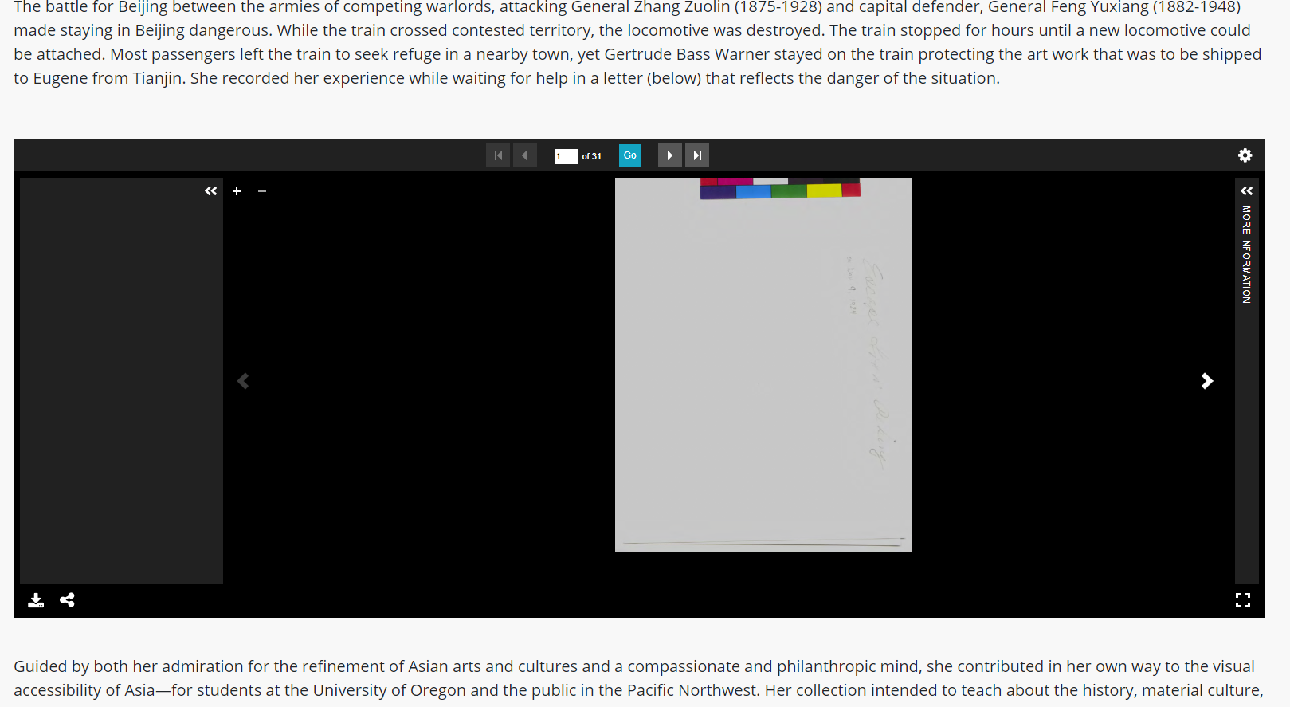
Figure 12 – First page of the Escape from Peking/three Japanese letters dated November 9, 1924 displayed in the Universal Viewer.

The presentation of this digital object is not consistent with the display design of other digital objects on similar pages (for example, John Ferguson page).
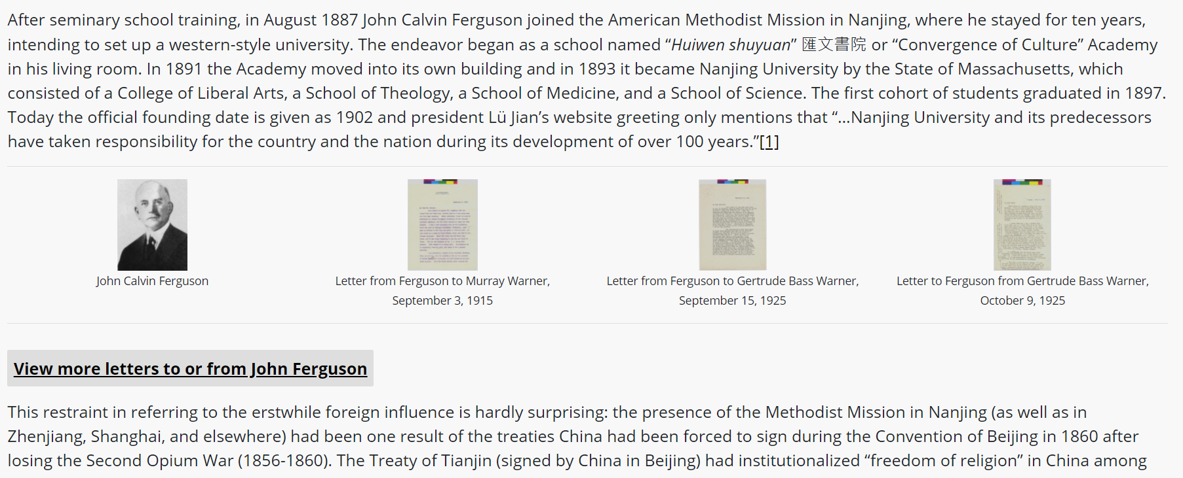
Figure 13 – Display of the digital objects on the John Ferguson page

One of the participants who is a graduate student experienced some difficulties while utilizing the Advanced Search function to locate a letter written by Gertrude Bass Warner. The participant was confused about which Property to select from the long list of metadata standards.
“I like the fact the Dublin Core is widely used, but it can be confusing, especially for properties such as Author or Creator. For me, in the art world, it is kind of confusing sometimes. I wouldn’t know where to... I would think maybe she[Gertrude Bass Warner] is the creator of this letter, but the system can't find it. Maybe it is too overwhelming for someone who is not very familiar with this.”

4. Uncertainty about StoryMap
The StoryMap on the Gertrude Bass Warner page captured the interest of several participants, but also made them unsure about it.
“I am not sure if this image [StoryMap] is an advertisement or a part of the exhibit, I would be a bit hesitant to click it”.
The StoryMap seems to be unfinished since there are just several images features and it lacks some descriptive text. Because of this, participants were confused and not sure about the purpose and functionality of the StoryMap.
“…Seems to be an interactive map here. Hmm, maybe I should do this in order since I didn’t understand what was happening. So is it a timeline of her events? I should probably read more [refers to the content of the page]”.
“I do like this start exploring button. Oh, it is interactive! Do I zoom in or click? I feel like there needs to be more information. It’s neat, I don't get much information from it, but I like the visuals and interactives of it. I am kind of confused about how to navigate it. The arrows are good but I am not sure where I am going when I click an arrow”.
There were also repeating loading issues when the StoryMap didn’t display correctly for several participants.
“Whatever this is - Travels - it is not loading; the letters are overlapping. This coming up blank”.
“This little landing for the map or something looks like its loading and buffering. Doesn’t look like it’s displaying correctly for me. I am going to reload the page since it was displaying earlier”.
Similar to the display of the Gertrude Bass Warner letter, the StoryMap doesn’t have a caption or a title featured outside of the embedded StoryMap itself. Thus when the Storymap is not loading properly it is hard to identify this object.

5. Look and Feel of the digital exhibit
Participants appreciated the visual design of the website, especially its color scheme – light background with dark text, and the use of high-quality “crisp” images.
“I like that the colors are not overwhelming. I like that it is black and white, it is very simple, it makes it less contaminated visually. I think it is perfect it doesn’t have an intense color scheme so the user can focus on the materials”.
“It looks very simple and straightforward. There is nothing that distracts from the actual exhibit. It looks good, it is very simple”.
4 out of 5 participants perceived the digital exhibit as having a large amount and density of the written content.
“It has a lot of text right upfront and that’s a little too much. I would prefer a lot more images and text to be broken more up instead of these long blocks. It feels like it would take me a long time to go through it”.

6. Navigation challenges
All participants experienced issues with utilizing the drop-down options of the main navigation menu. Hovering over the main navigation labels would reveal the drop-down options, but when participants attempted to select the page in the drop-down, the drop-down would disappear.
Some of these pages also have subpages. I am trying to click on it and I can’t. When I hover, it doesn’t do anything”.
“I was going to click on it, but I am not sure if it is linking me there or not. This hover menu is throwing me off a little bit”.
There was a mixed reaction to the labeling of the main menu. One of the participants noted that the pages’ labels were “succinct and clear”.
Another participant, however, while looking at the navigation, noted that it wasn’t immediately clear where the entire collection would be.
In the menu there is nothing that would say the collection is here, that would drive me to the collection… I want to try to find a collection if there is one”.
Several participants noted it would be helpful to also have local navigation on the pages that contain a lot of text.
“It could be useful to have a little index on top of the page about what is down”.
“It's text-heavy, so it makes me give up in the middle. Maybe an index with links on the top of the page, as Wikipedia has would help. So I would see the index heading and would click on it, and it would take me to the part I want fast”.

7. Glossary
3 out of 5 participants showed interest in the Glossary. They weren’t sure what the glossary would contain and went to the page to see what it features.
“Going to look at Glossary to see what’s there. Ok, it is more like references for textiles.”
“I see the glossary has 3 different categories - garment types, embroidery stitches, and weaves. So it is mostly on materials and not on anything else.”
This is very interesting to have a glossary because in the art world the language is technical and specific and it is very useful to have a glossary. And I see there are also definitions of technics in different languages - that's cool. And we can see them [points to the illustration of the technic] - I love that.”
“This looks pretty interesting - the words and the image across it. For the quick reference this seems pretty cool.”

System Usability Scale Results
Subjective usability scores gathered through the administering of System Usability Scale (SUS) survey in the end of the Usability Testing session are presented in the Figure 14. The average SUS score for “The Artful Fabric of Collecting” is A (81 points). This means that this digital exhibit performs above average (68 points).

Figure 14 – SUS Results for the “The Artful Fabric of Collecting” digital exhibit

Key Findings from Card Sorting
Card sorting helped to reveal some challenges about the content organization and labeling of the digital exhibit. Findings presented in the form of Categories Analysis and Standardization grid are available in Appendices H and J.
Creating a new category for items made out of silk. The highest agreement between participants was about creating new category for silk items. All participants that did the card sorting, were grouping clothes items, hangings, and badges into one category, assuming all of those items are made out of silk. Several participants also created smaller categories of Badges (Rank Badges, Festival Badges) and Ceremonial Stuff (Ceremonial and Decorative Hangings, Manchu Ceremonial Attire cards).
Confusion about John Ferguson and Johan Munthe cards. These cards were placed in different categories, such Gertrude Bass Warner category, in Collecting Silk, or in Everything Else categories.
“I am assuming these names go with Gertrude Bass Warner somehow”. I am not totally sure. But they are Westerners so I imagine they might be involved in her efforts to build this collection.”
“I put it [John Ferguson card] in the Collecting Silk - I assume he is collector because he seems like some old British men who bought some silk back in the day.”
“Another person - I have no idea. I am going to put this card into the Everything Else category.”
Low agreement about the Fashion Card. There was a low agreement about participants on where to put the Fashion card. Each participant put this card into a different category or left it unsorted.
“I don’t really know what to do with fashion, I don't see where it would go in any of the categories. Seems more like a category name that would explain how for example the sleeves of Manchu robes were changed over time, or how the clothes were different for married and unmarried women. Fashion to me seems like a thing that would be representing what was popular at the time and I don’t see where it fits in any of these.”
Collecting Silk category. All participants were unsure about what the Collecting Silk category means and what cards might belong to it.
“Does it [Collecting Silk] mean collecting silk objects, like robes? Or is it about gathering the silkworms and collecting the material from them?”
“Collecting Silk category as a pre-made option for me threw me off at first because I wasn’t really sure what to put there.”
This pre-defined category received the smallest amount of cards. Two participants placed John Ferguson and Johan Munthe cards there, assuming they were the ones who collected silk. Another person put the Sites of Imperial Silk Workshops in this category.
One of the points to consider was that came from the participant is to while developing the digital project, especially the navigation is to keep in mind the audience for whom this digital exhibit is designed:
“There were a whole bunch of things that I didn’t know what they were. Maybe they should be renamed to something more generic. But depends on what your audience is. If your audience is a completely uninformed user, then having those menu items be something that is a little more generic.”

“The Artful Fabric of Collecting” Recommendations
1. Universal Viewer. It is recommended to further review and test the performance of Universal Viewer for compound objects to decrease the loading time and loading errors. Adding a status indicator or loading message might be helpful in decreasing users’ uncertainty.
It is recommended to enable such functions as navigation and mouse click to zoom in the Universal Viewer for compound objects. This will allow to unify the user experience for working with single and compound objects and to increase learnability of utilizing the Universal Viewer.
2. Internet Archive Viewer. Review the need to use Internet Archive Viewer. It has a poor user experience. Consider using only one interactive viewer for the digital exhibit to unify the user experience. It is worth noting, that some objects, such as Ink Cakes are features in both Universal Viewer and the Internet Archive Viewer.
3. Content Findability.
3.1 Search Function. It is recommended to specify how the Search function on the website works and what kind of results it returns. It might be beneficial for users instead of featuring the “Search” label in the search field, write “Search digital objects”. A tooltip or a short text featured below the search field with more information also might be helpful.
3.2 Advanced Search Function. It is recommended to make the Advanced Search function to be more prominent to increase its discoverability by the users. Moreover, Advanced Search for the digital exhibits that are built with Omeka S utilizes a big number of metadata standards which overwhelms and confuses users. It is recommended to limit the number of different metadata standards if possible. It is recommended to include tips and examples on how to effectively use the Advanced Search.
3.3 Consistent design of digital objects’ display. It is important to keep the presentation of the content consistent. The digital object Escape from Peking/three Japanese letters dated November 9, 1924 featured on the Gertrude Bass Warner page presented differently from the rest of similar digital objects across other pages, and lacks caption. It is recommended to edit the display of this digital object for consistency, thus improving the discoverability for users.
4. Navigation. Navigation greatly contributes to content findability. It is recommended to further evaluate the current organization system and labeling of the digital exhibit based on the findings from Card Sort. In particular, it is recommended to consider creating a new page or a section of the digital exhibit that would be dedicated to the items made of silk; reviewing the Collecting Silk page and its label. It is recommended to create clear labels with no ambiguity.
The main navigation requires fixing the accessing pages from a drop-down menu on hover.
It is recommended to add local navigation to the rest of the pages and to make it consistently appear on top of all text-heavy pages.
To increase the findability and discoverability of digital objects it is recommended to add another section in the digital exhibit that would feature the item sets. The digital exhibit also might have a navigation structure, that would contain two options – Browse All Items and Browse Item Sets.
Currently, Advanced Search has an option for searching by item set, but it gives the list of all item sets of all digital exhibits created by Digital Scholarship Services on its Omeka S account.
5. StoryMap. It is recommended to review the Story map embedded on the Gertrude Bass Warner page. If the map’s content is still being developed, it is advisable not to display the map on the page yet. It would be helpful to provide more context to the users about the StoryMap, introducing its purpose in the text more prominently, as well as to provide a caption or a title.
6. Look and Feel. Since the digital exhibit is rich in written content it is recommended to follow the best practices of writing for the web when applicable. For example, using the meaningful headings and subheadings that stand out, using lists and bullet points, help to break up densely written content. Adding white space around paragraphs and images will also help to break up the page so it is easier for the users to perceive information.

“The March” Findings

“The March” digital project built on WordPress, utilizes the standard-looking compact navigation, that consists of 5 tabs. However, the Tree Testing demonstrated, that the labeling system of the current menu might create some usability issues.
Figure 15 shows what percentage of respondents succeeded/failed particular task directly/indirectly.
Of all of the tasks completed by participants, 32% of tasks were completed choosing the “correct” answer, either directly or indirectly. 56% of answers were chosen without backtracking.
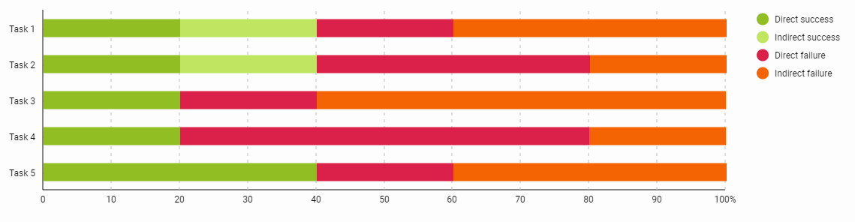
Figure 15 – Task Statistics
A low rate of “correct” answers indicates the difficulties all participants had while interacting with the navigation menu, making sense of labels, and trying to find specific information. Talking about their experience engaging with Tree Testing, participants noted:

“My mental image did not align very closely with what was presented on the website.”
“I was confused for some of them - I felt like the options weren’t perfectly fitting. So I would need to search through some of the links instead of knowing exactly where things are right away.”
Table 7 shows a breakdown of the final answers. The numbers in the table represent the number of respondents who choose a specific answer. The rows with no data are not displayed.
Table 7 – Destinations
 | Task 1 | Task 2 | Task 3 | Task 4 | Task 5
Home | 2 | - | 1 | - | -
Themes | - | - | - | - | -
The Civil Rights Movement | - | - | 1 | - | -
Lyndon B. Johnson | - | - | - | 2 | -
Chapters | - | - | - | - | -
Field Guide to the Film | - | - | 1 | - | -
Making the March on Washington | 2 | - | - | - | -
The Making of The March | - | 2 | 1 | - | 1
LBJ’s “Difficult Problem” | - | - | - | 1 | -
Conflicted Legacy | - | - | - | - | 2
Bibliography | 1 | 3 | 1 | 2 | 2
About | - | - | - | - | -
Table legend:
Correct |  |  | Incorrect
The participants’ answers were distributed pretty evenly across the table, indicating that there wasn’t strong agreement between participants of where to find particular information. In general, participants exhibited uncertainty about their choices and asked questions about labels’ meanings.
“Are Themes the ones covered in the movie? I think Chapters are about individual chunks of the movie… none of those immediately make sense to me”.
“I thought themes were about themes discussed in the movie and chapters would be like chapters on a DVD.”
“I would think Chapters are like specific parts in the movie”
“Is bibliography was used by the people who made the exhibit? Or it contains resources that the movie director used? I am having a little trouble with this.”
“Is timeline page about the movie timeline of the historical event?”
Some participants were also wondering about the difference between the Lyndon B Johnson page in Themes and the LBJ's Difficult Problem page in Chapters.

“The March” Recommendations
Navigation plays a crucial role in the overall user experience. The navigation structure and labels help visitors to find their way around the website, prompt them engage with the content and help locate specific information quicker.
Current navigation of “The March” would work for linear narrative, where the author leads the reader through the content in a specific order. In that case, the importance of navigation is decreasing. In the case of the digital project built on WordPress, where visitors can jump from page to page in no specific order, navigation should be clear and visitor-oriented. To increase the effectiveness of navigation of “The March” digital project it is recommended:
1. To review the organizational structure of the website and to clarify a distinction between the content dedicated to documentary and the content about the March on Washington.
For example, the distinction between Themes and Chapters navigation labels is not clear. Majority of the Tree Test participants treated Chapters as chapters of the movie. However, pages that are featured under this navigation label represent the mix of content about the movie itself and about the events the movie describes.
2. To create clear labels with no ambiguity. Current labels do not provide adequate information about the page they represent. Clear labels help visitors to determine whether a page under a label will have the desired information. Such labels, as “Making the March on Washington” and “The Making of The March”, which follow each other in the drop-down menu, use the same words and make visitors spend more time decoding the labels.

Conclusions
Findings from this UX Research highlighted the appreciation of the format of digital projects among the GLAM community and the value such format brings to increasing access to unique collections and in promoting research, teaching, and learning.
Participants of the UX Research especially liked the Universal Viewer available in digital exhibits and its ability to facilitate greater engagement with the digital items.
While digital projects reviewed in this research have different scholarly focus and are built on different platforms, they are characterized by complexity and richness of the content. Findings from the UX research highlighted challenges faced by participants in findability and discoverability of the content, navigating complex and content-rich digital exhibits, and engaging with digital objects through interactive viewers and metadata.
Majority of participants noted the that pages had too much written content that is presented in big blocks of text. Participants wished that the written content were broken down into smaller sections, and the local navigation for text-heavy pages were included.
While trying to use Search participants weren’t sure about what kind of results the Search would return (website text and/or digital objects). While using Advanced Search participants lacked assistance from the system on how to utilize the Advanced Search and were overwhelmed by the long drop-down list of all different metadata formats with overlapping and similar property names.
Content organization and labeling of pages also brought challenges to navigation of digital projects and to discoverability of content. Card Sort and Tree Testing highlighted the confusion participants had about some ambiguous labels and the need to reconsider how the content of the ditial exhibit is structured and presented.
The overarching recommendations are to:
1. Evaluate the information architecture of the digital projects, including reassessing the organizational structure, content categories, and labels. Improving information architecture will help users to find and discover content more easily.
2. Provide more support to visitors in utilizing Search and Advanced Search Functionality. Highlight these features on the websites, include some tips or examples on how to effectively perform search. Limit the number of metadata standards visitors are exposed to during the Advanced Search.
3. Adapt scholarly content to the realities of the web. Users engage with digital projects differently than with research papers. The written content needs to follow the best practices of writing for the web. Using meaningful headings and subheadings, shorter paragraphs, lists, bullet points, and white space can increase readability and support users in locating necessary information quicker.
The finding and recommendations from this report are also to be used during the development of the new digital projects. The finding from this report demonstrated the overlapping issues that are preventable in the development and design stage. Involving UX and Information Architecture expertise from early on, working with content producers to adapt the content for the Web, utilizing UX research practices to gain users’ perspective throughout the project development will ensure that digital projects are relevant and usable by users in their research, learning, and teaching.

References
Klug, B. (2017). An Overview of the System Usability Scale in Library Website and System Usability Testing. Weave, Vol.1 (6). https://doi.org/10.3998/weave.12535642.0001.602
Sauro, J. (2011a). Measuring usability with the System Usability Scale (SUS). Retrieved from http://www.measuringu.com/sus.php
Sauro, J. (2011b). SUStisfied? Little-Known System Usability Scale Facts. User Experience Magazine, 10(3). Retrieved from https://uxpamagazine.org/sustified/

Appendix A - “Tekagami and Kyogire” Participant Handout

Thank you for agreeing to participate in the UX Study: Leveraging GLAM Assets in Library-Museum collaboration conducted by University of Oregon Libraries and Jordan Schnitzer Museum of Art. This document is intended to act as a visual aid alongside direction from the study’s facilitator.
Things to Remember While Completing Scenarios and Tasks:
- There are no right or wrong answers to answering tasks
- Struggling with a task is okay because it gives the research team information about the system’s performance and human-computer interaction needs
- We are testing the digital exhibit, not you. So, if you feel uncomfortable or like you are doing something wrong then remember it’s the system, not you, that’s causing the challenge
- If you don’t want to answer a task then you don’t have to, please let your facilitator know.
- If you want to end the test at any point, please let your facilitator know.
- Phones and any computer applications should be turned off. We want to limit any disturbances.

Usability Scenarios and Tasks

Scenario 1
For this first scenario, you will familiarize yourself with the feel of Tekagami and Kyogire digital exhibit. You are not looking for anything specific, simply observing what stands out to you.
1) Please go to the direct link provided for accessing Tekagami and Kyogire digital exhibit. Take a moment to explore the website. While doing so, please let us know what draws your attention.

Scenario 2
You are writing a paper about the calligraphy collection that is housed in University of Oregon Jordan Schnitzer Museum of Art (JSMA).
1) Find a page that describes how Kyogire fragments entered the museum’s collection.
2) Find a page that describes how Tekagami entered the University of Oregon collection.

Scenario 3
You are writing a blog post about the Mirror of Hands Album. You want to use one of the images from the Album in your blog post.
1) Find pages 62-63 from the Mirror of Hands Album.
2) Make the image full-screen in the interactive viewer
3) Zoom in the different parts of the image to see the details better
4) Exit the full-screen mode
5) Save an image to your computer. Please download the image and open the folder containing it.
6) Find and copy the embed code
7) Find the rights holder of this item

Scenario 4
You are preparing a presentation about different types of Kyogire.
1) Find all the images of Kyogire fragments from Heian style/period. Tell the facilitator how many images suiting these criteria you were able to locate.

Post-Test Questions
At the end of the session, you will be asked to fill in the Post-Study Survey to rate your experience of using the digital exhibit.

Appendix B - “The Artful Fabric of Collecting” Participant Handout

Thank you for agreeing to participate in the UX Study: Leveraging GLAM Assets in Library-Museum collaboration conducted by University of Oregon Libraries and Jordan Schnitzer Museum of Art. This document is intended to act as a visual aid alongside direction from the study’s facilitator.
Things to Remember While Completing Scenarios and Tasks:
- There are no right or wrong answers to answering tasks
- Struggling with a task is okay because it gives the research team information about the system’s performance and human-computer interaction needs
- We are testing the digital exhibit, not you. So, if you feel uncomfortable or like you are doing something wrong then remember it’s the system, not you, that’s causing the challenge
- If you don’t want to answer a task then you don’t have to, please let your facilitator know.
- If you want to end the test at any point, please let your facilitator know.
- Phones and any computer applications should be turned off. We want to limit any disturbances.

Usability Scenarios and Tasks
Scenario 1
For this first scenario, you will familiarize yourself with the look and feel of The Artful Fabric of Collecting digital exhibit. You are not looking for anything specific, simply observing what stands out to you.
1) Please go to the direct link provided for accessing The Artful Fabric of Collecting digital exhibit. Take a moment to explore the website. While doing so, please let us know what draws your attention.
Scenario 2
You are researching the collection of Chinese textiles that is housed in the Jordan Schnitzer Museum of Art. You are interested to learn how this collection was built.
1)Find a page about John Ferguson - a collector of Chinese art.
2) Find letters written by Gertrude Bass Warner about her departure from Peking.
3) Make the images of the letters full-screen in the interactive viewer.
4) Zoom in the different part of the image to see the details better
5) Exit the full-screen mode
6) Find out the year the letters were written

Scenario 3
You are writing a paper about the scroll paintings that depict tilling and weaving.
1) Find a page that has information about scroll paintings that depict tilling and weaving.
2) Find Ink Cakes with Pictures of Tilling and Weaving on this page.
3) Have a closer look at the Ink Cakes with Pictures of Tilling and Weaving in the interactive viewer. Try to explore different details.

Scenario 4
You are writing a blogpost about Ceremonial and Decorative Hangings. You want to include some images of the hangings in your blogpost.
1) Find the image of Hanging with Filial Piety Performance Scene.
2) Find and copy the embed code.
3) Find information about the measurements and material of the hanging.
4) Find the rights holder of this item.

Scenario 5
You are preparing a presentation about Chinese textiles and want to include images of the Daoist Robes.
1) Find all the images of the Daoist Robes

Post-Test Questions
At the end of the session, you will be asked to fill in the Post-Study Survey to rate your experience of using the digital exhibit.

Appendix C – System Usability Scale

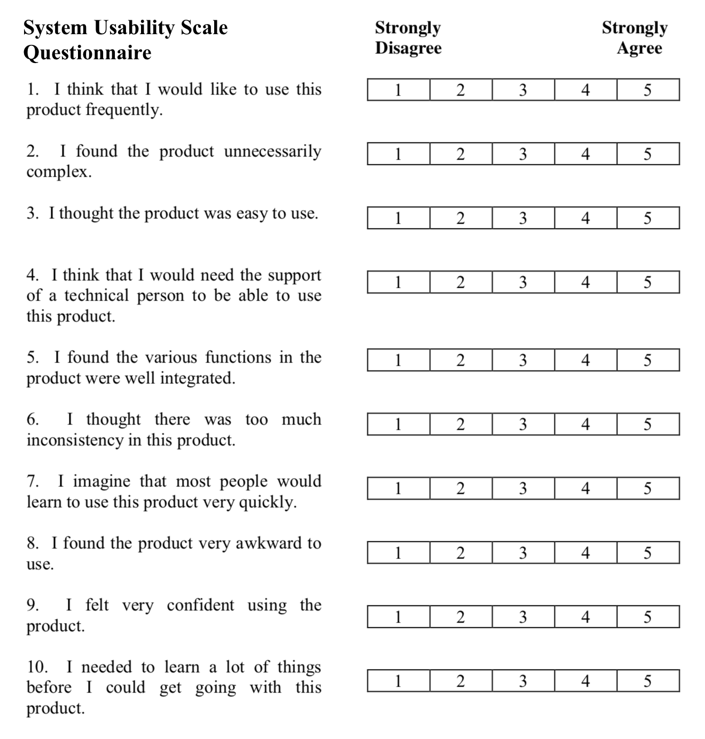

Appendix D – Card and Categories for Card Sort
Initial Cards for Card Sort
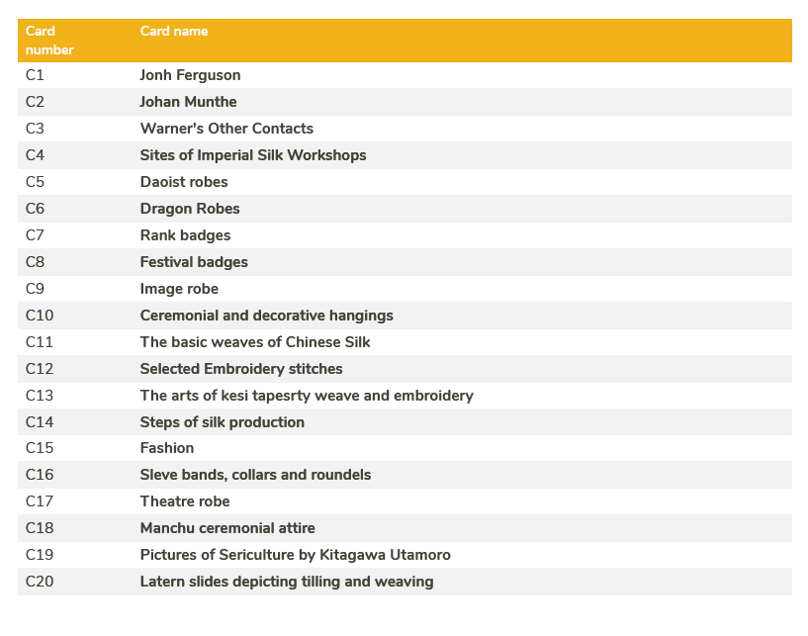
Initial Categories for Card Sort
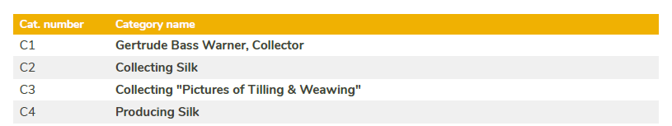

Appendix E – Navigation Tree and Tasks for Tree Test
Navigation Tree

Home
Themes
James Blue
The Civil Rights Movement
Lyndon B. Johnson
Chapters
Timeline
Field Guide to the Film
Meaning of the March
American Racism and Anti-Racism
The Making of James Blue
Making the March on Washington
The Making of The March
One Film, Three Versions
LBJ’s “Difficult Problem”
Conflicted Legacy
Bibliography
About
Acknowledgments
Copyright
Diversity, inclusion, and accessibility
Contact

Tree Test Tasks
1. You want to learn how the historical event March on Washington was organized. Where would you search for this information?

2. You want to find historical documents used by the movie director in the preparation for The March movie production. Where would you search for them?

3. You want to find information about the characters in The March movie. Where would you search for this information?

4. You want to listen to the phone call recordings of President Johnson’s reaction to The March movie. Where would you search for the phone calls recordings?

5. You are interested to learn how newspapers of that time reacted to The March movie. Where would you search for this information?

Appendix F – User Persona

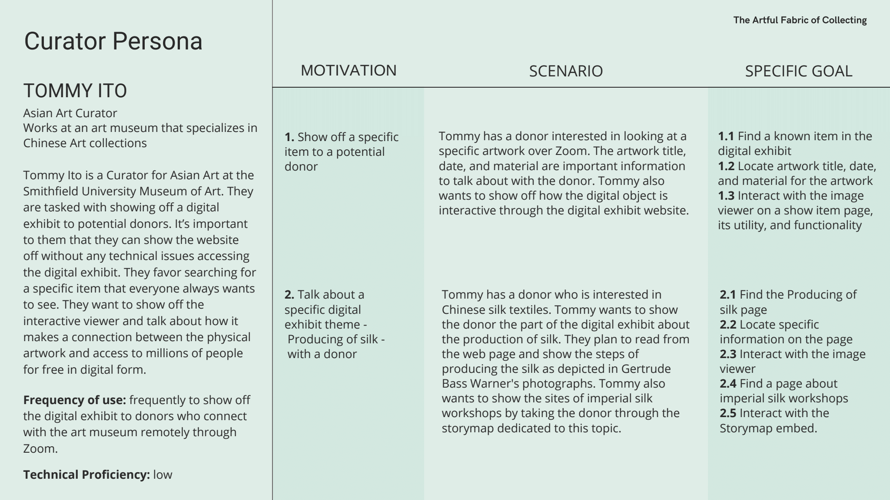

Appendix G – Consent Agreement
Consent for Research Participation

Title: UX Study: Leveraging GLAM Assets in Library-Museum Collaboration
Sponsor: Andrew W. Mellon Foundation
Researcher:  Researcher Contact Info: | Franny Gaede, Director of Digital Scholarship Services at UO Libraries  602-405-5052, mfgaede@uoregon.edu
Researcher:  Researcher Contact Info: | Kathryn (Kate) M. Thornhill, Digital Scholarship Librarian, University of Oregon  541-346-3714, kmthorn@uoregon.edu
Researcher:  Researcher Contact Info: | Anna Lepska, Mellon GLAM Library/Museum Collaboration UX GE, University of Oregon  458-210-1426, alepska@uoregon.edu

You are being asked to participate in a research study. The box below highlights key information about this research for you to consider when making a decision whether or not to participate. Carefully consider this information and the more detailed information provided below the box. Please ask questions about any of the information you do not understand before you decide whether to participate.
Key Information for You to Consider
Voluntary Consent. You are being asked to volunteer for a research study. It is up to you whether you choose to participate or not. There will be no penalty or loss of benefits to which you are otherwise entitled if you choose not to participate or discontinue participation.

Purpose. The purpose of this research is to enhance six digital exhibits to be used by teaching faculty, students, museum educational staff, teaching librarians, and archivists of the University of Oregon in research, teaching, and learning.
The information collected during this research will be used to develop strategies for the improvement of the user experience of the digital exhibits. The research team is specifically interested in learning how users engage and navigate digital exhibits and about their perceptions of the digital exhibits. This research is being conducted to gather direct experiential feedback about the digital exhibits to inform the strategies for making digital exhibits more intuitive and user-friendly.

Duration. Participants are expected to be part of the study for no more than 1,5 hours during June - July 2021.

Procedures and Activities. You will be asked to participate in the following activities:
- Coordinate over e-mail with research team logistics for completing the study
- Take part in the one-on-one user study session of the digital exhibit. The duration of the session will be 45-60 minutes and will be video recorded via Zoom web conference call.
- During the user study, you might be asked to participate in one of the two activities:

1. You might be asked to participate in the usability study. You will be asked to use a website while following short scenarios and share your thoughts and feelings about the website. At the end of the usability study, you might be asked several follow-up questions about your overall experience of using the digital exhibit. After the usability study, you will be asked to fill in a survey.

2. You might be asked to participate in the card sorting activity. You will be asked to organize different topics of the digital exhibit in the categories that make sense to you. During this activity, you will be asked to share your thoughts and explain the choices you made.
- Receive a gift card via your e-mail for supporting this research study

Risks. Some of the foreseeable risks or discomforts of your participation include:
- Feeling uncertain about your abilities when engaging with the digital exhibit

Benefits. The researchers hope to learn how you use the digital exhibit and/or the ways you naturally organize information. It will help researchers enhance the digital exhibit with your feedback and perspectives. Your contributions will be used to make the digital exhibits more intuitive to navigate and more user-friendly for all of the people who plan to use them for research, learning, and teaching.

Alternatives. As an alternative to participation, the only alternative is to not participate in this research study.

Wanting to be removed from the study. At any point during this study, you have the right to leave voluntarily for any reason. The data collected through your participation will be deleted and excluded from the research findings.

Who is conducting this research?
This research study will be lead and conducted by the University of Oregon Libraries Digital Scholarship Services.
Researchers are asking for your consent to this research. They will be conducting this research study and developing recommendations for improving the digital exhibits.
What happens to the information collected for this research?
Information collected for this research will be used to write recommendations for improving the digital exhibits. These recommendations will be used by the web developers at the University of Oregon Libraries to use as their direction to continue enhancing the digital exhibits.
How will my privacy and data confidentiality be protected?
We will take measures to protect your privacy including anonymizing and redacting participant names as much as possible before, during, and after data is collected and analyzed. The only data about you that will be collected for this research study are:
- Your First Name and Last Name
- Your E-mail Address
- UO Affiliation
This data will not be shared outside of the research study. Additionally, all data will be captured and stored on and with data security compliant tools at the University of Oregon. The only people who will be permitted to access data from this study are the research team. They will remove any personal identifiable information about you, and not include it as part of their final report. After this study has been completed in August 2021, all collected data will be permanently deleted. Despite taking steps to protect your privacy, we can never fully guarantee your privacy and security will be protected.
What are my responsibilities if I choose to participate in this research?
Your responsibilities in this research will be to:
- Participate in a one-on-one user study session of the digital exhibit. The duration of the session will be 45-60 minutes. The session will be in the form of either a usability study or card sorting activity.
- Share your feelings, thoughts, and opinions during the user study session.
- Fill in a survey after the user study that will ask you about your overall experience of using the digital exhibit.
What if I want to stop participating in this research?
Taking part in this research study is your decision. Your participation in this study is voluntary. You do not have to take part in this study, but if you do, you can stop at any time. You have the right to choose not to participate in any study activity or completely withdraw from continued participation at any point in this study without penalty or loss of benefits to which you are otherwise entitled. Your decision whether or not to participate will not affect your relationship with the researchers or the University of Oregon.
Will it cost me money to take part in this research?
No, this research study will not cost you any money.
Will I be paid for participating in this research?
Yes, you will receive a $20 Visa gift card after completing your participation in this study. The gift card will be delivered to you via e-mail or by mail.
Who can answer my questions about this research?
If you have questions, concerns, or have experienced a research-related injury, contact:
Kate Thornhill, Digital Scholarship Librarian
University of Oregon Libraries
kmthorn@uoregon.edu
541-346-3714

STATEMENT OF CONSENT
I have had the opportunity to read and consider the information in this form. I have asked any questions necessary to make a decision about my participation. I understand that I can ask additional questions throughout my participation.
I understand that by signing below, I volunteer to participate in this research. I understand that I am not waiving any legal rights. I have been provided with a copy of this consent form. I understand that if my ability to consent or assent for myself changes, either I or my legal representative may be asked to re-consent prior to my continued participation in this study.
I consent to participate in this study.

Name of Adult Participant Signature of Adult Participant Date

Researcher Signature (to be completed at the time of informed consent)
I have explained the research to the participant and answered all of his/her questions. I believe that he/she understands the information described in this consent form and freely consents to participate.

Name of Research Team Member Signature of Research Team Member Date

Appendix H – Categories Analysis from Card Sort
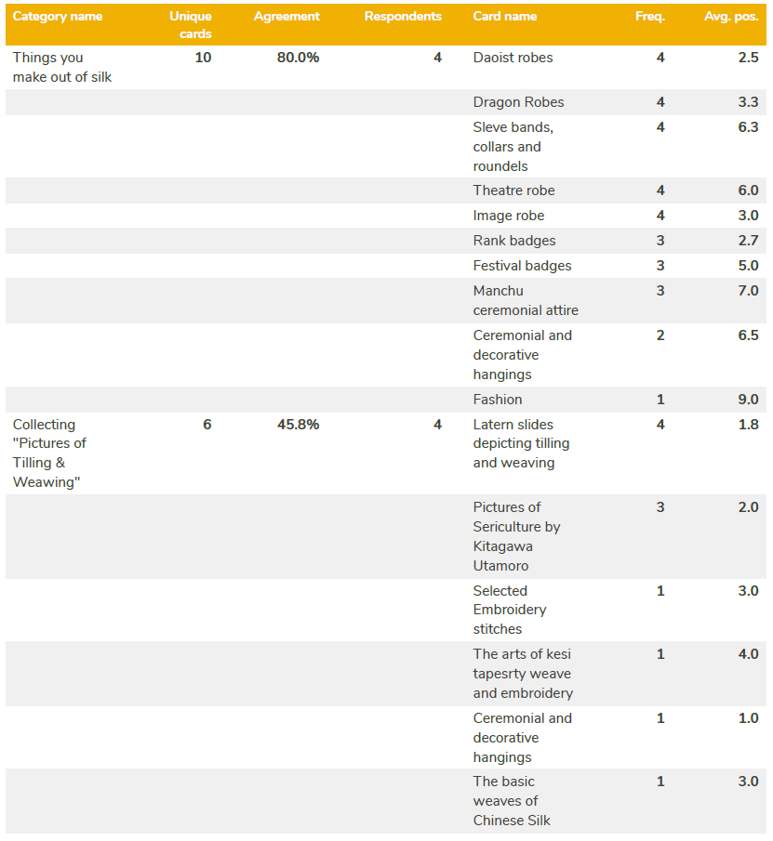

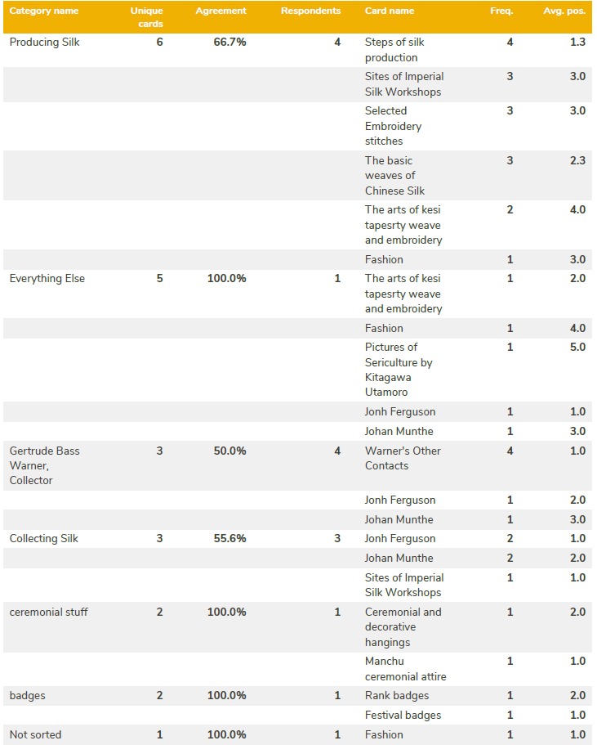

Appendix J – Standartization Grid from Card Sort
