THE EVOLUTION OF CHINESE VIOLIN CONCERTOS:
FROM FOLK IDIOMS TO CONTEMPORARY NARRATIVES

TABLE OF CONTENTS
I. INTRODUCTION 2
Statement of purpose 4
Existing scholarship and this study’s contribution 4
Scope of research and methodology 6
II. SOCIAL TRANSFORMATIONS AND THE GLOBAL CONTEXT 6
Social Upheaval before 1949- the Emergence of the Chinese Violin Concerto 7
Postwar Reconstruction and National Narrative under New Cultural Values 9
Reform and Opening-up to the World- The Absorption of Modernism 11
Humanistic Aesthetics of Fifth-Generation Cinema and a New Film Music Language 13
III. THE STRUCTURAL AND EXPRESSIVE EVOLUTION 15
The Evolution of Structure and Form 15
The Evolution of Expression and the Use of National Elements 26
The Evolving Narrative Relationship between Soloist and Orchestra 43
IV PERFORMANCE PRACTICE AND RECEPTION ACROSS CULTURAL CONTEXTS 50
Performance Materials and Interpretive Traditions 50
Dissemination and Reception 58

INTRODUCTION
The violin, as a western instrument, was introduced to China in the late 19th and early 20th centuries. At that time, the violin was performed only in the imperial court under the feudal social system and had not yet spread among the general public. Starting from the 1920s, as world-renowned violinists such as Fritz Kreisler and Jascha Heifetz performed in China, many young music enthusiasts were inspired to learn the instrument, which led to the emergence of the first generation of Chinese violin musicians. It was during this period that the earliest violin works composed by Chinese musicians appeared. Afterward, the development of violin music in China became increasingly diverse and refined. In 1943, Ma Sicong composed his Violin Concerto in F Major, signifying the formal establishment of the “Chinese violin concerto” as a distinct genre. Thereafter, the development of Chinese violin concertos was closely intertwined with the nation’s sociocultural transformations. In the 1950s, The Butterfly Lovers Violin Concerto, co-composed by Chen Gang and He Zhanhao, became a cultural icon of national music, blending Western symphonic language with Chinese narrative traditions and folk themes, and resonating widely through its expressive storytelling. In the latter half of the twentieth century, as the country underwent profound political and cultural transformations including wars, nation-building, and the Reform and Opening-up, Chinese composers continuously sought to balance national identity and modernist expression. As the twenty-first century unfolded, Chinese violin concertos began to display increasingly diverse modes of musical expression and aesthetic orientation. Some works emphasized the continuation of national characteristics and narrative traditions, while others incorporated modern artistic concepts and philosophical reflection, expressing personal emotion through more subtle musical language. When looking back on those developments, several essential questions remain worth exploring: How have Chinese composers used the Western-born genre of the violin concerto to express Chinese cultural identity within changing historical contexts? How have they absorbed Western artistic concepts and compositional techniques while reshaping them according to Chinese musical, narrative, and philosophical concerns? As these works have moved from domestic stages to international platforms, how have performance practice, reception, and dissemination changed across cultural contexts?

Statement of purpose
This study examines four representative Chinese violin concertos：Sicong Ma’s Violin Concerto in F Major (1943), the Butterfly Lovers’ Concerto (1959), Zhao Jiping’s Violin Concerto No. 1 (2017), and Qigang Chen’s Violin Concerto, “La joie de la souffrance” ( 2017). Spanning from the 1940s to the 21st century, these works show how Chinese composers have continually redefined the violin concerto as a medium for Chinese cultural expression..
This paper argues that the Chinese violin concerto has not simply developed through the combination of Chinese musical materials and a Western genre. Rather, across different historical periods, composers have reshaped the concerto form in response to changing ideas of nation, history, culture, and global exchange. Ma’s concerto represents an early attempt to place Chinese folk tunes within an international concerto framework. Structurally, the work closely follows the conventions of the traditional Western concerto, such as the double exposition and the fast–slow–fast three-movement design. Meanwhile, the piece incorporates elements of traditional Cantonese music, such as rhythmic fragments drawn from the traditional Cantonese piece Niao Jing Xuan. The Butterfly Lovers transforms the Western concerto into a narrative vehicle for Chinese folk legend and Yue opera style. It adopts a single-movement structure divided into eight narrative sections, through which it tells the tragic love story of Liang Shanbo and Zhu Yingtai. Its melodic writing draws heavily on Yue opera, particularly through the use of various types of portamenti. Zhao’s concerto moves away from a specific folk story and instead presents Chinese identity through a broader symphonic sound world and humanistic vision. As Zhao suggested, the work expresses a sense of “great love,” an abstract and universal form of compassion that gives the concerto a distinctly symphonic character. La joie de la souffrance further shifts the genre toward a more abstract and psychological modern musical language that is open to cross-cultural interpretation. It does not adhere to any conventional formal model, but unfolds in a distinctive stream-of-consciousness style.

Existing scholarship and this study’s contribution
Existing scholarship has provided important foundations for the study of Chinese violin music and Chinese violin concertos. For example, Yuan-Yuan Wang’s study of Ma Sicong’s Violin Concerto in F Major focuses on Ma’s biography, Western training, Chinese influences, and the formal and harmonic design of the concerto. Studies of The Butterfly Lovers, such as Yuli Jiang’s and Ying Zhang’s research projects, emphasize its historical background, nationalism, Yue opera influence, one-movement structure, and Chinese instrumental techniques. Existing research on Zhao Jiping’s Violin Concerto has focused mainly on the work’s formal structure, thematic materials, timbre and sonority, and technical challenges in violin performance, while current study of La joie de la souffrance have emphasized the transformation of national melodic materials and the construction of contrasting thematic ideas. Xin Xing has examined the evolution of the Chinese violin concerto genre in the 1940s–1980s. His study identifies collective authorship and ideologically oriented programmability as two important features of early Chinese violin concertos, while also emphasizing their reliance on European and Russian late-Romantic concerto models. My study extends this discussion into the twenty-first century and offers a broader comparison, including the evolving relationship between soloist and orchestra, musical form, Chinese musical materials, and performance practice. Zhuoyu Lu has also examined the broader evolution of Chinese violin music in the twentieth century through selected short violin pieces, focusing on how Chinese composers integrated folk melodies, traditional instrumental idioms, and Western violin techniques. Inspired by his approach to representative works, my study narrows the focus to the violin concerto as a specific genre and traces its development from its emergence in China to the contemporary period. Building on these studies, my research focuses more specifically on the Chinese violin concerto as a developing large-scale genre, bringing the discussion into the twenty-first century and examining its evolution through formal design, narrative strategy, the soloist–orchestra relationship, Chinese musical materials, and cross-cultural performance and reception.

Scope of research and methodology
The scope of this research will be limited to the four concertos mentioned above. The research will employ methods including score study and analysis, exploration of social and historical context, analysis of recordings, interviews with composers and performers, and review of relevant media coverage. Reference materials will include both Chinese and international books, articles, dissertations, original scores, recordings, and performance video. Since the interpretation of a specific work can vary across different eras and cultural contexts, this study will also include a comparative analysis of recordings and videos of the same concerto performed in different settings, in order to explore how interpretive styles change across contexts.

SOCIAL TRANSFORMATIONS AND THE GLOBAL CONTEXT
This chapter examines how major social and cultural transformations in modern China shaped the development of the Chinese violin concerto. Rather than treating historical background as separate from musical analysis, it argues that changing historical conditions influenced not only the themes of these works, but also the ways composers understood the concerto as a vehicle for national expression, humanistic reflection, and cross-cultural communication.

Social Upheaval before 1949- the Emergence of the Chinese Violin Concerto
From a long-term historical perspective, the first half of the twentieth century was a period of profound and rapid transformation in Chinese society. The 1911 Xinhai Revolution overthrew the Qing dynasty, bringing an end to more than two thousand years of imperial rule and initiating the Republican period in China. Alongside changes in the political system, deep shifts also occurred in social thought and cultural orientation, marking a crucial transition from a traditional society to a modern one.
The May Fourth Movement of 1919 was not only a patriotic student movement, but also an influential intellectual and cultural movement through which Western democratic philosophies were widely introduced into China. New-style schools and music conservatories were established, and Western music theory and compositional techniques were systematically incorporated into formal education. At the same time, many young musicians traveled abroad to study Western classical music and returned to China after their graduation, thereby contributing to the formation of the modern professional music system in China. Liang Mingyue, states in his book Music of the Billion: “The introduction of democratic ideals leading to the establishment of the Republic of China initiated the first stage of Westernization in China. With it came brass buttoned uniforms, ties, and hats, ballroom dancing, widescale public education, Western-styled music conservatories and universities, all new and fresh to the Chinese scene. Talented musicians were going abroad to Japan, Europe and the United States for Western music education.”
As a representative figure of the first generation of Chinese violinists and composers, Sicong Ma began his studies in France within this historical context. In 1923, he arrived in France and began his professional musical training at the age of eleven. During this period, he gradually developed a strong interest in composition and studied the works of major composers in the Western world, ranging from Baroque and Classical masters such as Bach and Mozart to nineteenth and twentieth century composers including Debussy and Stravinsky. In the meantime, he was encouraged by his composition teacher to explore his own musical language and incorporate elements of traditional Chinese culture into his work. At the same time, inspired by the successful incorporation of folk songs into symphonic works by nineteenth-century European composers and encouraged by his composition teacher, he began to explore his own musical language and incorporate elements of traditional Chinese culture into his work.
With the outbreak of the War of Resistance against Japan in 1937, Chinese society entered a period of intense instability, and musicians were forced to relocate frequently, facing extremely difficult living conditions. Under such circumstances, national consciousness was greatly heightened, and musical creation took on a strong patriotic character rather than purely artistic expression. Ma’s Violin Concerto in F Major was composed during this difficult period. Yuanyuan Wang noted in her doctoral dissertation that the spirit of Ma’s concerto “is to bring hope to people during the time of war.” As a large-scale genre, the concerto itself always carries a unifying and uplifting effect, and the choice of F major may not have been accidental. Ernst Pauer wrote in his “The Elements of the Beautiful in Music” that “F major is at once full of peace and joy, but also expresses effectively a light, passing regret-a mournful, but not a deeplysorrowful feeling.” There is therefore sufficient reason to suggest that the spirit of this work, at least in part, reflects a longing for peace in a time of wartime hardship.

Postwar Reconstruction and National Narrative under New Cultural Values
During the long years of war, music gradually came to carry national consciousness and the spirit of the time. In 1949, the civil war ended and the People’s Republic of China was founded. Workers, peasants, and soldiers were given new social status, and music also took on new social functions. As Liang Mingyue writes, “music and the other arts were committed to serve the workers, peasants, soldiers, as well as to communicate the messages of the government.” In the years before the Cultural Revolution, Chinese music experienced a revival of regional instrumental and dramatic music, promotion of narrative music. At the same time, solo instrumental works were widely encouraged, the level of Chinese orchestras was significantly improved, and state-sponsored music conservatories flourished across the country.
These changes created favorable conditions for the development of the concerto genre in China. As a major narrative violin concerto, the Butterfly Lovers was composed by He Zhanhao and Chen Gang, both of whom were trained in the conservatory system that expanded during this period. The work is based on a Chinese folk legend, and its melodic material draws from Yue opera, a regional theatrical form with a broad popular audience. In this way, it aligned closely with the cultural policy at that time which emphasized serving the nation and the people. Martin K. Whyte mentioned in his “Evolutionary Changes in Chinese Culture”: “A variety of far-reaching institutional changes were made in Chinese society, many traditional customs and cultural practices (such as arranged marriages, burials, spirit mediums, kowtowing to elders, and so forth) were discouraged or banned.” The Butterfly Lovers which centers on resistance to arranged marriage directly reflects this theme. This shows that, both in its musical material and narrative theme, the work resonates with the social values of its time.
However, this exploration of musical nationalism was interrupted after 1966. During the ten years of the Cultural Revolution, the artistic creation entered a period of intense politicization and ideological uniformity. Under such circumstances, personal emotions in artistic expression were suppressed, while collective heroism was strongly promoted. Almost no violin concertos were produced during this period, and the reason is quite clear: the concerto as a genre emphasizes the individual soloist, which conflicted with the prevailing collectivist values. Moreover, the violin possesses a strong lyrical character by its nature, which did not align with the revolutionary music that emphasized struggle and militancy. As a lyrical Western genre, the violin concerto almost disappeared from the musical stage, and even the once-popular Butterfly Lovers was marginalized for a time.

Reform and Opening-up to the World- The Absorption of Modernism
In the late 1970s, with the end of the Cultural Revolution and the restoration of the national college entrance examination, music conservatories welcomed the first new generation of composition students, including Qigang Chen. As Reform and Opening-up progressed, Chinese composers increasingly pursued advanced studies abroad, and contemporary Western compositional techniques gradually returned to this land.
With this opportunity, Qigang Chen became the last student of the renowned French composer Olivier Messiaen. Studying within the European educational system, he was exposed to more open and liberal artistic concepts. As Chen mentioned in an interview with Southern People Weekly, admission to the composition program did not necessarily require prior knowledge of composition，and sometimes having innovative ideas was already enough. This creative spirit is also reflected in his works, including the violin concerto La joie de la souffrance, from which we can see that the clear structures and functional harmony characteristic of traditional tonal language largely disappear. These compositional ideas were strongly influenced by Messiaen. In an interview with the online media Shangshufang, Chen also mentioned that after studying with Messiaen, his professional aspirations changed: he began to aspire to be a composer capable of innovation instead of simply becoming a teacher. With the door to a new artistic world opened, Chen kept absorbing new inspirations from modern composition, such as the works of György Ligeti, which also had a profound impact on the formation of his musical aesthetics.
As exemplified by Chen’s experience, that generation of Chinese composers broadened their professional horizons and aesthetic under the influence of Western educational systems, and consequently reshaped their own musical language. However, the influence of thousands of years of Chinese cultural heritage is deeply rooted. As Chen said, he instinctively realized that the meta-language that had shaped him since childhood was too unique to abandon, and Chinese culture is his meta-language.In his La joie de la souffrance, the traditional Chinese philosophical concept of yin-yang duality is reflected: the joy and sorrow of life are understood as two inseparable aspects of gain and loss. Where there is gain, there must also be loss. Also, the thematic material of the work is drawn from the ancient guqin piece Yangguan Sandie，which roots the work deeply in Chinese cultural tradition both in its spiritual meaning and musical material, while employing modern compositional techniques. Within this tension between modernism and traditional musical language, contemporary Chinese composers have gradually explored a creative path that combines an international perspective with a strong sense of national identity.

Humanistic Aesthetics of Fifth-Generation Cinema and a New Film Music Language
In 1905, the film Dingjun Shan, produced by native Chinese filmmakers, was presented to audiences. This year is widely regarded in many studies of Chinese film history as the beginning of Chinese cinema. Thereafter, Chinese cinema went through a period of commercial exploration and creative practice following the founding of the People’s Republic of China, and entered a new stage after the Reform and Opening-up. When it comes to the 1980s, China experienced a wave of intellectual and aesthetic innovation in literature and the arts, during which the Fifth Generation of filmmakers emerged. The films of this period embody a modernist and humanistic spirit, reflecting deeply on history, nation, culture, and the human condition. They portray human destiny through the relationship between humans and their environment. As a prominent film composer who grew alongside the Fifth Generation, Zhao Jiping’s music was deeply influenced by this humanistic cinematic movement and is firmly rooted in Chinese traditional culture. Having been born and raised on the loess plateau of northwestern China, his music has always maintained a close connection with the land. As he said, “I have always believed that a composer must take root in this vast land.”
Although his Violin Concerto No.1 adopts a non-programmatic form and the traditional musical elements in its theme do not carry a clearly regional reference,the humanistic spirit and emotional expression embedded in the work continue to reflect his consistent artistic philosophy—the desire to express “a universal sense of compassion shared by all humanity.” As he said in an interview: “I did not want to make my music overly obscure, something detached from everyday life.” His music remains accessible to a broad audience, expressing emotions in a distinctly Chinese way, which is profound yet restrained, weighty yet delicate.
These historical contexts show that the Chinese violin concerto developed not as a fixed national form, but as a flexible genre continually reshaped by changing historical and cultural conditions. These changes are not limited to subject matter or historical meaning. They are also embedded in musical structure, thematic design, orchestration, and the evolving relationship between soloist and orchestra. The following chapter therefore examines the structural and expressive evolution of these works.

THE STRUCTURAL AND EXPRESSIVE EVOLUTION

The Evolution of Structure and Form
This section examines how the formal structure of the Chinese violin concerto evolved across the four selected works. Ma Sicong’s concerto largely follows the relatively conventional model of the Western classical concerto, while The Butterfly Lovers reshapes the single-movement concerto into a continuous musical narrative based on a folk legend. Zhao Jiping’s concerto further loosens traditional formal expectations through an individualized single-movement design, and Chen Qigang’s La joie de la souffrance moves even further away from conventional concerto form by organizing the work through the recurrence and transformation of psychological and expressive states. Through these examples, this section argues that Chinese composers did not simply adopt the Western concerto form, but gradually transformed it into a flexible structure capable of carrying folk musical language, narrative meaning, and philosophical expression.
As one of the most important genres in Western classical music, the concerto has undergone a historical development from the ritornello form of the Baroque period to a concerto form influenced by sonata form in the Classical period. This mature structural model provided Chinese composers with an important framework, enabling them to explore new musical possibilities while drawing on Western traditions. Ma Sicong’s Violin Concerto in F Major is widely regarded in many studies as the first violin concerto composed in China. It adopts the traditional three-movement (fast–slow–fast) structure of the Western concerto. The first movement is in F major, and its overall framework approximates sonata form, while also incorporating elements of ritornello form, in which the thematic motives are presented repeatedly by the orchestra. The opening of the movement presents a double exposition structure commonly found in Western classical concertos: the orchestra first introduces the main theme,and after a lengthy introduction, the solo violin enters and restates the thematic material. The cadenza part appears near the end of the first movement and spans 44 measures, further highlighting the work’s virtuosic character. The second movement shifts to C minor, a key built on the dominant of the first movement. This movement is lyrical in character and follows an overall ternary form. The final movement is a lively rondo form, and the tonality returns to F major. Overall, this concerto largely follows the formal and structural framework of the traditional Western violin concerto in both formal design and organization.
Apart from being designated in F major, this work carries no additional explicit title or programmatic indication. It therefore belongs to the tradition of the untitled concerto, similar to most conventional Western concertos. In contrast, the Butterfly Lovers Violin Concerto (known in Chinese as Liang Shanbo and Zhu Yingtai) is a typical example of program music with a clear narrative orientation. The story is based on a Chinese folk legend and tells of two lovers who come to know and love each other, but are forced apart under the constraints of feudal ethics. They eventually achieve a spiritual reunion by transforming into butterflies after a double suicide. The concerto adopts a single-movement structure and is guided by a narrative progression. It is divided into eight sections—Birdsong and Fragrant Flowers, First Meeting at Caoqiao, Studying Together, The Eighteen-Mile Farewell, Resisting the Arranged Marriage, The Balcony Meeting, Lamenting at the Tomb, and The Transformation into Butterflies—each corresponding closely to the development of the story. There are no grand pauses between these sections, ensuring a continuous musical narrative.
In the concluding section, the opening thematic melody returns. Although some studies interpret this structure as the recapitulation of a sonata form, from the perspective of musical narrative, this theme functions more like a Wagnerian "leitmotif": acting as a symbolic motif for their love, it recurs during the couple’s encounters and undergoes continuous transformation across different contexts to convey the characters' evolving emotions and the plot’s progression.
For example, the theme at the beginning portrays the beautiful feelings that arise when Liang and Zhu first meet and come to know each other. Figure 2 shows a variation of this theme that appears during the Eighteen-Mile Farewell, depicting the lovers’ reluctant goodbye. Although Figure 3 does not quote the theme in its entirety, the measure at letter D reveals it to be another variation derived from the theme, appearing in the Balcony Meeting section. Finally, the theme returns in full in the Transformation into Butterflies ending. This suggests that, rather than being simply understood as a traditional sonata form, it is more convincing to interpret it as a narrative thematic motive that runs through the entire work.
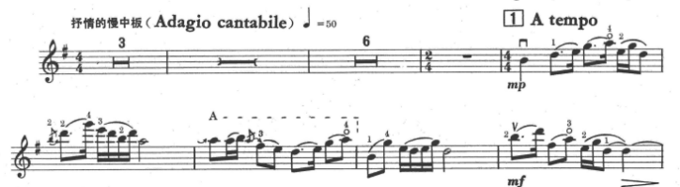

Figure 1: the Butterfly Lovers, beginning
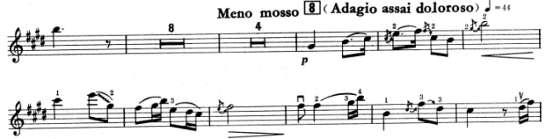

Figure 2: Eighteen-Mile Farewell
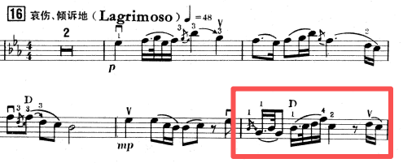
Figure 3: The Balcony Meeting
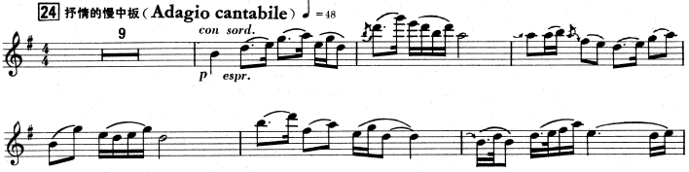
Figure 4: Transformation into Butterflies

Similarly, Zhao Jiping’s Violin Concerto No. 1 is also a continuous single-movement concerto. Unlike Butterfly Lovers, however, it adopts the non-programmatic form of traditional Western concertos, with no specific narrative or title. Structurally speaking,it begins with a lyrical slow section, which primarily serves to present the main theme. This is followed by a brief two bars rubato passage for solo violin with a cadenza-like character, which leads into a faster section. As the fast section unfolds, the musical tension correspondingly increases. One notable feature is that this fast section closes in a way similar to the preceding slow section- allowing the solo violin to conclude on its own.
After this, the music returns to a slow tempo, but instead of immediately restating the main theme, the orchestra presents some fragmentary sections that serve as an emotional preparation and transition. Following thirteen measures of slow unfolding, the solo violin finally begins a thematic restatement which sounds like a recapitulation. However, this statement does not last long. The music soon shifts again into a more impassioned passage with clear characteristics of a development section. As the orchestra rises into a higher register with fast-moving notes, the texture grows noticeably thicker and the music is gradually driven toward a climax. After this section comes to an end, the solo violin enters a cadenza. After this the orchestra returns with the opening theme, giving this new part a very clear recapitulative character.
This shows that the concerto has an unusual structure, particularly in that it seems to contain two passages with development characteristics. From the perspective of the overall formal layout, it is reasonable to regard the first fast section as part of the exposition. More specifically, this section may be understood as a secondary thematic area within the exposition, contrasting with the primary slow theme. Wang Kexin mentions a similar argument in her master’s thesis.
Unlike the first movement of Ma Sicong’s Violin Concerto, which adopts a double exposition, the opening of Zhao Jiping’s concerto presents a unique structural design. The opening of the work presents a passage that is introductory in character. In terms of phrase organization, this section does not form the kind of complete and balanced antecedent–consequent structure typically found in traditional phrase structure. Taking the opening as an example, mm 1–3 is the first statement by the winds, while mm 4–6 form a second statement. However, this second statement appears closer to a repetition of the first, which is an octave lower, rather than a logical response. From a harmonic perspective, both those statements end on a C-minor harmony rather than on the tonic of E-flat major, which further reinforces the sense of incompleteness. These features suggest that this passage is more like two questions posed by the winds without receiving any clear answer—as if only the antecedent were present, with no corresponding consequent ever arriving. A similar situation can also be observed later, after the strings enter. For this reason, the entire passage from the opening to mm 25 is better understood as a functional introduction.
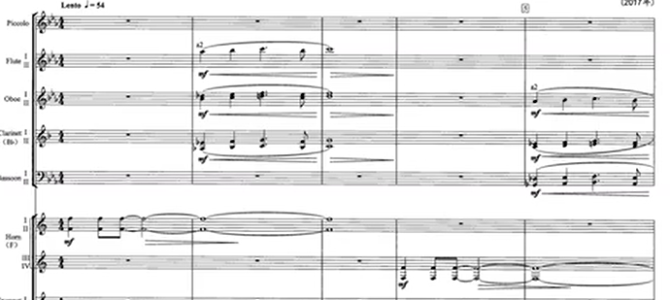
Figure 5: Opening of Zhao Jiping’s concerto
Although the orchestra does not directly state the main theme during the introduction, the material in this section is closely related to it and can be seen as having been developed from the core motifs of the theme (see figure 6). Meanwhile, the solo violin also participates in the introduction, presenting a brief motif that is also likewise closely related to the thematic material (see figure 7). This technique, in which the primary motifs of the main theme are hinted at in the introduction, and the soloist and orchestra jointly participate in the emergence of the theme, reflects a distinctive and highly individual compositional approach.
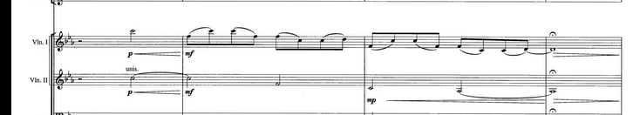
Figure 6: Zhao’s concerto, mm 21-24

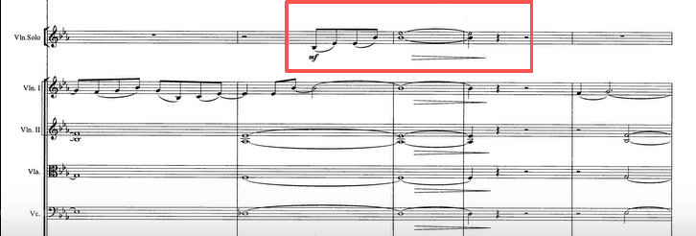
Figure 7: Zhao’s concerto, mm 11-15
However, after the solo violin formally enters and states the theme, the orchestra follows immediately with a responsive restatement of that theme (see figure 8). This section can be regarded as a somewhat unusual form of double exposition. Unlike the orchestra usually presents the main theme at the very beginning in the traditional concerto, here the main theme is first introduced by the solo violin after the introduction, then the orchestra presents the theme again. In this sense, the basic structural feature of double exposition is still preserved, although the order of presenting part is reversed. What is even more noteworthy is that the composer does not stop there. After the orchestral statement, a third presentation shared by the soloist and the orchestra follows, and the solo violin joins the first violin section in playing the theme (see figure 9). This creates a distinctive sonic effect, further reinforcing the presence of the theme.
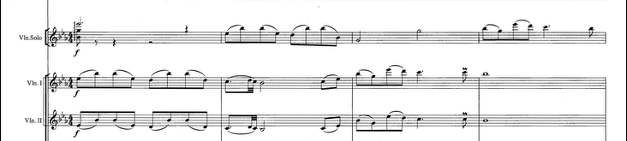
Figure 8: Zhao’s concerto, mm 41-44

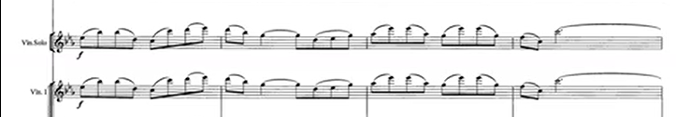
Figure 9: Zhao’s concerto, mm 49-52
Besides that, Zhao Jiping mentioned in an interview that this concerto also adopts contrapuntal technique. This can be heard particularly clearly in the passage from mm 175–193, where the orchestra repeatedly restates a four-measure motive. The motive is presented successively by different sections of the ensemble: it first appears in the lower strings, then moves to the viola, second violin, and first violin, and finally was taken up by the wind section as a whole.
While the three concertos all retain some relationship to sonata form, Qigang Chen’s concerto can hardly be understood within such a traditional framework. The first thematic motive appears at mm 21, first stated by the cellos in the orchestra. At mm 36, the solo violin enters and takes up the same motive. A second thematic motive then appears at mm. 51. From the opening to this point, the music remains in a generally slow tempo and a predominantly sorrowful expressive atmosphere.
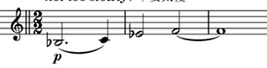
Figure 10: Chen’s concerto, mm 36-38
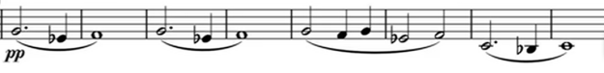
Figure 11: Chen’s concerto, mm 51-58
After this, the solo violin begins an extended passage of double stops, with the figuration becoming increasingly rapid, until it reaches a completely new and more impassioned section at mm 122. After this, the music returns at mm 178 to a more lyrical expression, and the first thematic motive is introduced once again. Following a brief unfolding of this material, the music shifts back into a passionate section. At mm. 245, the first thematic motive returns once more. By mm. 271, the work enters a solo cadenza. After mm. 302, the music returns to a tragic expressive world, and both a transformation of the first thematic motive and the second thematic motive reappear. Following this, the intensity begins to build, with increasingly virtuosic writing unfolding throughout the following passage. Through this intense section, which lasts more than four minutes, the music gradually builds toward the climax of the entire work, the “Excruciating Song” at mm. 491. After the climax, it finally returns to the sorrowful passage, in which thematic motives 1 and 2 appear together once again, and the concerto ends in a mood of calm.
This suggests that the concerto displays a highly individualized mode of formal organization. In Zhao Chunting’s article “Artistic Creation and Musical Analysis of the Orchestral Work La joie de la souffrance,” this work is regarded a ternary form, which seems somewhat forced to me. In fact, the piece unfolds through a continual alternation between lyrical and agitated sections, while maintain its overall unity by the repeated return and transformation of the two thematic motives.
In my view, two ways of understanding the form of this work might be convincing. First, it may be regarded as a narrative structure, in which the entire concerto portrays the psychological states in different situations. This interpretation also corresponds to the composer’s expressive markings for different sections in the score. Second, it may be understood as a rondo-like form. The thematic motives recur several times throughout the work, while a number of contrasting passages are inserted between their returns. Although the individual sections do not strictly follow the conventions of a traditional rondo, the overall structure shows clear similarities to that form.

The Evolution of Expression and the Use of National Elements
This section examines how Chinese musical elements are transformed across the four concertos. In the earlier works, these elements are often more directly connected to folk melodies, regional styles, and the imitation of traditional instruments. In the later works, they become less immediately recognizable, but continue to shape the music through broader symphonic expression, philosophical ideas, psychological contrast, and the organization of sound. In this sense, the development of the Chinese violin concerto should not be understood as a movement away from Chinese identity, but as a process in which Chinese musical expression is continually reinterpreted and given new forms.
Historically, Chinese music was centered on a single melodic line. With harmony often overlooked before the 1900s, the music’s full expressive range was never completely realized. In the 20th century, however, Chinese composers began to draw on the rich harmonic language of the European Romantic tradition. Rather than conflicting with national themes, these harmonic resources could be organically integrated with them, providing a modern depth that successfully supplemented the national character of the music.
Sicong Ma frequently drew upon folk songs as a source of inspiration for his composition, and this is also clearly reflected in his Violin Concerto in F Major, which makes extensive use of folk musical materials from Guangdong, a province in southern China. In the first movement, he borrows material from the Cantonese piece Niao Jing Xuan (Birds Startled by Clamour) and presents it as a principal motive (mm. 14-19, Figure 12). Its musical shape is highly fluid and well-suited for development, giving the music a strong sense of vitality and momentum. However, the borrowing is reflected mainly in the use of rhythmic patterns, whereas Butterfly Lovers, which will be discussed later, differs somewhat in that it directly quotes specific melodic material.
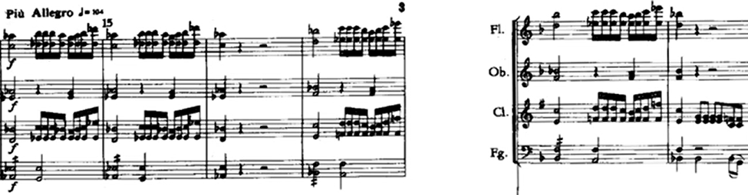
Figure 12: mm 14-19
In the first movement, the solo violin part makes extensive use of broken octaves, for example in mm. 45–46 , where the register leaps are especially wide, and again in mm. 234–237. In the folk song Niao Jing Xuan, broken octaves are frequently used in plucked instruments, and the violin writing here is therefore very likely an imitation of that style. In fact, the use of broken octaves is widely found in the music of traditional Chinese plucked-string instruments, such as the traditional octave-symmetrical fingering used on the guzheng (a traditional Chinese zither). Since traditional Chinese music is primarily monophonic and lacks the harmonic structures found in the Western musical system, the alternation and expansion of octaves across different registers can enrich the sonority and add layers to the sound while maintaining melodic continuity, thereby significantly enhancing musical expressiveness.
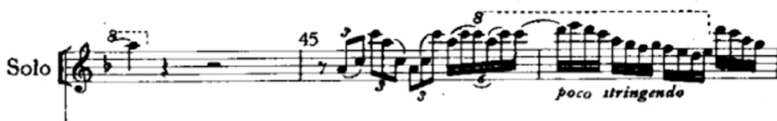
Figure 13: mm 44-46

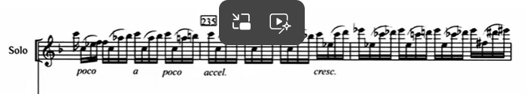
Figure 14: mm 234-236

In addition, the solo violin part contains numerous extreme high-register passages, as shown in the figure above. Such writing appears throughout the entire work , and its highest pitch even approaches high A, near the upper limit of the violin’s range (see figure 15). One of the principal instruments in the original Niao Jing Xuan is the gaohu, a high-pitched Chinese bowed string instrument. The frequent use of the violin’s upper register in this concerto may, to some extent, draw on or respond to the timbral character of the gaohu, or at least produce a comparable sonic effect.
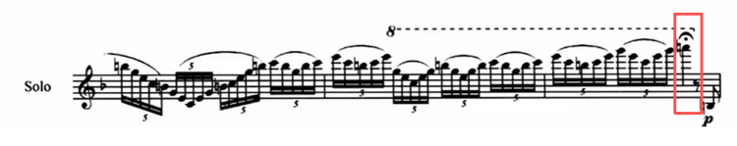
Figure 15: Candenza of first movement
In contrast to the use of folk material in Ma’s concerto, The Butterfly Lovers not only absorbs a large amount of folk material into its thematic writing and imitates the sonorities of traditional instruments, but also draws its entire narrative foundation from a widely known Chinese legend.
In the early 1930s in Zhejiang, China, two types of opera were particularly popular: Yue Opera (Yueju) and Shaoxing Daban. He Zhanhao, one of the composers of Butterfly Lovers, grew up in this environment. Under the influence of his grandmother, he was exposed to Yue opera from an early age and was deeply immersed in its musical style, which laid a crucial foundation for his later composition of The Butterfly Lovers Violin Concerto. After entering the Shanghai Conservatory of Music, He Zhanhao helped form an experimental group devoted to exploring how the performance techniques of Chinese folk music and local opera could be applied to violin playing. It was through this research project that he collaborated with composition student Chen Gang to co-create The Butterfly Lovers Concerto. In fact, the Yue Opera version of Liang Shanbo and Zhu Yingtai had already been established and widely performed on the Chinese stage as early as the first half of the twentieth century. This concerto stands as a representative work that based on that tradition, while adopting the formal framework of the Western concerto.
Thus, it is clear that the work is deeply influenced in its musical language by Yue opera and the broader tradition of Chinese folk music. A study of the score reveals that portamento is used extensively throughout the concerto and appears in several different forms. One important type is back-and-forth portamento, in which the finger moves down by a semitone from its original position and then returns to the starting pitch (see figure 16). This technique imitates a characteristic gesture of the erhu, a traditional Chinese bowed string instrument. In erhu repertoire, it is often used to imitate the sound of weeping or to evoke a strong sense of sorrow. The portamento shown in the example appears in the Balcony Meeting section, where it serves to express Liang and Zhu’s complex and stirred emotions upon their reunion. At this moment in the narrative, the gesture conveys not only excitement at seeing one another again, but also the restraint, hesitation, and underlying sorrow shaped by their tragic circumstances. For this reason, performers often slow down the sliding speed and incorporate a degree of rubato to heighten the melody's lyricism. In expressive effect, such treatment can even evoke the inflection of traditional Chinese operatic singing.
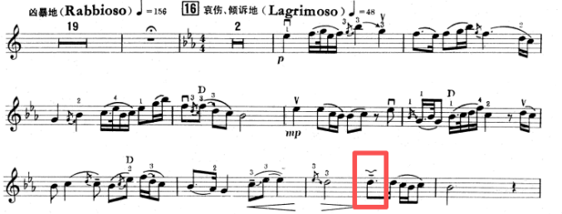
Figure 16: The Balcony Meeting
Next is the portamento within a minor third using the same finger, which is the most frequently occurring sliding technique in the entire concerto. It appears especially often in lyrical passages—for instance, in the First Meeting at Caoqiao section, it occurs as many as twenty times. This type of portamento may be executed either as an upward slide or a downward slide, as shown in the figure 17. It is closely related to performance practices found in Chinese folk opera and traditional instrumental music. We can observe extensive use of this portamento in the Yue Opera version as well. The excerpt is notated in jianpu, the traditional Chinese numbered notation system, in which the numbers 1, 2, 3, 4, 5, 6, 7 correspond to the scale degrees C, D, E, F, G, A, B. The red box in the example marks precisely a portamento within a minor third, sliding from E to G.
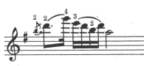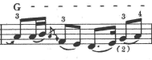
Figure 17: mm 13, mm 19
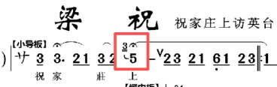
Figure 18: Yue Opera version
The use of portamento in this concerto goes far beyond these two types. For example, in Figure 17 mm 19, the first note does not even indicate the exact pitch from which the slide begins. Also, the following figure illustrates a glissando—a slide spanning a wide interval. In practice, any portamento can be employed wherever it helps express inner emotion and heighten dramatic effect. In Yue opera singing as well, performers often do not adhere strictly to the notated score. For instance, in The New Liang Zhu, Episode 18, the syllable ying in the phrase “fang Yingtai” at the opening is sung with a series of flexible, improvisatory slides that move both upward and downward, producing a highly expressive effect.
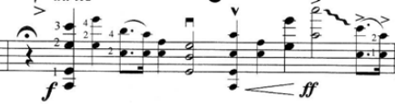
Figure 19: mm 481
The imitation of traditional Chinese string instruments in the Butterfly Lovers Violin Concerto is not limited to bowed instruments such as the erhu, but also includes plucked instruments. For example，measures 124–130 simulate the guzheng, by producing similar articulations through special bow strokes and by employing chords built on perfect fourths and perfect fifths, which are characteristic sonorities of the Zheng.
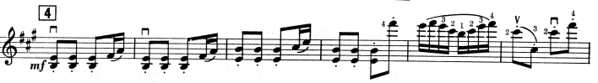
Figure 20: mm 123-128
In addition to imitating the sonorities of traditional Chinese instruments, the composers also utilize orchestral orchestration to vividly depict the development of the story. At the beginning of the concerto, the flute is used to evoke a scene of birdsong and blossoming flowers, creating a bright and animated pastoral atmosphere. In the Resistance to the Arranged Marriage section, a Chinese gong is introduced to create a dark and oppressive atmosphere, while the horns are brought in to reinforces the orchestra’s sonic power, thereby heightening the dramatic tension of the scene. In the Balcony Meeting section, the violin first presents a sorrowful and tender melody, which is then answered by the cello. As the violin re-enters, it engages in a dialogue with the cello. The two instruments form a close relationship in which their melodic lines intertwine closely, as if portraying the profound, intimate and lingering exchange between Liang and Zhu.
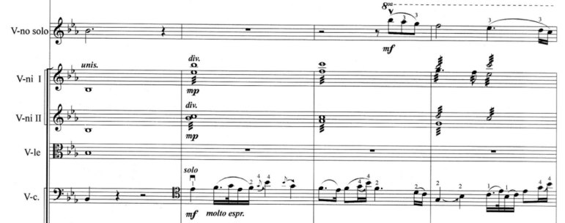
Figure 21: The duet in the Balcony Meeting section

If The Butterfly Lovers is a combination of Jiangnan folk music and the Western symphonic tradition, then Zhao’s Violin Concerto can be understood as a fusion of the musical traditions of northwestern China and the symphonic style. Born and raised on the Loess Plateau in northwestern China, the composer grew up “listening to Peking opera, Henan opera, and Qinqiang,” and his music is deeply shaped by the regional culture of northwestern China as well as by folk musical materials. In fact, he achieved considerable success as a film composer, which may in part help explain the distinctive structural design of this concerto. As discussed above, this work alternates between multiple slow and fast sections without clear movement boundaries, a feature that gives it a certain narrative quality.
Zhao has mentioned in several interviews that he is deeply passionate about folk song. He once devoted himself to the study of northern Shaanxi folk songs at the Shaanxi Opera Research Institute. In an article titled“A Study of the Double-Fourth Melodic Characteristics of Northern Shaanxi Folk Songs,” Li Hongyang from the School of Music at Liaocheng University points out one of their main melodic features: “the melodies are often built on either a fourth plus a second, or two overlapping fourths-the so-called double fourth.” In Zhao’s concerto, when the strings first enter at the opening, the interval of a second is introduced. The larger contour of the following melody is built around B and E, forming a fourth, and the solo violin, which enters shortly afterward, reinforces this interval again (see figure 22). After the formal beginning of the exposition, the main theme presented by the solo violin is once again centered on B and E and is marked by a number of wide melodic leaps. This feature is closely related to the geographical environment of the Loess Plateau , and reflects the deep influence of northern Shanxi folk music as a natural outgrowth of the composer’s musical language.
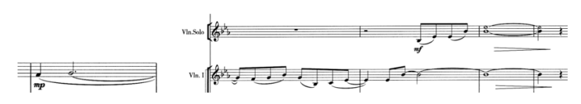
Figure 22: mm 10-13
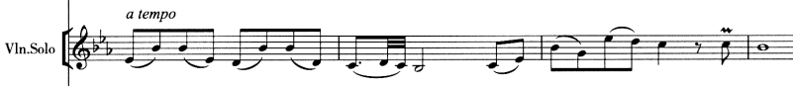
Figure 23: Beginning of the exposition
Although the title of the work does not point to any specific program, Zhao stated in several interviews that he hoped to express through this concerto “a spirit of great love, for humanity ultimately seeks peace.” He also repeatedly emphasized that the work should carry a strong sense of its own time. In fact, this kind of artistic expression, marked by a broad humanistic vision and a clear awareness of the spirit of the age, can be found throughout Chinese musical works in the decades before and after the founding of the People’s Republic of China. In my view, this kind of “great love” is not limited to private feeling at the individual level, but points instead to a higher emotional consciousness that extends to the fate of the nation and even of humanity as a whole. These melodies of those musical works are typically concise and memorable in structure, with relatively broad melodic contours and an increasingly elevated expressive character, thus producing a strong sense of emotional force.
From another perspective, this “great love” can also be seen as a kind of heroic feeling born out of turbulent times, or as a powerful sense of national emotion arising from times of war. Typical examples include The East Is Red, the music and dance epic composed to celebrate the fifteenth anniversary of the founding of the People’s Republic of China, and the Yellow River Cantata. The Cantata was later arranged in several different versions, the best known of which is the Yellow River Piano Concerto. These works are all closely connected to particular historical contexts: The East Is Red centers on the praise of the founding leader of the People’s Republic, while the Cantata portrays the powerful collective strength that the Chinese nation united in a time of crisis. Even in the twenty first century, this spirit continues to resonate in China, as shown, for example, by the large-scale vocal-symphonic suite Ode to Heroes, which premiered in 2021.
In terms of artistic expression, such works are typically characterized by large scale performing groups, including large choruses, dance, and symphonic writing, all of which contribute to a grand narrative manner. One important feature of this type of work is the prominence of the main melodic line, which is usually smooth and strongly lyrical, and is typically carried by the string section or the human voice. Compared with Western classical works, their overall texture is relatively simple. For example, in the Yellow River Piano Concerto, even at the climax of the final movement, “Defend the Yellow River,” when the full orchestra enters, most of the instruments are still playing the same melody (see figure 24). The main effect is therefore an amplification of the sonority, which is used to produce a grand effect.

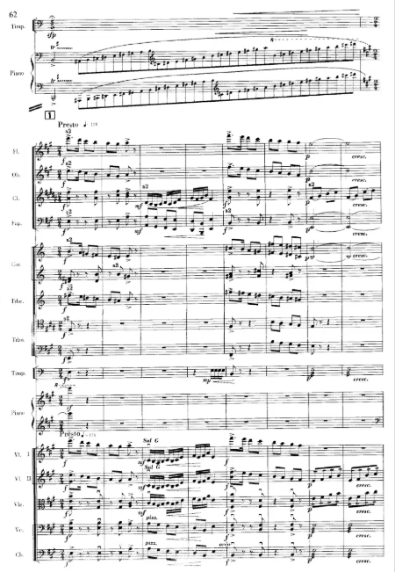
Figure 24: Defend the Yellow River

This compositional feature can also be observed in Zhao’s violin concerto. As can be seen, after the introduction comes to an end and the solo formally enters, the accompanying texture consists only of strings, clarinet, and harp (see figure 25). By mm 43, although the vertical texture becomes somewhat thicker, the wind parts, in terms of horizontal motion, still remain mostly in longer note values and relatively simple patterns (see figure 26), rather than developing into highly independent contrapuntal lines. Even in the passage where the development section builds toward its climax and more instruments join in (see figure 27), the overall sonority is indeed greatly strengthened. However, this strengthening lies mainly in the expansion of volume and the enrichment of timbre, rather than in any fundamental change in the organization of texture, and other parts still serve to highlight the main melodic line. From this perspective, Zhao Jiping in this work continues a mode of grand narrative expression characteristic of its time, which also embodies what he described as the spiritual meaning of “great love.”
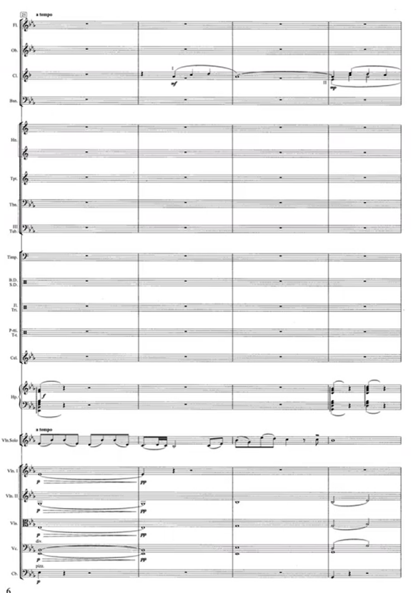
Figure 25: mm 25-28
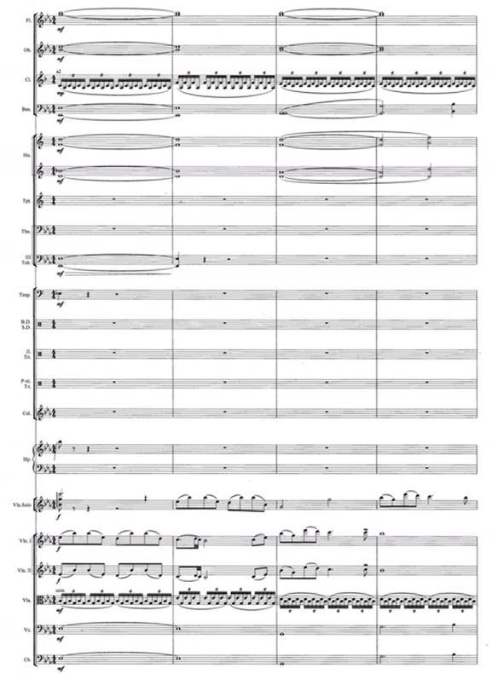
Figure 26: mm 41-44

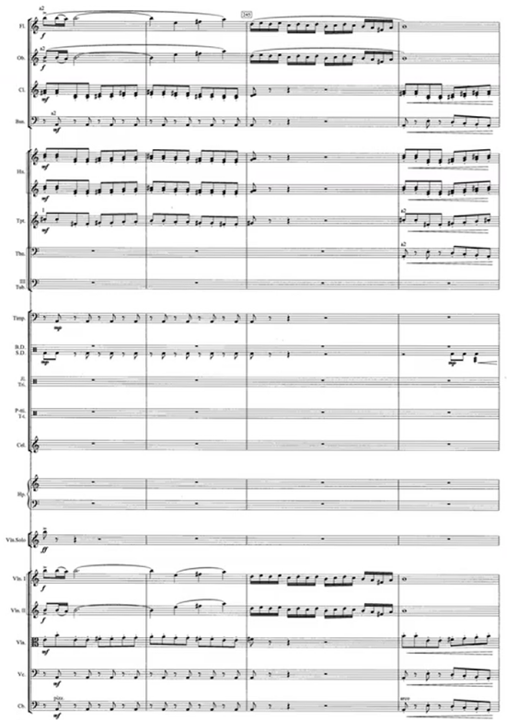
Figure 27: mm 121-124
It is worth noting that the treatment of the cadenza in this concerto shows a clear innovation. Beginning at mm 273, the composer introduces the Sanban Sign (see figure 28), which is rarely encountered in the Western concerto tradition, but is commonly found in Chinese traditional music. Derived from the left part of the Chinese character “散”（Sàn）, it indicates that the passage is no longer strictly bound by a fixed meter or tempo, allowing the performer to treat rhythm and pacing with greater freedom according to personal understanding and musical expression. The use of this sign gives the cadenza, within the formal framework of the Western concerto, a distinctively Chinese aesthetic quality. In other words, Zhao Jiping does not treat the cadenza merely as a space for virtuosity. Instead, he brings into the concerto a rhythmic concept drawn from Chinese traditional music—one that is free, expansive, and chant-like in character.

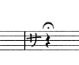
Figure 28: mm 273
Besides that, near the end of the cadenza, the composer specifically writes that “the performer may improvise here,”and gives an approximate duration of twenty seconds. As is well known, in the Classical period, cadenzas in concertos were often improvised by performers in performance. Since the Romantic period, cadenzas have more often been fully composed in advance, leaving little room for performers’ improvisation. In this respect, the treatment of the cadenza in Zhao’s concerto is especially distinctive. Although most of it is still written out in advance, the composer deliberately leaves a short space for improvisation. This approach is different both from the fully open improvisatory tradition and from the fully written-out cadenza model of later concertos. Instead, it creates an intermediate state between fixed writing and performer freedom.
While Zhao’s concerto still preserves certain elements of traditional Romantic expression, Qigang Chen’s La joie de la souffrance turns much more clearly toward a modern musical language. On first hearing, one may feel that this work is less immediately shaped by the clear and beautiful melodic lines found in the previous concertos. The score also shows clear differences in compositional technique from the previous three, more traditional concertos, and reveals several features commonly associated with modern composition since the twentieth century: a move “away from traditional harmony, rhythm and even notation. Music started to lose its traditional feel of patterns, cadences and regularity and instead embraced new complexity.”
For example, in this concerto the time signatures change constantly (see figure 29), showing the composer’s clear intention to break away from structural balance. In addition, the score uses musical markings in three languages—French, English, and Chinese—throughout the work. For instance, when the solo first presents the thematic motive, it is marked Solitaire / Solitary / 孤独地. Another example appears at mm. 82: Divinement solitaire / Divinely alone / 仙境般的寂寞. These markings are highly personal, as well as delicate and rich in expression, helping the performer grasp the composer’s intention more precisely. An even more striking example appears at mm. 122: Excité par des illusions / Thrilled by illusions / 幻觉带来的振奋. Such markings can make use of almost any descriptive phrase suited to the musical situation, rather than relying mainly on tempo indications and basic articulation markings, as in more traditional works.
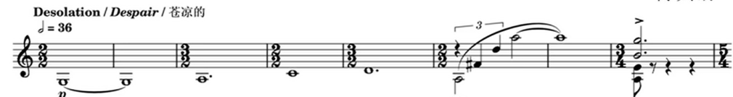
Figure 29: mm 1-8
Traditional concertos usually have relatively clear phrase divisions. In La joie de la souffrance, however, apart from a few passages in the lyrical sections where a more recognizable phrase structure can still be heard, phrase boundaries remain blurred for most of the work. Some passages show a strongly fragmented style of expression, while others unfold in a more continuous, “long-phrase” manner. For instance, mm. 133–151 contains almost no obvious melodic direction or clear phrase division, focusing instead on the sustained shaping of an overall atmosphere. Similarly, mm. 200–207 forms a broad crescendo, in which the orchestra and solo violin alternate the same motive and, through their interweaving, drive the music toward a small climax. This forward motion does not stop there, but continues all the way through mm. 242. In other words, these dozens of measures are all directed toward the same climactic goal.
In the slow sections, both thematic motives are drawn from the guqin piece Yangguan Sandie, giving the work a clearly recognizable national musical idiom. The title itself, La joie de la souffrance, already suggests a fairly definite expressive orientation. In an interview with The Pengpai News, the composer described happiness and suffering in life as being like twin brothers. This idea of gain and loss is closely in line with the Daoist view that all things contain both yin and yang,and when one reaches an extreme, it turns into the other one. In this sense, joy and sorrow are not presented as strict opposites, but are interdependent.
Regarding the thematic material of the work, Chen Dayong, in an article published in Music Life, identifies thematic motive 2 as a sorrowful theme and thematic motive 1 as a joyful theme. In my view, however, this interpretation is somewhat limited in its explanatory power. From an aural perspective, both motives carry a clearly lyrical character. In addition, the composer himself mentioned in another interview that, whether expressing joy or sorrow, the work is concerned more with presenting states of life and personal reflection. It is therefore unlikely that he intended the two motives to correspond clearly to joy and sorrow. In terms of expression, the work contains both very deep slow sections and extremely intense, almost wild fast sections. This strong contrast may be understood as the musical expression of the idea of joy and sorrow.

The Evolving Narrative Relationship between Soloist and Orchestra
This section examines the changing relationship between the solo violin and the orchestra as another important dimension of the Chinese violin concerto’s evolution. Across the four works, the solo violin does not function only as a virtuosic voice placed in front of an accompanying ensemble. Its role becomes increasingly flexible: at times it leads the musical narrative, at times it enters into dialogue with the orchestra, and at other moments it blends into the larger orchestral texture. This shift reflects a broader transformation of the concerto genre itself.
In Ma Sicong’s Violin Concerto in F Major, the winds in tutti passages frequently double the melodic line of the strings. This can be seen, for example, in the thematic motive in mm 14–19, as well as in mm 7–8. In mm 7–8, the strings also employ pizzicato, apparently in order to imitate the sonority of traditional Chinese plucked instruments. Such writing is closely related to the texture found in Niao Jing Xuan. In the original Cantonese piece, the Xiao, a traditional Chinese bamboo flute, and the Yangqin, a traditional Chinese hammered string instrument, perform the same melodic line together. Ma’s orchestration seems to echo this model.
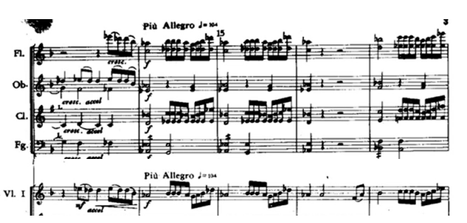
Figure 30: mm 14-19
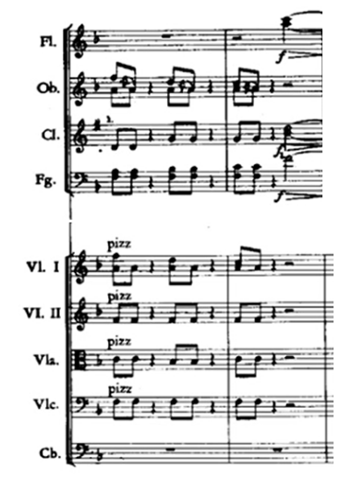
Figure 31: mm 7-8
As can be seen, the solo violin part in this concerto is technically demanding throughout the entire piece and at times even suggests a deliberate display of virtuosity. For example, immediately after the soloist’s entrance in the first movement, the violin executes a series of rapid-fire passages composed entirely of double stops (see figure 32). By contrast, the orchestra plays a comparatively restrained role. Apart from presenting the exposition at the opening and restating the main thematic motive at several later points, it more often serves to provide harmonic support or simple thematic repetition. Highly demanding solo writing of this kind recurs throughout the concerto, especially in the first and third movements, whereas the orchestra generally remains in the background without a significant role. As a result, much of the first movement gives the impression of an extended solo cadenza in character, especially from mm 33–87. In such passage, the violin is clearly the center of attention, while the orchestra functions largely as accompaniment. To a considerable extent, the two are separated rather than fully integrated, showing a concerto style in which virtuoso display is more important than close interaction between the soloist and orchestra.
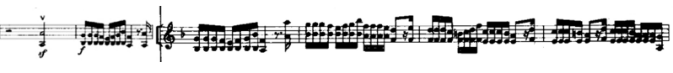
Figure 32: mm 33-38
By contrast, in the Butterfly Lovers Violin Concerto, the orchestra no longer remains primarily in the role of harmonic support or thematic repetition. Instead, it participates much more actively in the shaping of musical imagery and the unfolding of the narrative. As noted earlier, the entire work is divided into eight narrative sections, and the opening section, Birdsong and Blossoming Flowers, is presented entirely by the orchestra, with the solo violin remaining completely silent. This writing highlights the important role of the orchestra in depicting the natural scene and establishing the atmospheric setting. As the music continues to unfold, the relationship between the soloist and the ensemble shifts with organic fluidity. For instance, at mm 38, the principal melody is first played by the orchestra, while the solo violin shifts into an accompanying role. In the second half of mm 40, the violin takes over the main melody, while by mm 41 it returns once again to an accompanying position, allowing the orchestra to continue developing the theme. A similar exchange of roles can also be found around mm 105. When it comes to mm 208 , the principal melody is played entirely by the wind section, while the solo violin accompanies with bariolage, playing broken chords across four strings to provide textural support for the orchestral line.
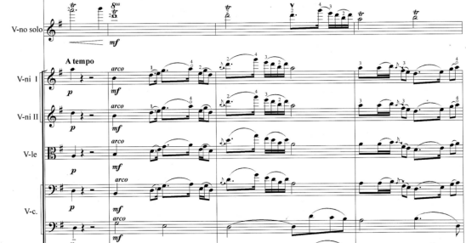
Figure 33: mm 38-41
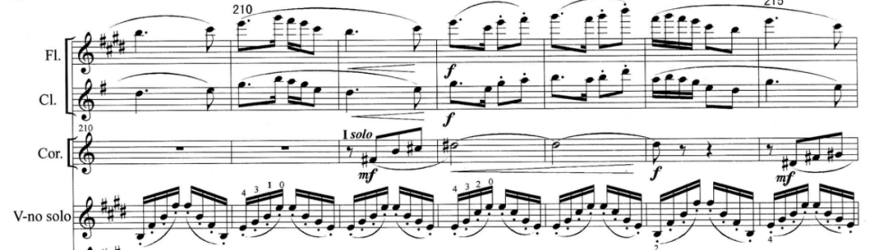
Figure 34: mm 208-214
Such passages show that the solo violin no longer consistently occupies the central position in the concerto. Instead, soloist and orchestra alternate, respond to one another, and at times exchange functions, creating a more fluid relationship. Through this interplay, the orchestra becomes an essential participant in the narrative rather than merely a background accompaniment. This marks a significant difference from Ma’s Violin Concerto. This shift reflects an important stage in the evolution of the Chinese violin concerto, in which the relationship between soloist and orchestra gradually develops from a largely accompanimental framework into a more flexible and narratively interactive one.
A similar blurring and shifting of roles can also be found in Zhao’s Concerto. For example, in the introduction, after the strings first enter and play a long melody, the solo violin extends it, almost as if adding a short phrase ending (see figure 35), rather than entering with a clear statement of the main theme, as in a traditional concerto. The same compositional technique appears again at mm 42 in the exposition, where the main melody remains in the orchestra, and the solo violin adds a short extension at the end of the phrase. Later, in the third presentation of the theme, the solo violin begins to play the same melody as the first violins (see figure 36). This clearly blurs the boundary between the roles of the soloist and the orchestra, transforming their relationship into one of mutual blending, as if they were becoming a single part within the texture.
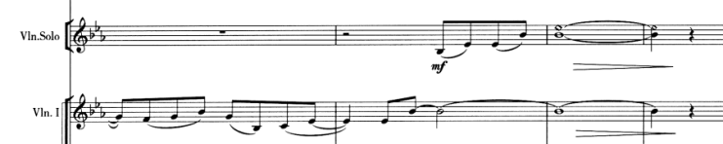
Figure 35: mm 11-14
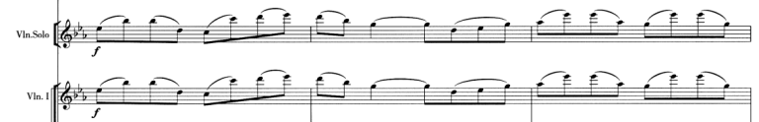
Figure 36: mm 49-51
At mm. 94, the orchestra takes over the main melody again. By mm. 98, the solo violin reenters, but it no longer serves a melodic role. Instead, it provides harmonic background support through tremolo. At the same time, the orchestra continues to carry the main melody, so in fact the solo has shifted fully into an accompanying role. When it comes to mm. 103, the main melody is transferred further to the solo flute in orchestra, while all the other instruments, including the solo violin, serve accompanying functions. The solo violin mainly contributes to the texture by playing broken arpeggios. It can therefore be seen that, in this concerto, the relationship between soloist and orchestra extends beyond a simple division of principal and accompanying roles. Instead, both contribute to the unfolding of the musical narrative through constant interaction and blending.
Unlike Zhao’s concerto, in which the soloist and orchestra may at times accompany one another while still remaining closely connected, Qigang Chen’s concerto sometimes gives the impression that no direct correspondence exists between them. For example, in mm. 51–58, the solo violin presents the main melody, while the orchestra provides a series of single-note hairpins that seem to function as a kind of backdrop. Beginning in m. 59, the orchestra takes over the main melody, while the soloist instead plays single-note hairpins.
Although this passage may still be understood in terms of melody and accompaniment, its function differs from the accompanimental patterns commonly found in the traditional concerto. Conventional accompaniment typically supports the principal melody through textural richness, harmonic support or the extension of timbre. Here, however, the soloist and orchestra seem to unfold more independently, each following its own musical line. The part that carries the hairpin functions more as an atmospheric suggestion than as a conventional accompaniment. Like an impressionistic painting, it creates a blurred sonic contour that draw the listener into a particular emotional state, rather than serving as a conventional accompaniment that provides explicit support for the main melody.
Beginning at mm 90, the texture becomes increasingly indistinct, and all voices seem to be flowing forward, making it difficult to distinguish clearly between principal melody and background. At this point, the orchestra and the solo violin appear to move along relatively independent lines, while they are not entirely unrelated, but remain subtly intertwined. At certain moments one line becomes more prominent, while at other moments the other briefly comes to the foreground. From mm 116, the orchestra begins to join the solo violin’s melodic line intermittently, and the connection between the two becomes increasingly close, as if two parallel lines were gradually drawing together, until they fully merge at mm 122.
At mm. 290, the solo function is temporarily transferred from the violin to the clarinet within the orchestra, with the score specifically marking, “let the clarinet solo play freely, without being conducted.” This indicates that the clarinet here exceeds its usual role as an orchestral voice and functions with a level of independence usually associated with a soloist. Such a treatment not only weakens the violin’s central position as the primary solo voice, but also further blurs the boundary between soloist and orchestra, making their relationship more fluid and open.

IV PERFORMANCE PRACTICE AND RECEPTION ACROSS CULTURAL CONTEXTS

Performance Materials and Interpretive Traditions
Due to the early date of Ma’s Violin Concerto and the limitations of recording technology at that time, few early recordings of the work are available. At present, one recorded version can be found on the Chinese video-sharing platform Bilibili: https://www.bilibili.com/video/BV1zv411Y7Ke/?vd_source=9e5012cb2641379c626fe00ed486394d. Based on the sound quality of the recording and information available from online users, this version may have been transferred from an older tape recording. It possibly dates from the mid-twentieth century or even earlier. Some online sources suggest that the performer may have been Ma Sicong himself, although this cannot be confirmed.
In August 2020, violinist Xu Weiling recorded this concerto as the soloist with the Guangzhou Symphony Orchestra. This recording marked the first public release of the work in mainland China. In 2007, another Chinese violinist Chen Xi, a violin professor at the Central Conservatory of Music, also recorded Ma’s concerto with the China Youth Symphony Orchestra under the baton of conductor Xia Xiaotang. However, this album was not officially released by Beijing Universal Audio and Video Publishing House until 2024.
This work was premiered in 1951 at the Prague Spring International Music Festival in Czechoslovakia. At that time, Ma was serving as president of the Central Conservatory of Music and traveled to Czechoslovakia as part of a delegation of Chinese musicians invited to attend the Sixth Prague Spring International Music Festival. This marked the first time that the newly founded People’s Republic of China had sent a delegation to participate in this major international music event. The performance was given by the Czech Radio Orchestra, with the composer himself as the violin soloist. However, the recording of this performance is currently preserved by China National Radio and has not yet been publicly released.
For several decades after its premiere, this concerto appears to have been rarely performed in public, at least according to currently available reports. The work reappeared in 2020 at an educational event in Guangdong province devoted to the memory of revolutionary history. Significantly, this performance took place in the region where the concerto had originally been composed. Rather than being presented in its full orchestral version, it was performed in an arrangement for solo violin and string quartet. In 2021, to commemorate the 109th anniversary of Ma’s birth, the Guangzhou Museum of Art, in collaboration with the Guangzhou Symphony Orchestra, held a music salon featuring his works. At this event, Ma’s Violin Concerto in F Major was again presented in a chamber-music arrangement. The event, titled “Remembering a Loyal Heart and Passing Down a Spirit of Devotion to the Nation,” once again framed the performance within a commemorative context.
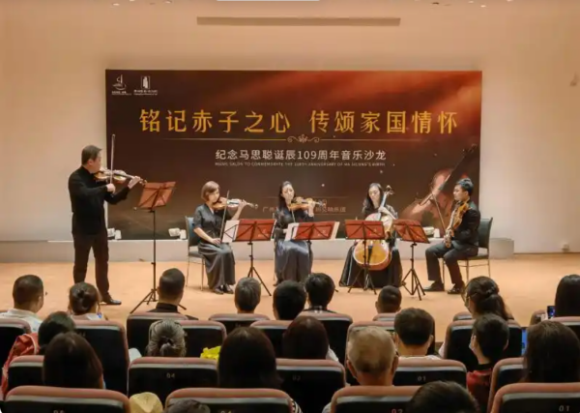
Figure 37: Ma’s Violin Concerto, string quartet version
Overall, the existing audio and video materials suggest that Ma’s Violin Concerto has not developed through a clearly continuous performance tradition. Instead, they reflect a process in which an early Chinese violin concerto has been rediscovered and reinterpreted in contemporary contexts.
By contrast, both recordings and live-performance materials of The Butterfly Lovers are far more abundant. In 1959, the concerto received its first public performance at the Lanxin Grand Theatre in Shanghai, with Yu Lina, then a violin student at the Shanghai Conservatory of Music, as the soloist. The work spread rapidly thereafter. Since the 1960s, many performers have recorded it, including Shen Rong and Liu Yuansheng in the 1960s, Lin Kechang in the 1970s, and the Japanese violinist Takako Nishizaki, whose recording had a significant impact on the international recording market in the 1980s.
In the twenty-first century, new recordings of The Butterfly Lovers have continued to appear, including interpretations by Chinese violinists Lü Siqing and Xue Wei, Singaporean violinist Cai Keyi, and American violinist Gil Shaham. At the same time, the work has been performed frequently in live settings, ranging from local music salons and student concerts to professional concert halls and large-scale national events. This abundance of materials provides a solid foundation for examining how interpretations of this piece have changed across different historical periods and cultural contexts.
Among the many recordings, Yu Lina’s interpretation, as the soloist of the premiere, may be regarded as an important reference for the early Chinese-style performance tradition of the work. Ning Feng, by contrast, represents the interpretation of contemporary Chinese violinists within the modern concert-hall context, while Joshua Bell’s version offers a cross-cultural performance perspective. Although these three performances belong to different historical and cultural contexts, they do not show a fundamental difference in interpretive approach. All of them emphasize melodic lyricism and narrative continuity, while portamento and rubato remain important means of expressing the work’s nationalized musical language. This suggests that, through its long process of dissemination, The Butterfly Lovers’ Violin Concerto has gradually developed a relatively stable performance tradition.
However, the different versions still reveal subtle differences in interpretation. In Yu Lina’s recording, the rubato is handled in a more direct and less gradual way. For example, in mm 31–38 and around mm 330, she conveys emotion mainly through localized tempo changes, either by speeding up certain moments or by slowing down abruptly. By contrast, Ning Feng’s version shows more deliberate tempo shaping within individual phrases, often creating a slow–fast–slow rubato shape. This approach is closer to the kind of phrase shaping commonly found in modern Western classical training. In more emotionally charged passages, Ning’s interpretation is also more flexible. For example, around mm 195, the sound at the end of the bow stroke is more open and projected, which adds to the dramatic tension.
In terms of portamento, Yu Lina’s version is more pronounced than Ning Feng’s, and it comes closer to the vocal inflections of Yue opera and the expressive language of Chinese bowed string instruments. Ning Feng, while retaining the necessary slides, places greater emphasis on the broader melodic line. Joshua Bell uses portamento most frequently, even in faster passages such as “Studying Together.” However, some of his slides sound more like expressive slides in the Western violin tradition. At times, the slide is accompanied by a forward impulse, rather than being shaped as a vocalized gesture with a specific Chinese operatic meaning.
This shows that Yu Lina’s performance preserves more of the early national style and the flavor of Chinese opera, while Ning Feng’s interpretation is more in line with the aesthetics of the contemporary concert stage. When the work is performed by a foreign violinist, its Chinese musical elements are reinterpreted and transformed into another mode of expression. Interestingly, Joshua Bell’s version is accompanied by a Chinese traditional orchestra rather than the original Western orchestral setting. In this version, The Butterfly Lovers is no longer simply a case of telling a Chinese story through a Western concerto form. Instead, it becomes a cross-cultural dialogue between the Western violin and the Chinese traditional orchestra.
These versions from different periods and national backgrounds show that The Butterfly Lovers has moved from a local Chinese narrative to the international stage. In the process of cross-cultural transmission, the work has absorbed more diverse forms of understanding and interpretation. At the same time, the incorporation of the Chinese traditional orchestra allows this work to return to a Chinese sound world in a new and transformed way.
Compared with The Butterfly Lovers, recordings and performance materials of Zhao Jiping’s Violin Concerto No. 1 are much more limited. At present, the commercially available recording is mainly the version performed by Ning Feng with the China National Centre for the Performing Arts Orchestra, commonly known as the China NCPA Orchestra. The concerto has also been performed in live concerts by violinists such as Lü Siqing, Lao Li, Chen Xi, and the Canadian-Chinese violinist Timothy Chooi.
A comparison between Ning Feng’s and Lü Siqing’s interpretations reveals clear differences in musical character. Ning Feng’s version tends to be slower in lyrical passages, but moves forward more quickly in fast and emotionally intense sections, creating a stronger sense of contrast overall. His interpretation is closer to the dramatic language of the Western Romantic concerto tradition: lyrical passages are shaped through broader phrase expansion, while moments of intensity are heightened through freer rhythm and more outward bowing gestures, such as making a crescendo at the end of a long bow stroke. By contrast, Lü’s playing is relatively more restrained. His tempo and emotional pacing are steadier, and his use of portamento is somewhat more noticeable. As a result, the melodic expression carries a more Chinese sense of subtlety and lyricism.
Timothy Chooi’s interpretation presents yet another tendency. His vibrato is relatively wide, and his playing has a strong singing quality, with particular emphasis on the continuous unfolding of the broader melodic line. Unlike Ning Feng and Lü, who make greater use of flexible breathing within phrases to create a sense of rise and fall, Chooi tends to maintain continuity between notes. As a result, the melody takes on a broader and more sustained linear quality.
This suggests that Zhao’s concerto has not yet formed a highly stable performance tradition in the way that The Butterfly Lovers has. Instead, it remains in the process of being continually reshaped by different performers. This difference shows that, after the beginning of the twenty-first century, the evolution of Chinese violin concertos is no longer centered only on specific national narratives or fixed performance conventions. Rather, it has entered a more open space of interpretation within the contemporary concert stage.
Compared with Zhao Jiping’s Violin Concerto No. 1, Chen Qigang’s La joie de la souffrance appears to have a more international background. The work was premiered in 2017 at the Beijing Music Festival by Maxim Vengerov with the China Philharmonic Orchestra. Since then, the work has been taken up by performers from different cultural and national backgrounds, including Vengerov, the associate concertmaster of the China Philharmonic Orchestra, Taiwanese violinist Zhangyuan Ding, and American violinist Nancy Zhou. It is also worth noting that this piece was selected as the required Chinese work for the final round of the second Shanghai Isaac Stern International Violin Competition.
In terms of performance interpretation, the different versions also reveal certain differences. Taking the versions by Vengerov and the associate concertmaster of the China Philharmonic Orchestra as examples, Vengerov’s version has a stronger sense of flow overall. The inflections, emotional turns, and changes of character are more clearly shaped, allowing some of the work’s more subtle psychological processes to come through. By contrast, the version by the China Philharmonic’s associate concertmaster is more even in its overall treatment, with a relatively restrained emotional progression. Such differences do not mean that performers from a particular cultural background are naturally better able to understand the work. Rather, they suggest that the musical language of La joie de la souffrance is already highly accessible across cultural boundaries. A performer’s interpretation of this piece depends less on familiarity with traditional Chinese musical idioms alone, and more on their understanding of modern musical language, rhythmic flexibility, and psychological narrative.
Unlike earlier Chinese violin concertos, which often express national identity through folk melodies and folk narratives,the Chinese elements in the work does not mainly rely on directly recognizable national tunes. Instead, it is expressed through philosophical ideas and the organization of sound. For this reason, the work can more easily enter the context of international modern music, where it can be understood and reinterpreted by performers from different cultural backgrounds. In other words, by the time we reach Chen Qigang, the evolution of the Chinese violin concerto has moved beyond the earlier integration of national materials and the narration of national stories. It has turned toward a more abstract, psychological, and international mode of expression.

Dissemination and Reception
As the first Chinese violin concerto, Ma Sicong’s Violin Concerto was also an important early attempt to connect national musical expression with an international musical context. At the time of its international performance, the work attracted considerable attention and received positive critical responses. At its premiere, the Czech newspaper Prague News published a special report, stating: “The renowned composer Ma Sicong attracted great attention. He performed his own violin piece Tibetan Tone Poem with piano accompaniment, as well as his Violin Concerto, which was composed in 1943 and based on folk melodies.”
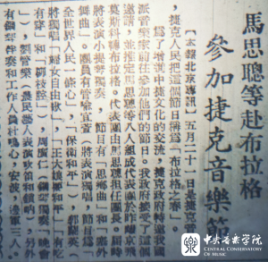
Figure 38: Newspaper report on Ma’s participation in the Czech Music Festival

In addition to performing in the capital, the group was also invited to give concert tours in several major Czech cities. The official newspaper of the Czechoslovak Writers’ Union, Lidové noviny, gave the performance high praise, writing: “The performance of the Chinese musicians showed what a magnificent future had opened up for Chinese musical art after the victory of the Chinese people!”
An early recording of this work, as mentioned above, is still preserved today. In the twenty-first century, violinists have also recorded and released new versions of the concerto, suggesting that its value has begun to receive renewed attention. However, this concerto has not become a standard repertory work frequently performed on major concert stages. Instead, it is more often revived in commemorative events, special concerts, or programs with a historical focus. In this sense, its contemporary recordings and performances are better understood as acts of historical rediscovery, rather than as the continuation of a stable performance tradition. This point is also reflected in violinist Chen Xi’s explanation of why he chose to record the concerto: “the work has deep historical and scholarly value.”
By contrast, the dissemination of The Butterfly Lovers follows a path more typical of the making of a national classic. At its 1959 premiere in Shanghai, the audience reportedly remained silent for a moment after the performance ended, before breaking into long and enthusiastic applause. Since no encore had been prepared, the musicians could only return to the stage again and again to acknowledge the audience, until the piece was eventually performed once more. This premiere marked the beginning of The Butterfly Lovers’ journey onto the world stage. Yu Lina later brought the concerto to many countries and regions, including the United States, Australia, and Canada. With its distinctive Eastern aesthetic, the work moved audiences around the world and attracted many world-class violinists to perform and record it. It has also appeared as a required or frequently selected work in a number of international violin competitions.
The impact of The Butterfly Lovers in overseas concerts can also be seen in foreign reviews. In 2016, the Singapore Symphony Orchestra performed the concerto at Victoria Concert Hall, conducted by Zheng Xiaoying, with Kong Zhao Hui as the soloist. The Singapore-based classical music website The Flying Inkpot described The Butterfly Lovers as a work that “needs no introduction,” noting that few other large-scale Chinese works composed through a Western symphonic medium had achieved a comparable level of popularity and recognition. It also highlighted the performance’s effective presentation of special effects and techniques associated with Chinese opera. In particular, the dialogue-like duet between the solo violin and cello in the Balcony Meeting section was described as deeply moving. This suggests that, on overseas concert stages, The Butterfly Lovers is no longer received as an unfamiliar Chinese work, but rather as a highly recognizable and representative Chinese concerto.
Zhao’s Violin Concerto No. 1 was commissioned by the China National Centre for the Performing Arts Orchestra and received its premiere in the United States, with Ning Feng as the violin soloist. According to related reports, tickets for the concert had already sold out ten days before the performance. It is also worth noting that the second half of the same concert featured a concerto for pipa and string orchestra, yet this work was composed by an American composer. This programming choice suggests that musical exchange between China and the West was no longer a one-way process in which Chinese elements simply moved outward. It also involved Western composers actively absorbing Chinese musical elements into their own musical language. Zhao Jiping’s concerto was therefore presented within this broader cross-cultural context.
In an interview with the American classical music publication Classical Voice North America, Patrick Ren, then executive director of the China National Centre for the Performing Arts Orchestra, mentioned that “Zhao’s concert works really opened doors in national music much like Dvořák and Tchaikovsky.” This shows that although Zhao’s concerto has not yet developed the kind of broad international performance tradition associated with The Butterfly Lovers, it represents another direction in the development of Chinese violin concertos in the twenty-first century. It enters the contemporary professional concert context through a grander symphonic sound world and a more abstract humanistic theme. In this sense, it offers a contemporary form of national symphonic expression within the professional concert tradition.
The dissemination of Chen Qigang’s La joie de la souffrance presents yet another model. The work does not rely primarily on large-scale concert performances or commercial recordings. Instead, its dissemination has taken place more through international music festivals, professional competitions, and contemporary concert stages. Commissioned by the Beijing Music Festival, the work received its world premiere at the closing concert of the 20th Beijing Music Festival. It then entered the international competition system soon afterward. For example, at the second Shanghai Isaac Stern International Violin Competition in 2018, all six finalists were required to perform this work with the Shanghai Symphony Orchestra. This reveals a new mode of dissemination for Chinese violin concerto: from the very beginning, the work was placed within the framework of international commissions, international competitions, and professional concert performance, and was interpreted by performers from different cultural backgrounds.
In this way, the Chinese violin concerto has continually reshaped its modes of dissemination across different historical periods. It has appeared in forms ranging from early historical presentation and the popular circulation of national classics to professional concert-stage performance and international contemporary music platforms. Through these evolving paths, the Chinese violin concerto has gradually moved beyond local creation and entered a broader space of cultural exchange.

BIBLIOGRAPHY
Bin Luo. “The Butterfly Lovers Violin Concerto - Ning Feng (宁峰演奏).” YouTube video, 30:02. n.d. Accessed May 14, 2026. https://www.youtube.com/watch?v=-g0f8L8Kqx0

Bin Zhou and Zhenlin Li, 华语影视戏剧的历史与现状The History and Current State of Chinese-Language Film, Television, and Theatre (Beijing: China Film Press, 2014)

Caplin, William E. 1998. Classical Form: A Theory of Formal Functions for the Instrumental Music of Haydn, Mozart, and Beethoven. New York: Oxford University Press.

Central Conservatory of Music. 2024. “北京环球音像｜陈曦《马思聪小提琴协奏曲》专辑出版并全球数字发行 [Beijing Global Audio-Visual: Chen Xi’s Ma Sicong Violin Concerto Album Published and Released Digitally Worldwide].” WeChat, August 30, 2024.

Chen, Dayong. “陈其钢小提琴协奏曲《悲喜同源》创作观念与作曲技法研究 [A Study of the Creative Concept and Compositional Techniques in Chen Qigang’s Violin Concerto].” Music Life, no. 2 (2025): 45–47.

Chen, Junjun. “专访作曲家陈其钢：人生是悲喜交集的单行道，在雾漫漫中寻找真我 [Interview with Composer Chen Qigang: Life Is a One-Way Road Where Joy and Sorrow Intersect, Searching for the True Self in the Mist].” Shangguan News, November 17, 2023.

Timothy Chooi. “Z. Jiping: Violin Concerto No. 1 | Timothy Chooi | Sichuan Symphony Orchestra.” YouTube video, 20:46. n.d. Accessed May 14, 2026. https://www.youtube.com/watch?v=t3RIVIhRYGg

第艺流. 2018. “《音乐人生》赵季平：用中国音乐和世界对话 20180830 | CCTV综艺 [Music Life: Zhao Jiping: Using Chinese Music to Dialogue with the World].” YouTube video, 29:43. August 30, 2018.

Feng, Yili. “请君为我倾耳听：赵季平专访 [Please Lend Me Your Ear: An Interview with Zhao Jiping].” Huayin, March 22, 2023.

Gu, Xiaojin. 2021. “《英雄颂》赏析 | 辜晓进：宏大主题的独特音乐叙事 [An Appreciation of Ode to Heroes: Gu Xiaojin on the Unique Musical Narrative of a Grand Theme].” 澎湃新闻·澎湃号·政务 [The Paper], July 6, 2021.

Guiyang Symphony Orchestra. “赵季平：第一小提琴协奏曲，指挥：张国勇，小提琴：宁峰 [Zhao Jiping: Violin Concerto No. 1, conducted by Zhang Guoyong, violin: Ning Feng].” Bilibili video, 20:23. June 22, 2020. https://www.bilibili.com/video/BV1xZ4y1H7Vz/

Guo, Mei. 2024. “越剧‘梁祝’故事：从《梁祝哀史》到《梁山伯与祝英台》 [The Yue Opera Story of Liang Zhu: From The Sorrowful History of Liang Zhu to Liang Shanbo and Zhu Yingtai].” China Arts News, August 22, 2024.

He, Ping. 2020. “马思聪在广东韶关管埠完成的两部交响音乐作品 [Two Symphonic Works Ma Sicong Completed in Guanbu, Shaoguan, Guangdong].” Guangzhou Symphony Orchestra. WeChat, September 3, 2020.

Hong, Hong. “从探索到转型：论中国第五代导演的电影观念 [From Exploration to Transformation: On the Film Concepts of China’s Fifth-Generation Directors].” Chinese Language and Literature, no. 68 (2015): 275–290.

Huang, Zhouhui. 2020. “时隔77年！马思聪《F大调小提琴协奏曲》再在作品创作地奏响 [After 77 Years, Ma Sicong’s Violin Concerto in F Major Is Performed Again at the Place Where It Was Composed].” Jinyang Net, September 3, 2020.

Jiang, Fang. 2018. “‘斯特恩’决赛阶段，陈其钢寄语选手：期待你们用弓弦诉说自己的《悲喜同源》 [During the Stern Competition Finals, Chen Qigang Encourages Contestants: I Look Forward to Hearing You Tell Your Own La joie et la tristesse with Bow and Strings].” Wenhui, August 30, 2018.

Jiang, Yuli. “The Chinese Violin Concerto The Butterfly Lovers by He Zhanhao and Chen Gang for Violin and Orchestra.” Doctoral dissertation, University of Texas at Austin, 2004.

Li, Hongyan. “一封联名信‘改写’音乐史 [A Joint Letter ‘Rewrites’ Music History].” Beijing Daily, September 10, 2014.

Li, Hongyang. n.d. “陕北民歌的双四度旋律特点探究 [A Study of the Double-Fourth Melodic Characteristics of Northern Shaanxi Folk Songs].” Liaocheng University School of Music. Accessed May 11, 2026.

Li, Juan. 2012. “古筝‘快速指序技法体系’的产生及其传播历程 [The Emergence and Dissemination of the Guzheng ‘Rapid Finger-Sequence Technique System’].” 北方音乐 [Northern Music], no. 1, pt. 2: 122–123.

Liang, Mingyue. Music of the Billion: An Introduction to Chinese Musical Culture. New York: Heinrichshofen’s Press, 1985.

梁祝小提琴协奏曲 | 俞丽拿演奏 [Liang Zhu Violin Concerto, performed by Yu Lina].” YouTube video. n.d. Accessed May 14, 2026. https://www.youtube.com/watch?v=CeBXoxCvJig

Lu, Zhuoyu. “The Evolution of Chinese Violin Music in the Twentieth Century.” DMA lecture document, University of Arizona, 2024.

Ouyang, Lei X. Music as Mao’s Weapon. Chicago: University of Illinois Press, 2021.

Pauer, Ernst. The Elements of the Beautiful in Music. London: Novello; New York: Novello, Ewer, [1877].

Pengpai News. 2023. “专访｜作曲家陈其钢：悲喜同源，选择‘我说’ [Interview with Composer Chen Qigang: La joie et la tristesse, Choosing ‘I Say’].” 凤凰网 [Ifeng], November 2, 2023.

Prout, Ebenezer. 1895. Applied Forms: A Sequel to “Musical Form.” London: Augener.

N Rapp. “Maxim Vengerov plays Qigang CHEN’s ‘La joie de la souffrance’ Violin Concerto.” YouTube video, 27:57. n.d. Accessed May 14, 2026. https://www.youtube.com/watch?v=_Bm5XZm_2qM

Shi, Xuejun. 2019. “赵季平：我的音符，长于泥土中 [Zhao Jiping: My Notes Grow from the Soil].” Wenhui Daily, January 27, 2019.

Smith, Ken. 2017. “Cultures Converge In U.S. Tour By Chinese Orchestra.” Classical Voice North America, October 29, 2017.

Soares Rodrigues, Gonçalo Alexandre. 2023. “Time Signatures in Modern Music.” Master’s thesis, Malmö Academy of Music, Lund University.

Song, Xiaojing, and Xuejun. 2021. “记忆的力量 | 回望70年前‘央音人’的首次国际音乐文化交流之旅 [The Power of Memory: Looking Back on the First International Musical and Cultural Exchange Trip by Members of the Central Conservatory of Music Seventy Years Ago].” Central Conservatory of Music. May 2021.

Soo, Kian Hing. 2016. “Concert Review: Singapore Symphony Orchestra ‘The Butterfly Lovers’ 19 February 2016.” The Flying Inkpot, March 3, 2016.

Tang, Tianqi. 2025. “俞丽拿教授讲述《梁祝》故事，用小提琴奏响文化自信 [Professor Yu Lina Tells the Story of The Butterfly Lovers and Sounds Cultural Confidence with the Violin].” Shanghai Conservatory of Music, November 12, 2025.

The Paper. “斯特恩小提琴赛决赛正酣，陈其钢作品《悲喜同源》成焦点 [The Stern Violin Competition Finals Are Underway; Chen Qigang’s La joie et la tristesse Becomes a Focus].” The Paper, August 31, 2018.

Tio Ngee Ping. “梁祝 Butterfly Lovers 2023 Joshua Bell / Singapore Chinese Orchestra.” YouTube video, 27:02. n.d. Accessed May 14, 2026. https://www.youtube.com/watch?v=fsPBpxmSUnY

Wang, Kexin. “Music and Performance Analysis of Zhao Jiping’s The First Violin Concerto.” Master’s thesis, Xi’an Conservatory of Music, 2023.

Wang, Yuan-Yuan. “Ma Si Cong’s Violin Concerto in F Major: Western Traditions and Chinese Elements.” Doctoral dissertation, Indiana University, 2015.

Whyte, Martin K. “Evolutionary Changes in Chinese Culture.” CSST Working Paper no. 14, University of Michigan, 1988.

Xinhua Net. 2017. “‘中国元素’奏响美国，震撼当地观众 [‘Chinese Elements’ Sound in the United States and Impress Local Audiences].” Originally from Beijing Daily, November 2, 2017.

Xing, Xin. “The Basic Tendencies of Violin Concerto Genre Evolution in the Creative Work of Chinese Composers of the 1940–1980s.” Manuscript 14, no. 12 (2021): 2797–2802. https://doi.org/10.30853/mns20210475

Zhang, Ying. “The Butterfly Lovers’ Violin Concerto (1959).” Doctoral dissertation, University of Nevada, 2021.

Zhang, Yue. 2018. “赵季平：‘一手’伸向民间 ‘一手’伸向世界 [Zhao Jiping: ‘One Hand’ Reaches toward the Folk, and ‘One Hand’ Reaches toward the World].” China Arts News, March 26, 2018.赵季平：“一手”伸向民间 “一手”伸向世界--艺术--中国作家网

Zhang, Yuxin. “陈其钢：我继续往前走，前途未卜 [Chen Qigang: I Continue to Move Forward, Though the Future Is Uncertain].” Southern People Weekly, February 1, 2019.

Zhao, Chunting. 2021. “管弦乐作品《悲喜同源》的艺术创作与音乐分析 [Artistic Creation and Musical Analysis of the Orchestral Work La joie et la tristesse].” 演艺科技 [Entertainment Technology], no. 9. doi:10.3969/j.issn.1674-8239.2021.09.011.

Zheng Li. 2025. “越剧新《梁祝》回十八，演唱李征, Yue Opera The New ‘Liang Zhu,’ Zheng Li.” YouTube video. April 23, 2025.越剧新《梁祝》回十八， 演唱李征，Yue Opera The New "Liang Zhu"， Zheng Li

Zhu, Hanguo. “民国时期中国社会转型的态势及其特征 [The Trends and Characteristics of Social Transformation in Republican China].” Journal of Historical Science, no. 11 (2003): 12–14.

YuanYuan Wang, “Ma Si Cong’s Violin Concerto in F Major: Western Traditions and Chinese Elements” (Doctoral Dissertation, Indiana University, 2015).
Yuli Jiang, “The Chinese Violin Concerto ‘The Butterfly Lovers’by He Zhanhao (1933) and Chen Gang (1935) for Violin and Orchestra” (Doctoral Dissertation, University of Texas at Austin, 2004).
Ying Zhang, “THE BUTTERFLY LOVERS’ VIOLIN CONCERTO (1959) ” (Doctoral Dissertation, University of Nevada, 2021).
Kexin Wang, “Music and performance analysis of zhao jiping's 《The FirstViolin Concerto》” (Master Dissertation, Xi’an Conservatory of Music, 2023).
Chen Dayong, “陈其钢小提琴协奏曲《悲喜同源》创作观念与作曲技法研究A Study of the Creative Concept and Compositional Techniques in Chen Qigang’s Violin Concerto,” Music Life, No.2 (2025): 45-47.
Xin Xing,“The Basic Tendencies of Violin Concerto Genre Evolution in the Creative Work of Chinese Composers of the 1940-1980s,”Manuscript 14, no.12 (2021): 2797-2802, doi:10.30853/mns20210475.
Zhuoyu Lu, “The Evolution of Chinese Violin Music in the Twentieth Century” (DMA Lecture Document, University of Arizona, 2024).
Zhu Hanguo, “民国时期中国社会转型的态势及其特征The Trends and Characteristics of Social Transformation in Republican China,” 史学月刊Journal of Historical Science，No.11 (2003): 12-14.
Liang Mingyue, Music of the Billion-An introduction to Chinese Musical Culture（New York: Heinrichshofen’s Press, 1985), 136.
YuanYuan Wang, “Ma Si Cong’s Violin Concerto in F Major: Western Traditions and Chinese Elements” (Doctoral Dissertation, Indiana University, 2015).
YuanYuan Wang, “Ma Si Cong’s Violin Concerto in F Major: Western Traditions and Chinese Elements” (Doctoral Dissertation, Indiana University, 2015).
Ernst Pauer, The Elements of the Beautiful in Music (London:Novello, Ewer), 25.
Liang Mingyue, Music of the Billion-An introduction to Chinese Musical Culture（New York: Heinrichshofen’s Press, 1985), 135.
Ibid., 153-156.
Whyte, Martin K. “Evolutionary Changes in Chinese Culture.” CSST Working Paper No. 14, University of Michigan, 1988.
Lei X. Ouyang, Music as Mao’s Weapon (Chicago: University of Illinois Press, 2021), 189.
Ibid., 265.
Hongyan Li, “一封联名信‘改写’音乐史,” Beijing Daily, September 10, 2014.
Yuxin Zhang,“陈其钢：我继续往前走，前途未卜Chen Qigang: I Continue to Move Forward, Though the Future Is Uncertain,” Southern People Weekly, February 1, 2019.
Junjun Chen, “专访作曲家陈其钢：人生是悲喜交集的单行道，在雾漫漫中寻找真我Interview with Composer Chen Qigang: Life Is a One-Way Road Where Joy and Sorrow Intersect, Searching for the True Self in the Mist,” Shangguan News, November 17, 2023.
Ibid.
Junjun Chen, “专访作曲家陈其钢：人生是悲喜交集的单行道，在雾漫漫中寻找真我Interview with Composer Chen Qigang: Life Is a One-Way Road Where Joy and Sorrow Intersect, Searching for the True Self in the Mist,” Shangguan News, November 17, 2023.
The Paper, “斯特恩小提琴赛决赛正酣，陈其钢作品《悲喜同源》成焦点The Stern Violin Competition Finals Are Underway; Chen Qigang’s La joie et la tristesse Becomes a Focus,” The Paper, August 31, 2018.
Bin Zhou and Zhenlin Li, 华语影视戏剧的历史与现状The History and Current State of Chinese-Language Film, Television, and Theatre (Beijing: China Film Press, 2014), 14.
Hong Hong,“从探索到转型：论中国第五代导演的电影观念From Exploration to Transformation: On the Film Concepts of China’s Fifth-Generation Directors,”Chinese Language and Literature, No. 68 (2015): 275–290.
Bin Zhou and Zhenlin Li, The History and Current State of Chinese-Language Film, Television, and Theatre (Beijing: China Film Press, 2014), 267.
Yili Feng, “请君为我倾耳听：赵季平专访Please Lend Me Your Ear: An Interview with Zhao Jiping,” Huayin, March 22, 2023.
Kexin Wang, “Music and performance analysis of zhao jiping's 《The FirstViolin Concerto》” (Master Dissertation, Xi’an Conservatory of Music, 2023).
Ibid.
Xin Xing, “The Basic Tendencies of Violin Concerto Genre Evolution in the Creative Work of Chinese Composers of the 1940–1980s,” Manuscript 14, no. 12 (2021): 2798, doi:10.30853/mns20210475.
Ebenezer Prout, Applied Forms: A Sequel to “Musical Form” (London: Augener, 1895), 204.
William E. Caplin, Classical Form: A Theory of Formal Functions for the Instrumental Music of Haydn, Mozart, and Beethoven (New York: Oxford University Press, 1998), page number.
Yuli Jiang, “The Chinese Violin Concerto ‘The Butterfly Lovers’by He Zhanhao (1933) and Chen Gang (1935) for Violin and Orchestra” (Doctoral Dissertation, University of Texas at Austin, 2004).
Kexin Wang, “Music and performance analysis of zhao jiping's 《The FirstViolin Concerto》” (Master Dissertation, Xi’an Conservatory of Music, 2023).
第艺流, “《音乐人生》赵季平：用中国音乐和世界对话 20180830 | CCTV综艺Music Life: Zhao Jiping: Using Chinese Music to Dialogue with the World,” YouTube video, 29:43, August 30, 2018.
Zhao Chunting, “管弦乐作品《悲喜同源》的艺术创作与音乐分析Artistic Creation and Musical Analysis of the Orchestral Work La joie et la tristesse,” 演艺科技Entertainment Technology, no. 9 (2021), doi:10.3969/j.issn.1674-8239.2021.09.011.
Xin Xing,“The Basic Tendencies of Violin Concerto Genre Evolution in the Creative Work of Chinese Composers of the 1940-1980s,”Manuscript 14, no.12 (2021): 2797-2802, doi:10.30853/mns20210475.
YuanYuan Wang, “Ma Si Cong’s Violin Concerto in F Major: Western Traditions and Chinese Elements” (Doctoral Dissertation, Indiana University, 2015).
Juan Li, “古筝‘快速指序技法体系’的产生及其传播历程The Emergence and Dissemination of the Guzheng ‘Rapid Finger-Sequence Technique System’,” 北方音乐Northern Music, no. 1, pt. 2 (2012): 122–123.
Yuli Jiang, “The Chinese Violin Concerto ‘The Butterfly Lovers’by He Zhanhao (1933) and Chen Gang (1935) for Violin and Orchestra” (Doctoral Dissertation, University of Texas at Austin, 2004).
Mei Guo, “越剧‘梁祝’故事：从《梁祝哀史》到《梁山伯与祝英台》The Yue Opera Story of Liang Zhu: From The Sorrowful History of Liang Zhu to Liang Shanbo and Zhu Yingtai,” China Arts News, August 22, 2024.
Ying Zhang, “THE BUTTERFLY LOVERS’ VIOLIN CONCERTO (1959) ” (Doctoral Dissertation, University of Nevada, 2021).
Yuli Jiang, “The Chinese Violin Concerto ‘The Butterfly Lovers’by He Zhanhao (1933) and Chen Gang (1935) for Violin and Orchestra” (Doctoral Dissertation, University of Texas at Austin, 2004).
Zheng Li, “越剧新《梁祝》回十八，演唱李征, Yue Opera The New ‘Liang Zhu,’ Zheng Li,” YouTube video, April 23, 2025.
Yuli Jiang, “The Chinese Violin Concerto ‘The Butterfly Lovers’by He Zhanhao (1933) and Chen Gang (1935) for Violin and Orchestra” (Doctoral Dissertation, University of Texas at Austin, 2004).
Yue Zhang, “赵季平：‘一手’伸向民间 ‘一手’伸向世界Zhao Jiping: ‘One Hand’ Reaches toward the Folk, and ‘One Hand’ Reaches toward the World,” China Arts News, March 26, 2018.
Xuejun Shi, “赵季平：我的音符，长于泥土中Zhao Jiping: My Notes Grow from the Soil,” Wenhui Daily, January 27, 2019.
Hongyang Li, “陕北民歌的双四度旋律特点探究A Study of the Double-Fourth Melodic Characteristics of Northern Shaanxi Folk Songs,” Liaocheng University School of Music, accessed May 11, 2026.
Ibid.
Yue Zhang, “赵季平：‘一手’伸向民间 ‘一手’伸向世界Zhao Jiping: ‘One Hand’ Reaches toward the Folk, and ‘One Hand’ Reaches toward the World,” China Arts News, March 26, 2018.
Xiaojin Gu, “《英雄颂》赏析 | 辜晓进：宏大主题的独特音乐叙事An Appreciation of Ode to Heroes: Gu Xiaojin on the Unique Musical Narrative of a Grand Theme,” 澎湃新闻·澎湃号·政务The Paper, July 6, 2021.
Gonçalo Alexandre Soares Rodrigues, “Time Signatures in Modern Music” (master’s thesis, Malmö Academy of Music, Lund University, 2023).
澎湃新闻, “专访｜作曲家陈其钢：悲喜同源，选择‘我说’Interview with Composer Chen Qigang: La joie et la tristesse, Choosing ‘I Say’,” 凤凰网Ifeng, November 2, 2023.
Chen Dayong, “陈其钢小提琴协奏曲《悲喜同源》创作观念与作曲技法研究A Study of the Creative Concept and Compositional Techniques in Chen Qigang’s Violin Concerto,” Music Life, No.2 (2025): 45-47.
Fang Jiang, “‘斯特恩’决赛阶段，陈其钢寄语选手：期待你们用弓弦诉说自己的《悲喜同源》During the Stern Competition Finals, Chen Qigang Encourages Contestants: I Look Forward to Hearing You Tell Your Own La joie et la tristesse with Bow and Strings,” Wenhui, August 30, 2018.
Ping He, “马思聪在广东韶关管埠完成的两部交响音乐作品Two Symphonic Works Ma Sicong Completed in Guanbu, Shaoguan, Guangdong,” Guangzhou Symphony Orchestra, WeChat, September 3, 2020.
Central Conservatory of Music, “北京环球音像｜陈曦《马思聪小提琴协奏曲》专辑出版并全球数字发行Beijing Global Audio-Visual: Chen Xi’s Ma Sicong Violin Concerto Album Published and Released Digitally Worldwide,” WeChat, August 30, 2024.
Ping He, “马思聪在广东韶关管埠完成的两部交响音乐作品Two Symphonic Works Ma Sicong Completed in Guanbu, Shaoguan, Guangdong,” Guangzhou Symphony Orchestra, WeChat, September 3, 2020.
Zhouhui Huang, “After 77 Years, Ma Sicong’s Violin Concerto in F Major Is Performed Again at the Place Where It Was Composed,” Jinyang Net, September 3, 2020.
Xiaojing and Xuejun Song, “记忆的力量 | 回望70年前‘央音人’的首次国际音乐文化交流之旅The Power of Memory: Looking Back on the First International Musical and Cultural Exchange Trip by Members of the Central Conservatory of Music Seventy Years Ago,” Central Conservatory of Music, May 2021.
Xiaojing and Xuejun Song, “记忆的力量 | 回望70年前‘央音人’的首次国际音乐文化交流之旅The Power of Memory: Looking Back on the First International Musical and Cultural Exchange Trip by Members of the Central Conservatory of Music Seventy Years Ago,” Central Conservatory of Music, May 2021.
Central Conservatory of Music, “北京环球音像｜陈曦《马思聪小提琴协奏曲》专辑出版并全球数字发行Beijing Global Audio-Visual: Chen Xi’s Ma Sicong Violin Concerto Album Published and Released Digitally Worldwide,” WeChat, August 30, 2024.
Tianqi Tang, “俞丽拿教授讲述《梁祝》故事，用小提琴奏响文化自信Professor Yu Lina Tells the Story of The Butterfly Lovers and Sounds Cultural Confidence with the Violin,”Shanghai Conservatory of Music, November 12, 2025.
Soo Kian Hing, “Concert Review: Singapore Symphony Orchestra ‘The Butterfly Lovers’ 19 February 2016,” The Flying Inkpot, March 3, 2016.
“中国元素”奏响美国，震撼当地观众‘Chinese Elements’ Sound in the United States and Impress Local Audiences,” Xinhua Net, November 2, 2017.
Ken Smith, “Cultures Converge In U.S. Tour By Chinese Orchestra,”Classical Voice North America, October 29, 2017.

