Statistical Abstract
Fiscal Year 2013–2014
UO Libraries Assessment Team

Nancy Slight-Gibney, David C. Fowler, Helen Chu, David Ketchum,
Kirstin Hierholzer, Damon Campbell

© UO Libraries, 2014

Table of Contents
Library Mission Statement
Vision Statement
Strategic Directions
Trends and Highlights
Library Development
Sources of Funds
ARL Investment Index Ranking
Expenditure Details
Use of Library Collections and Services
Assessment: Learning From and About Library Users
Academic Technology Support: CMET
Library Systems and Campus Computer Labs
Library Administration Organization Chart

University of Oregon Libraries
Architecture and Allied Arts Library
Global Scholars Hall Library Commons
John E. Jaqua Law Library
Knight Library
Center for Media and Educational Technologies
Digital Scholarship Center
Network Startup Resource Center
Special Collections and University Archives
Mathematics Library
Rippey Library, Oregon Institute of Marine Biology
Science Library
UO Portland Library and Learning Commons

Library Mission Statement
The University of Oregon Libraries enriches the student learning experience, encourages exploration and research at all levels, and contributes to advancements in access to scholarly resources.

Vision Statement
The UO Libraries will be an active and visible partner in the enhancement of learning and creation of new knowledge. We will engage students, faculty, and campus leadership in dynamic, user-centered processes for planning, delivering, and assessing all programs, services, and information resources.

Strategic Directions

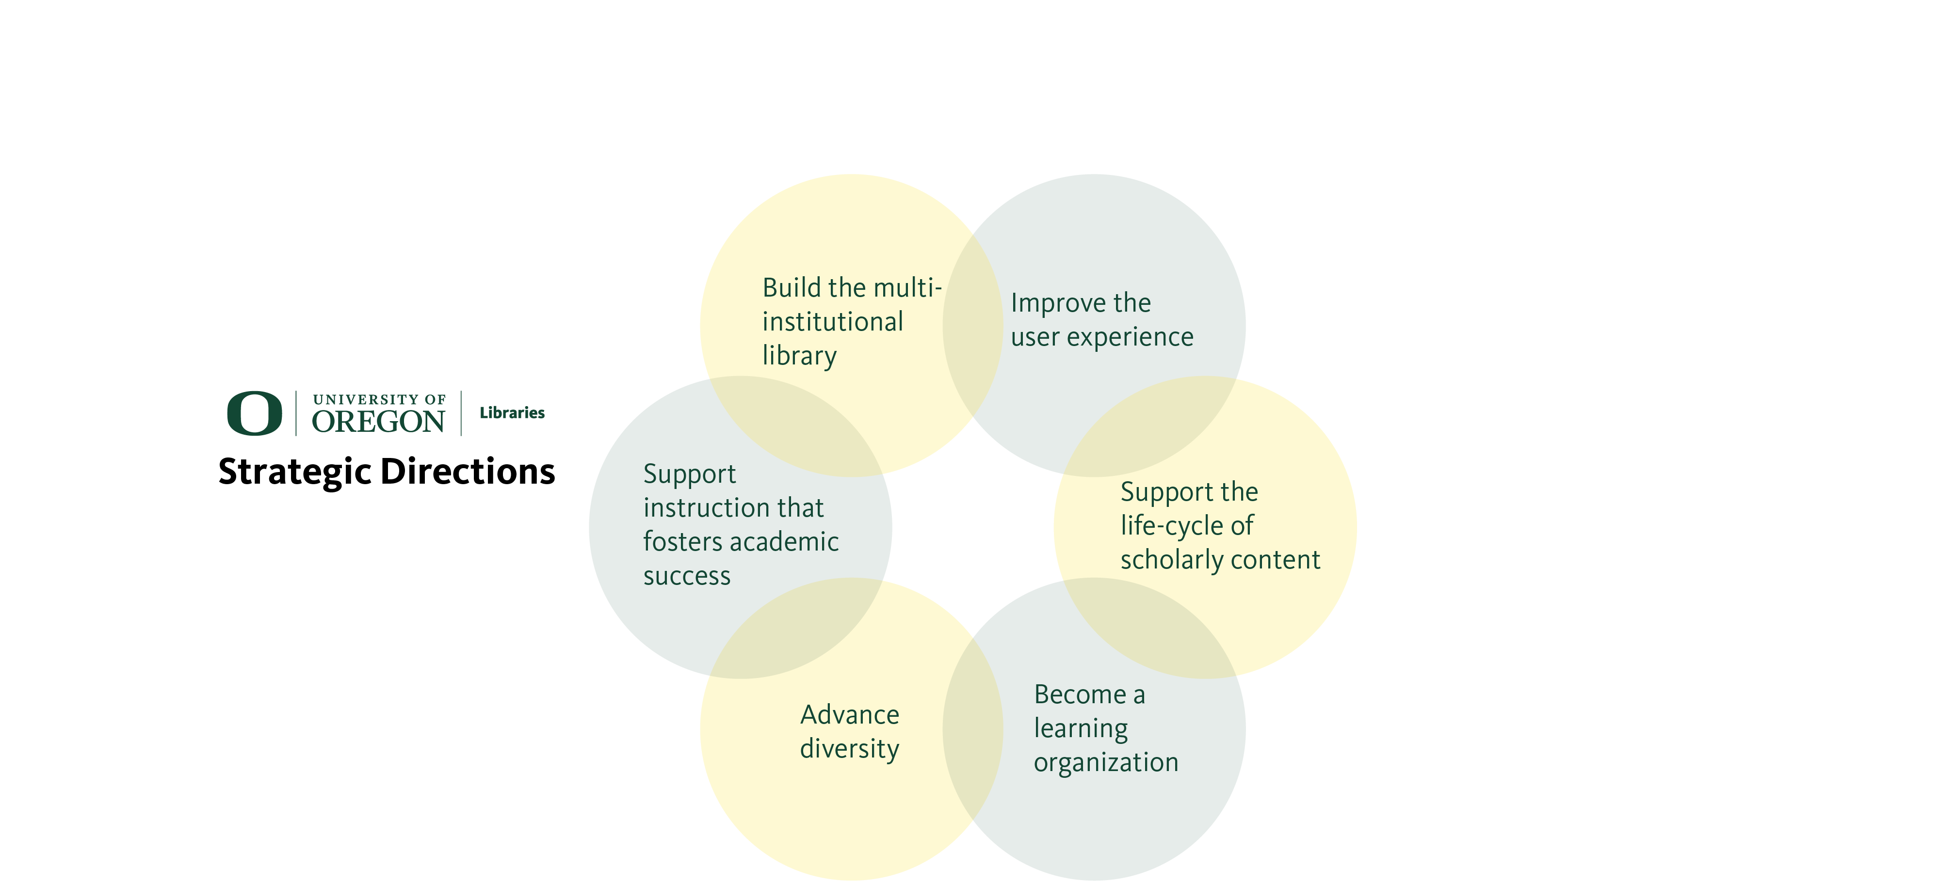

Fig. 1 Strategic Directions

Trends and Highlights
- Deborah Carver, Philip H. Knight Dean of Libraries retired April 30, 2014.
- Andrew Bonamici, Associate Dean for Media and Instructional Services, and Mark R. Watson, Associate Dean for Research Services, were appointed interim co-deans on May 1 and served in this role until the new permanent dean of libraries, Adriene Lim, started her appointment on July 28, 2014.
- Prepared for and began the implementation of the Ex Libris shared Integrated Library System.
- Conducted extensive evaluation of possible Learning Management Systems.
- Began migration to a new Digital Asset Management System for digital cultural objects.
- Administered the LibQual+ service quality survey.

Library Development
Thanks to the generous support of nearly 1,800 donors, the library raised more than $3 million in gifts and pledges during the fiscal year 2013–14. The UO Libraries’ current endowment totals over $26 million as of June 30, 2014. Major highlights for the year include:
- Received $1 million—from siblings Dan Giustina, Gennifer Giustina, Gregory Giustina, Nicholas Giustina, and Thomas Giustina—to enable the purchase of the Ken Kesey papers, keeping this precious archive in Oregon.
- Received $100,000 from the Laughton Family to create an endowment to process and preserve the Kesey archive.
- Created the Doris Scharpf Library Student Employee Endowment with an anonymous gift of over $200,000. This will enable the library to hire additional student workers, giving them valuable hands-on experience.
- In addition, $100,000 was pledged to establish the Barbara B. and Milton C. Sparks Student Employee Endowment Fund.
- Received an addition of over $144,000 to the Proctor Library Endowment.
- Continued fundraising for the Allan Price Science Commons and Research Library and raised over $100,000 for the Deb Carver Classroom to be included in the project.

Sources of Funds

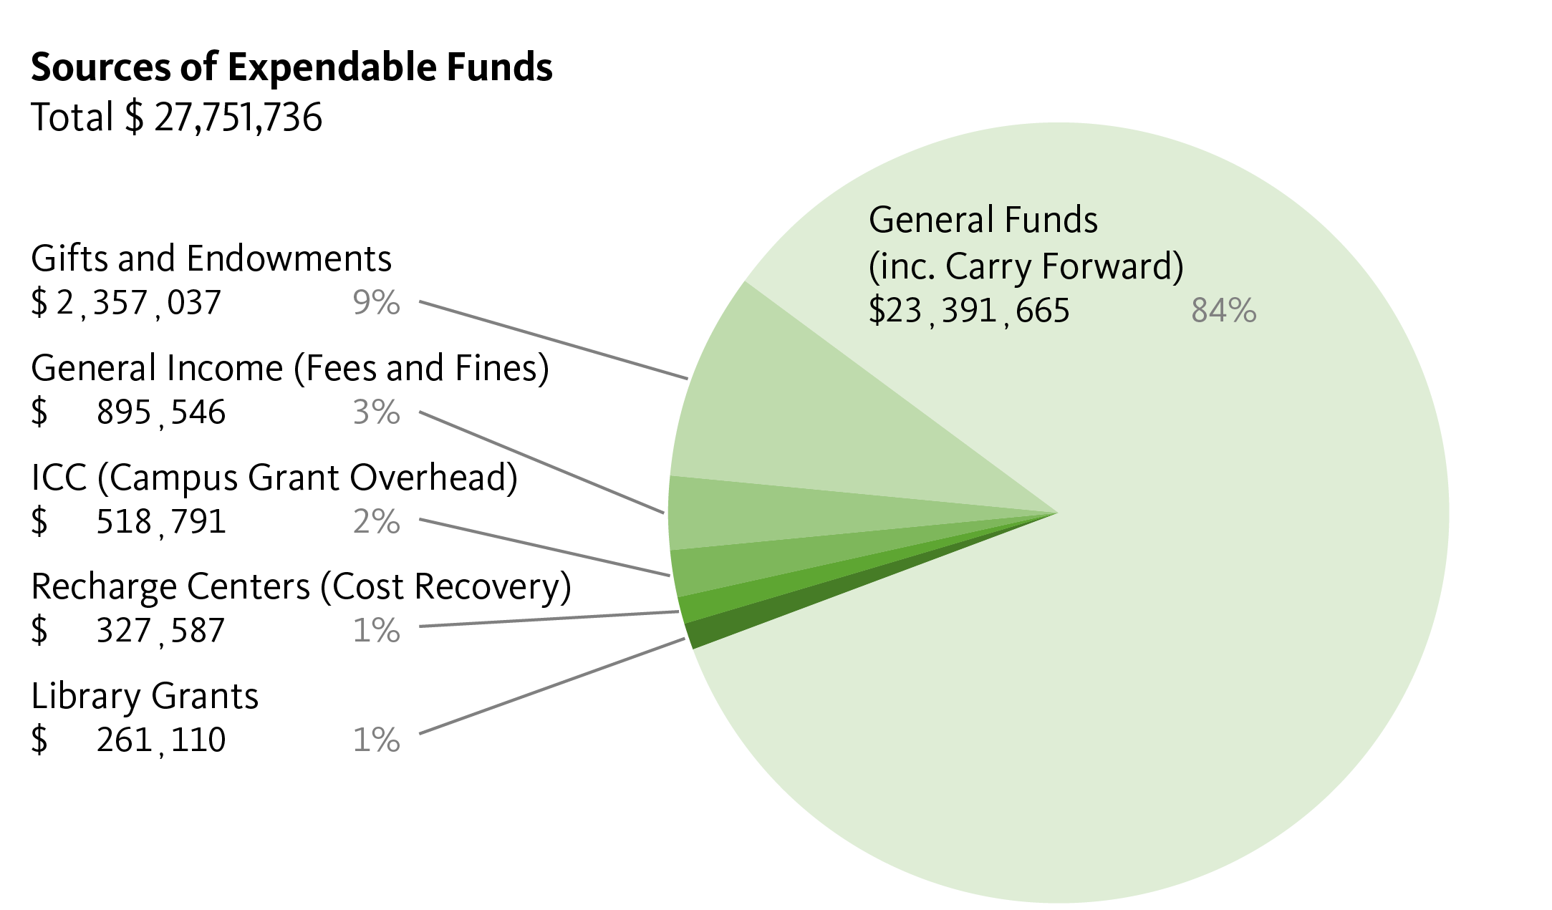
Fig. 2 Sources of Expendable Funds

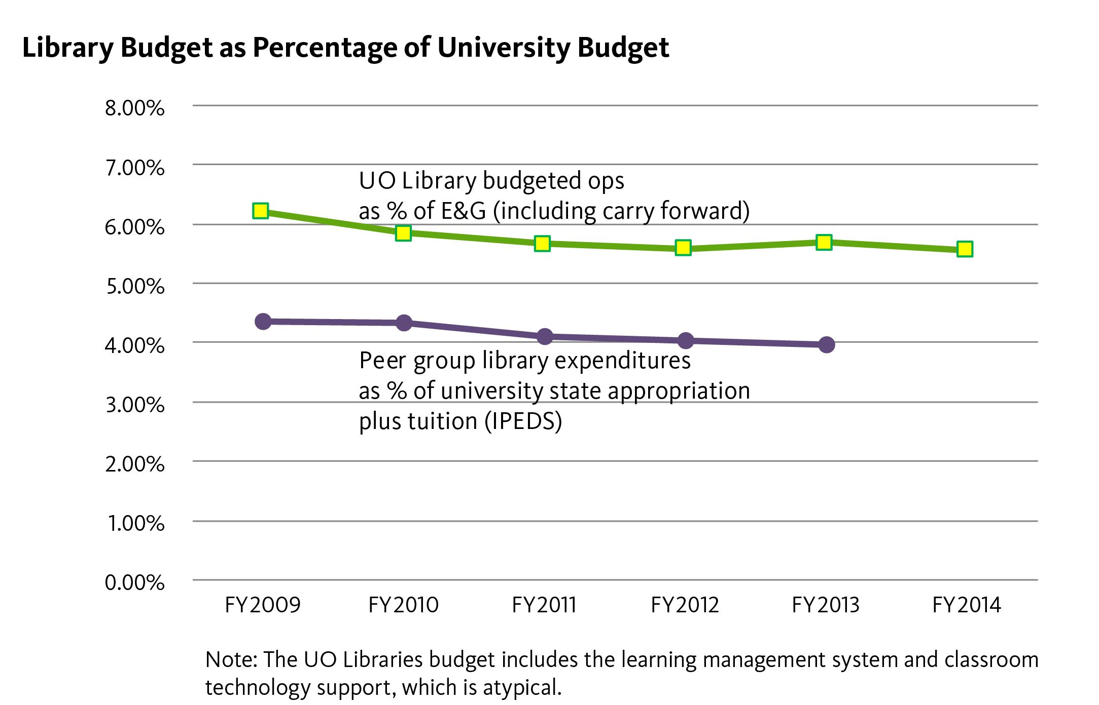
Fig. 3 Library Budget as Percentage of University Budget

ARL Investment Index Ranking
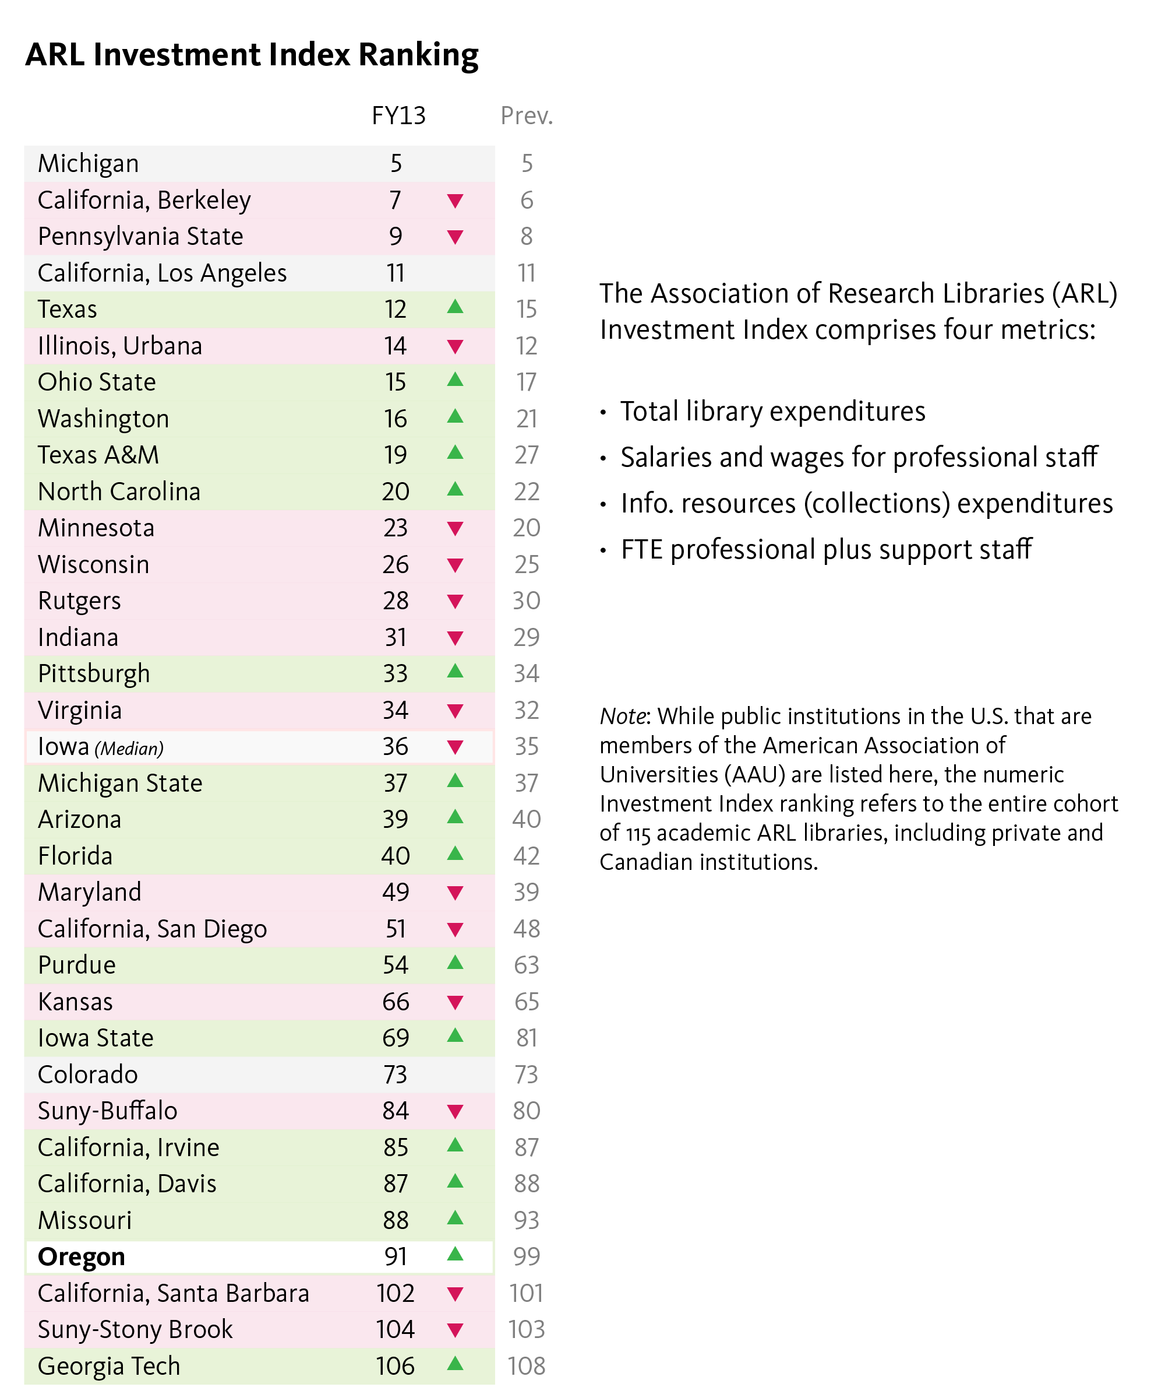

Fig. 4 ARL Investment Index Ranking

Expenditure Details
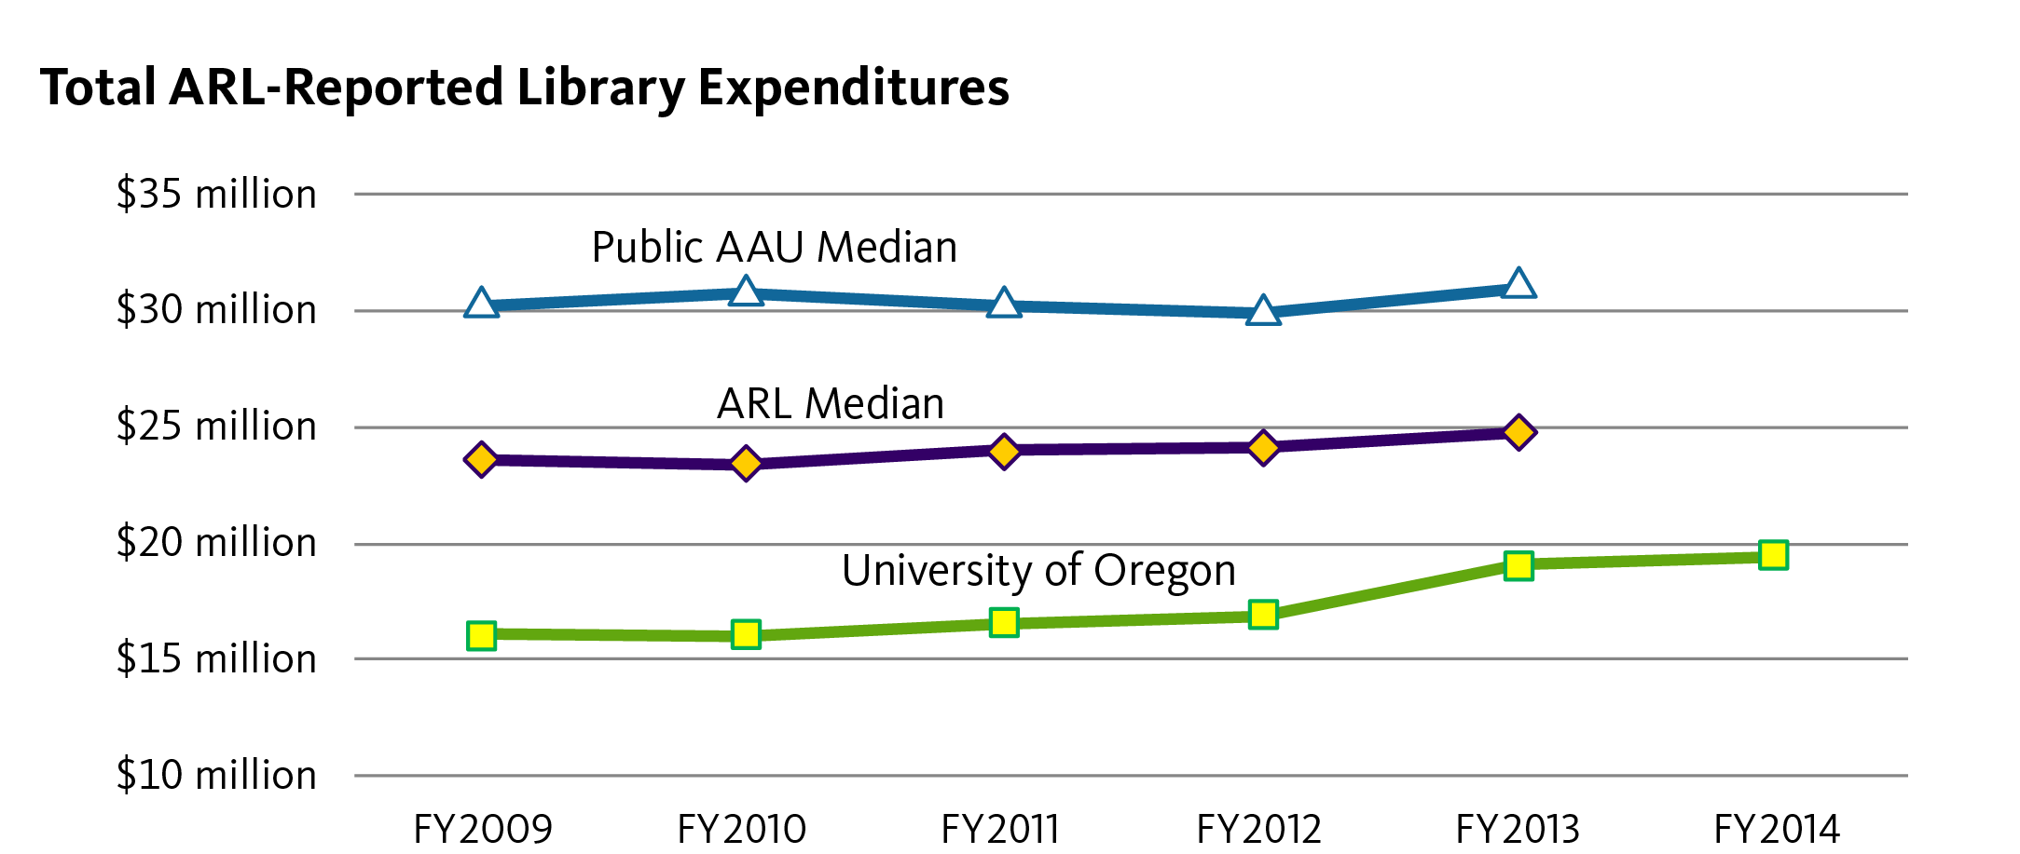

Fig. 5 Total ARL-Reported Expenditures

For comparative purposes, expenditures reported to the Association of Research Libraries (ARL) exclude benefits or “Other Payroll Expense.” Roughly half the increase for the UO in the last two years reflects the reorganization of Academic Technology, bringing more staff into the libraries.

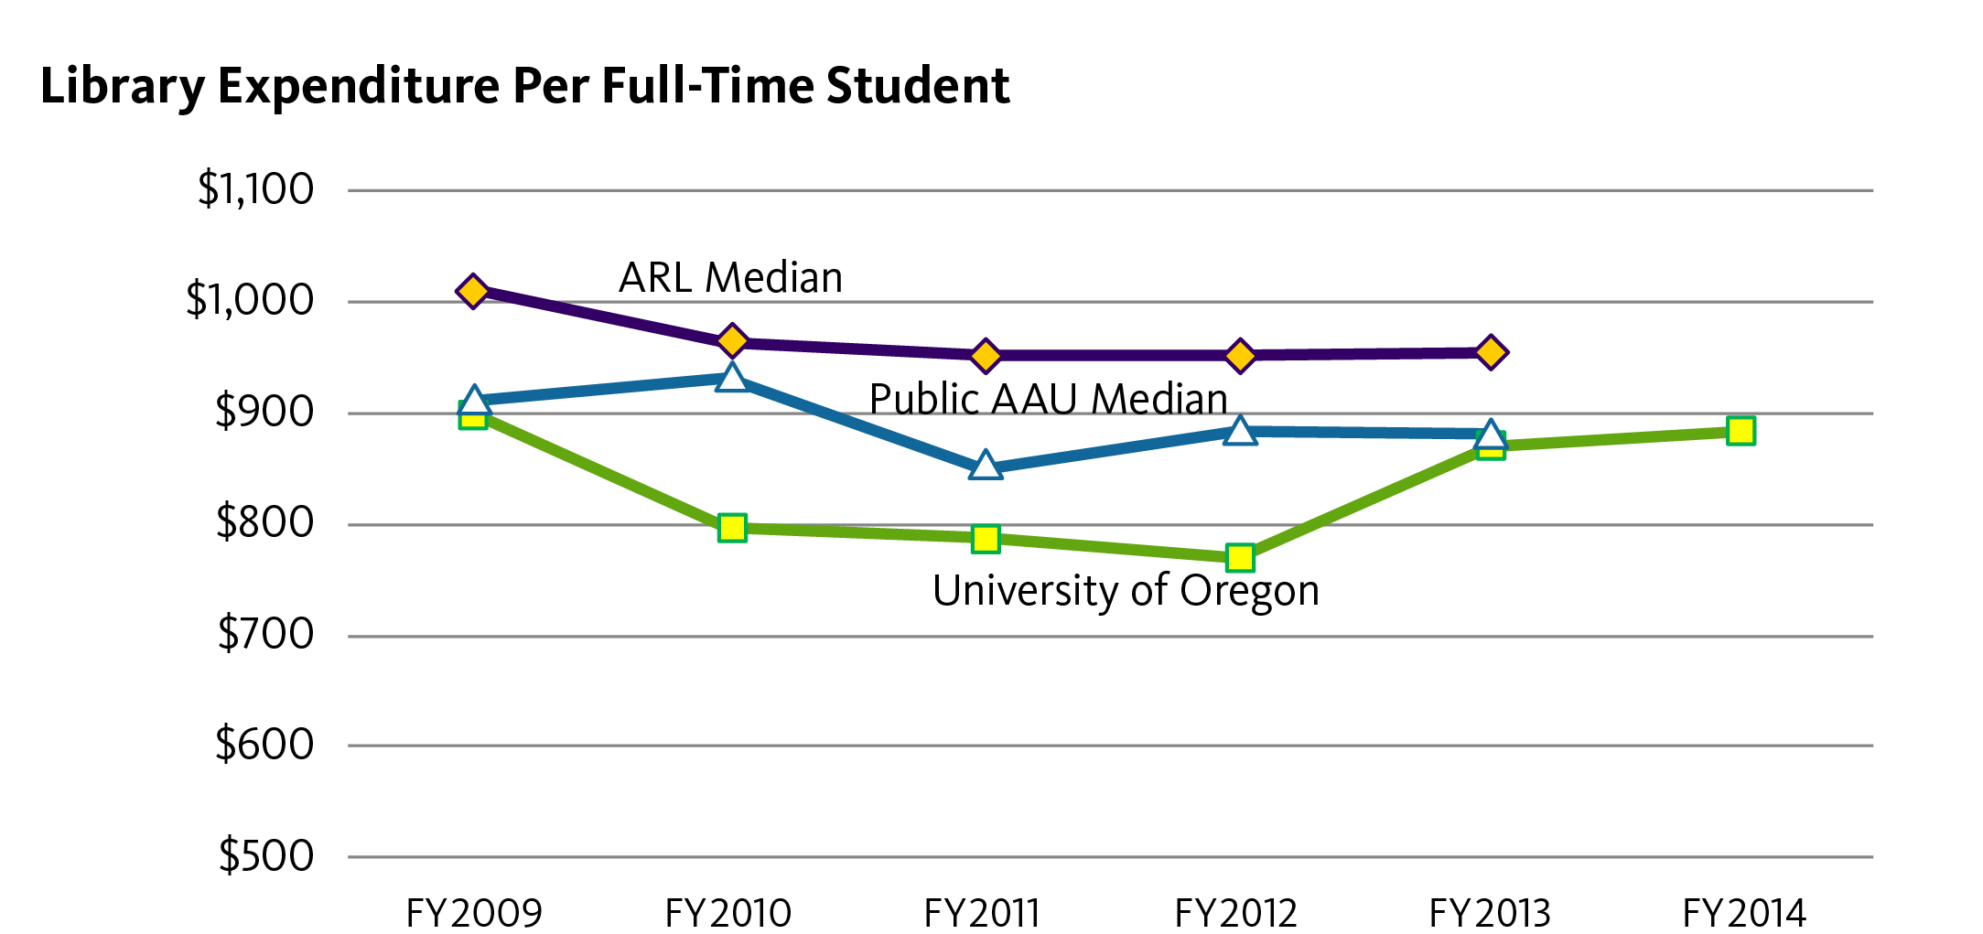

Fig. 6 Library Expenditure Per Full-Time Student

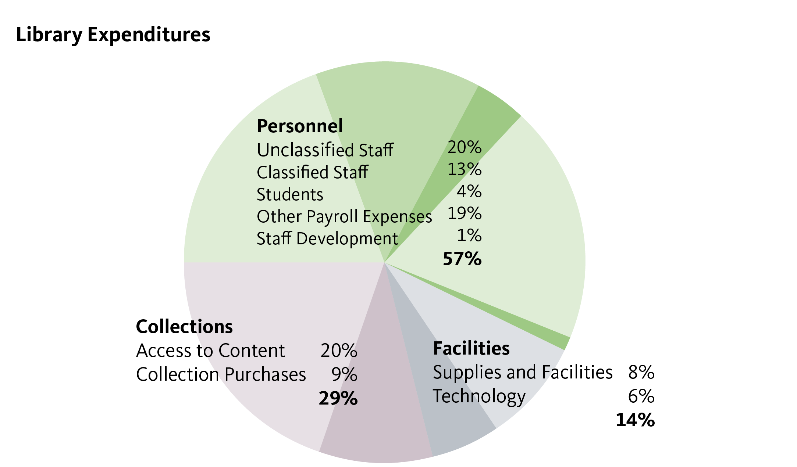

Fig. 7 Library Expenditures

Personnel-related expenses, including benefits and professional development, account for 57% of total expenditures. Collections and access to electronic resources account for a combined 29% of the total. Supplies and technology account for the remaining 14%. Technology expenditures now include campus computer labs as well as classroom educational technology.
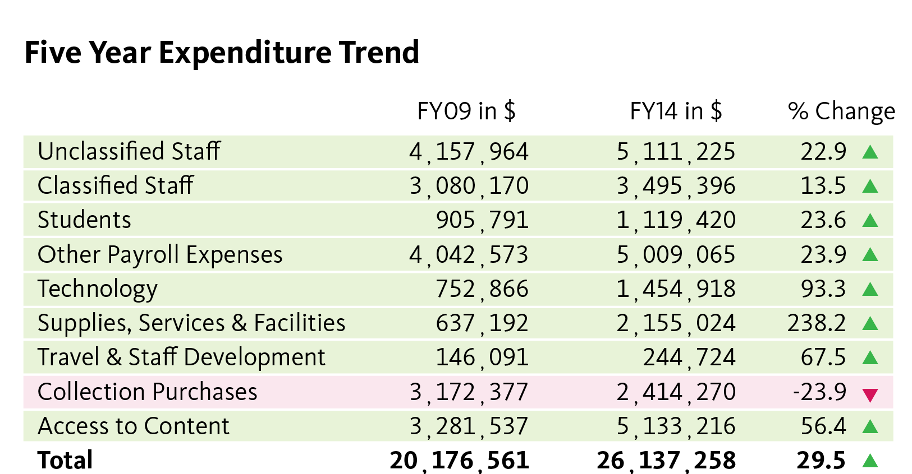

Fig. 8 Five Year Expenditure Plan

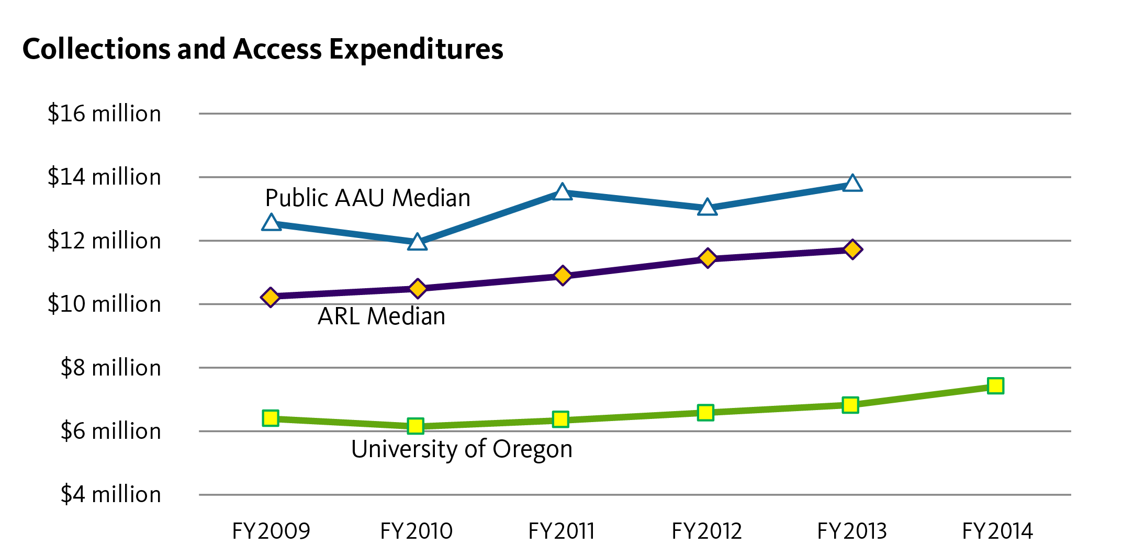

Fig. 9 Collections and Access Expenditures

Collections needs are driven more by the scope of the programs, particularly graduate programs that we support. There are some incremental costs, especially for licensed resources, that are impacted by student FTE.
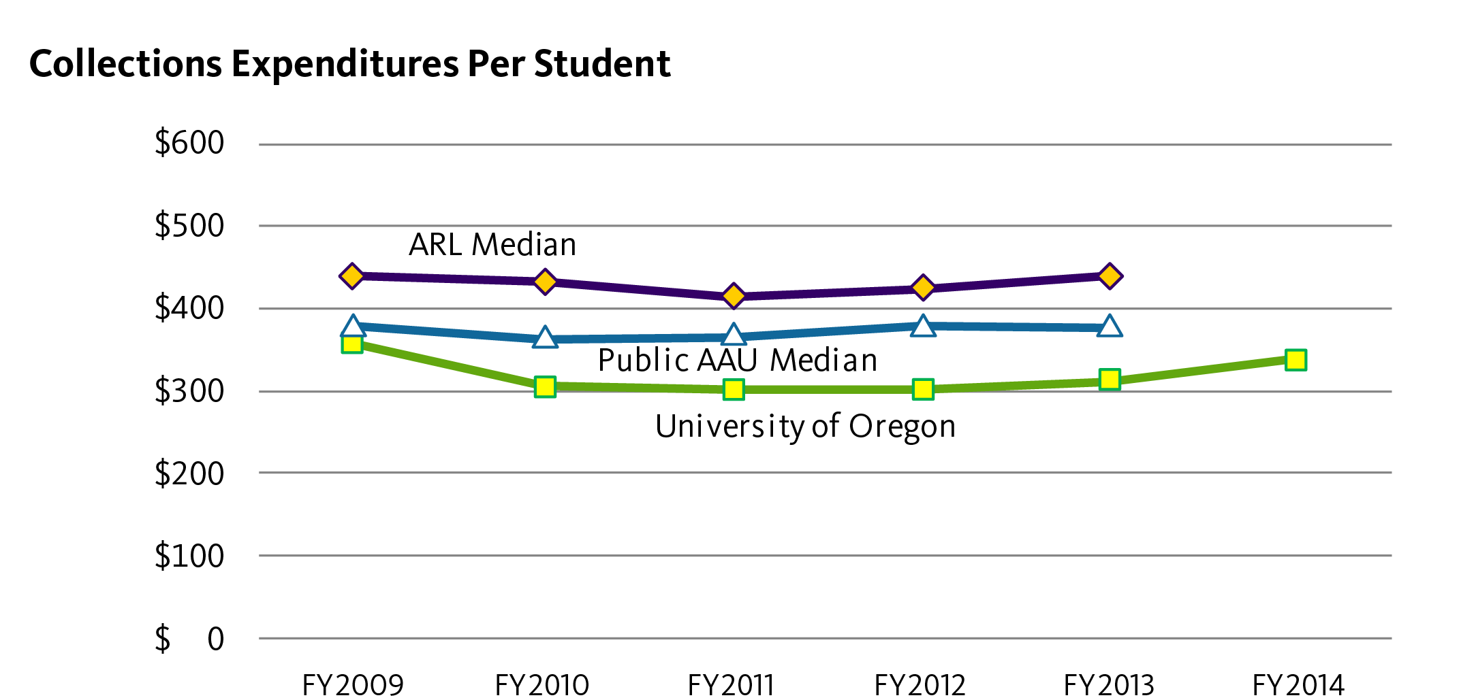

Fig. 10 Collections Expenditures Per Student

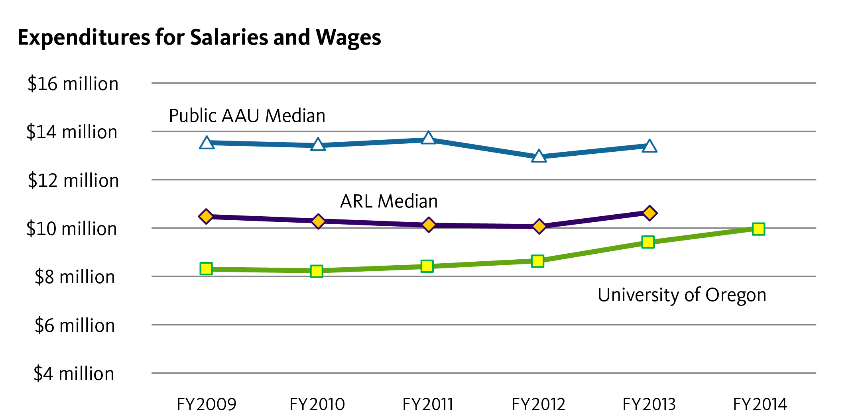

Fig. 11 Expenditures for Salaries and Wages

Expenditures for salaries and wages for the UO Libraries includes a broader scope of services than is normally found with our comparator institutions, including campus classroom technology, computer labs (added in 2013), and learning management system.

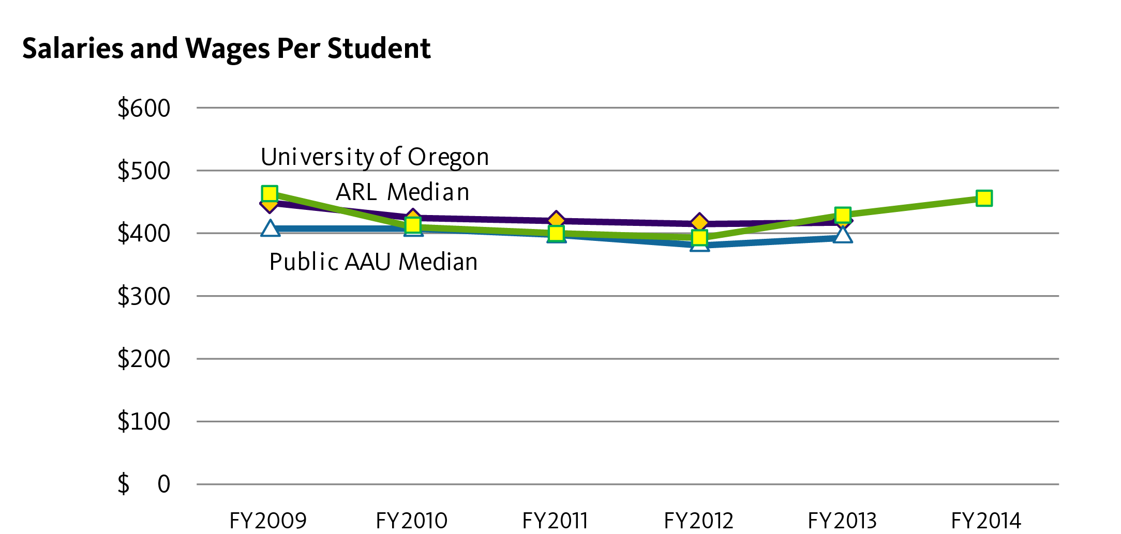

Fig. 12 Salaries and Wages Per Student

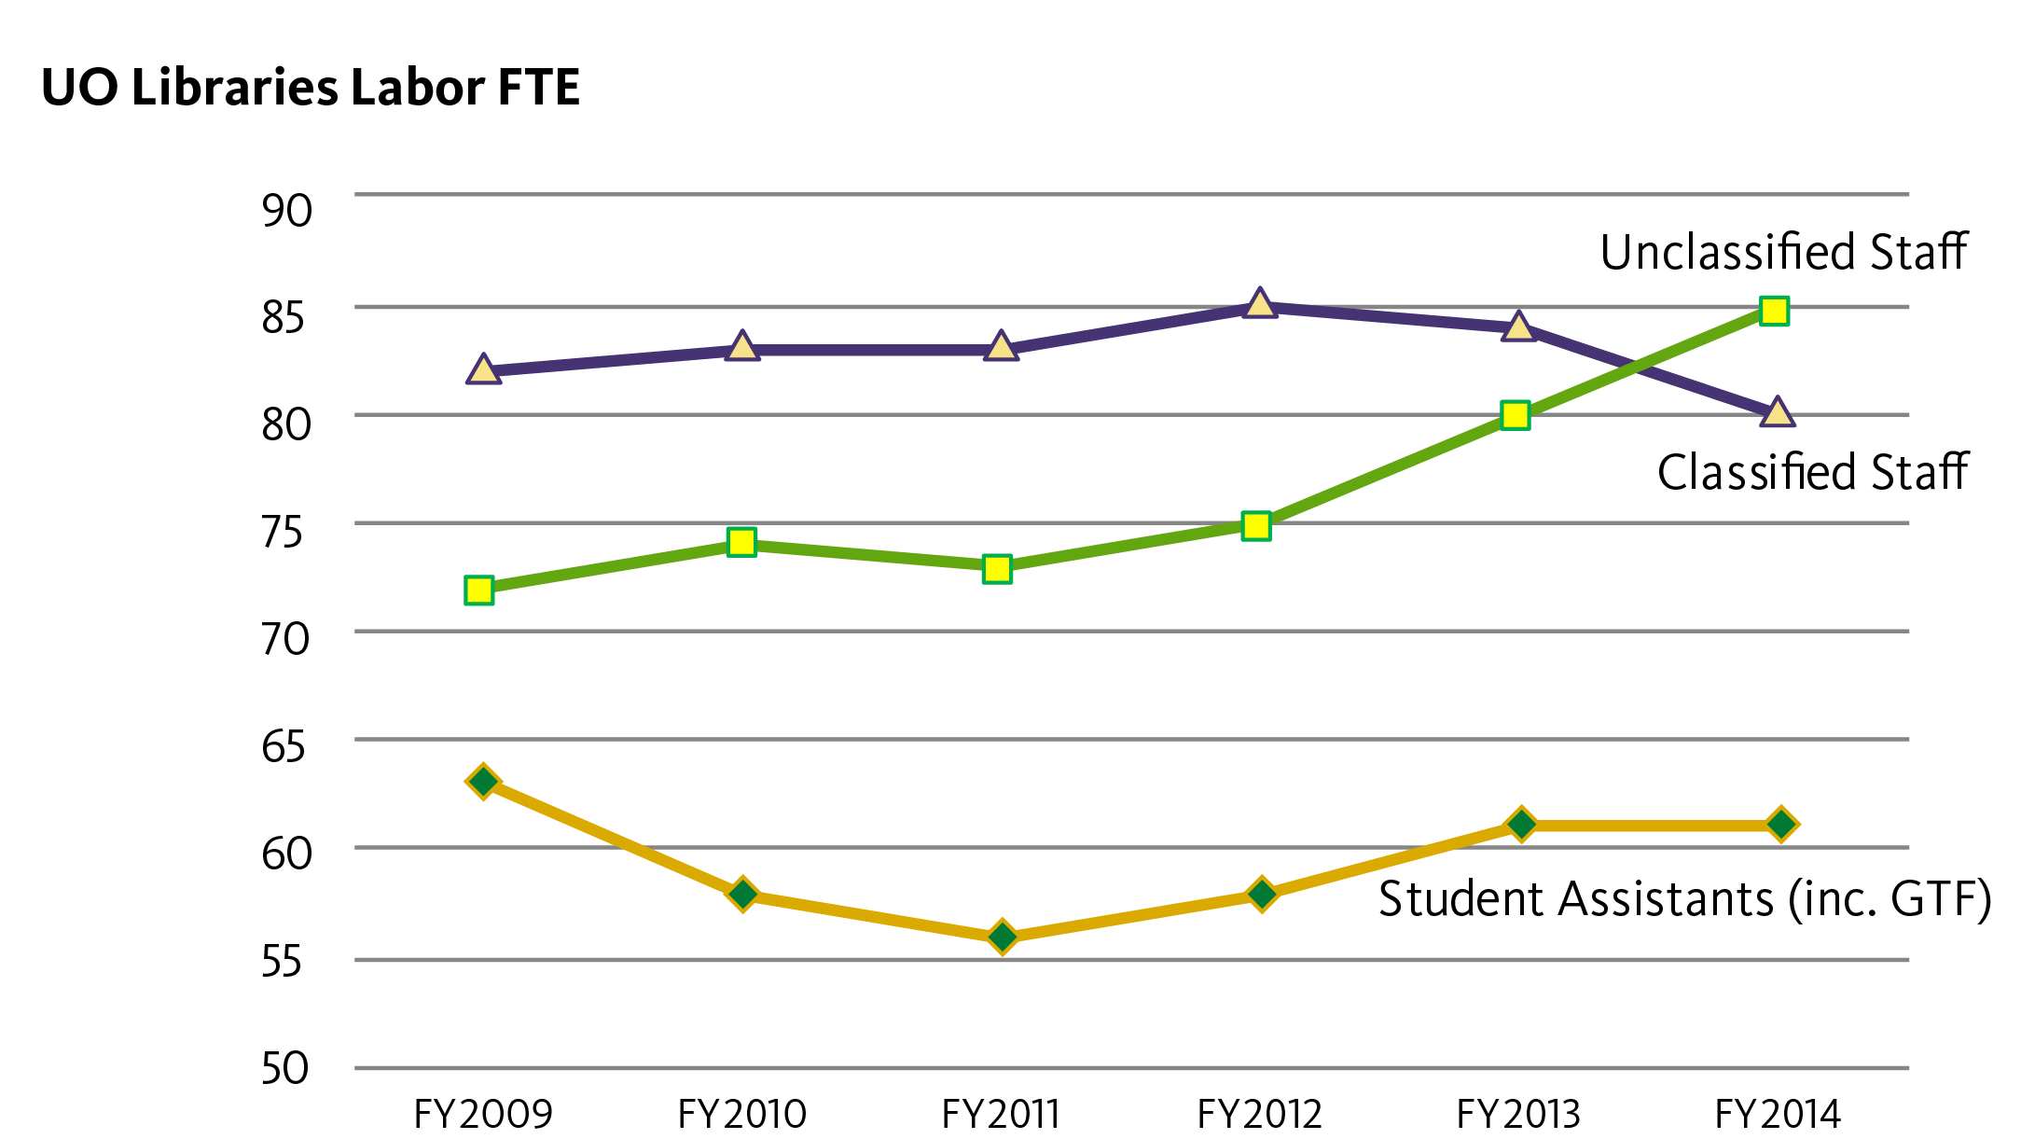

Fig. 13 UO Libraries Labor FTE

This reflects changes to the makeup of the libraries’ staff, in particular the addition of staff related to the academic technology organizational change in 2013. This also demonstrates the changing nature of the work in libraries with a greater need for professional expertise.

Use of Library Collections and Services
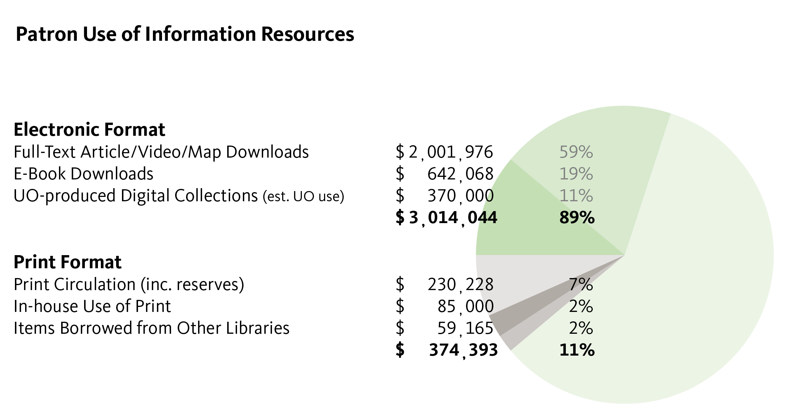
Fig. 14 Patron Use of Information Resources

A total of 89% of the use of library-provided content is in electronic format, a number that has stabilized over the last two to three years. Door counts are falling slightly, perhaps a reflection of new campus buildings with more study space.
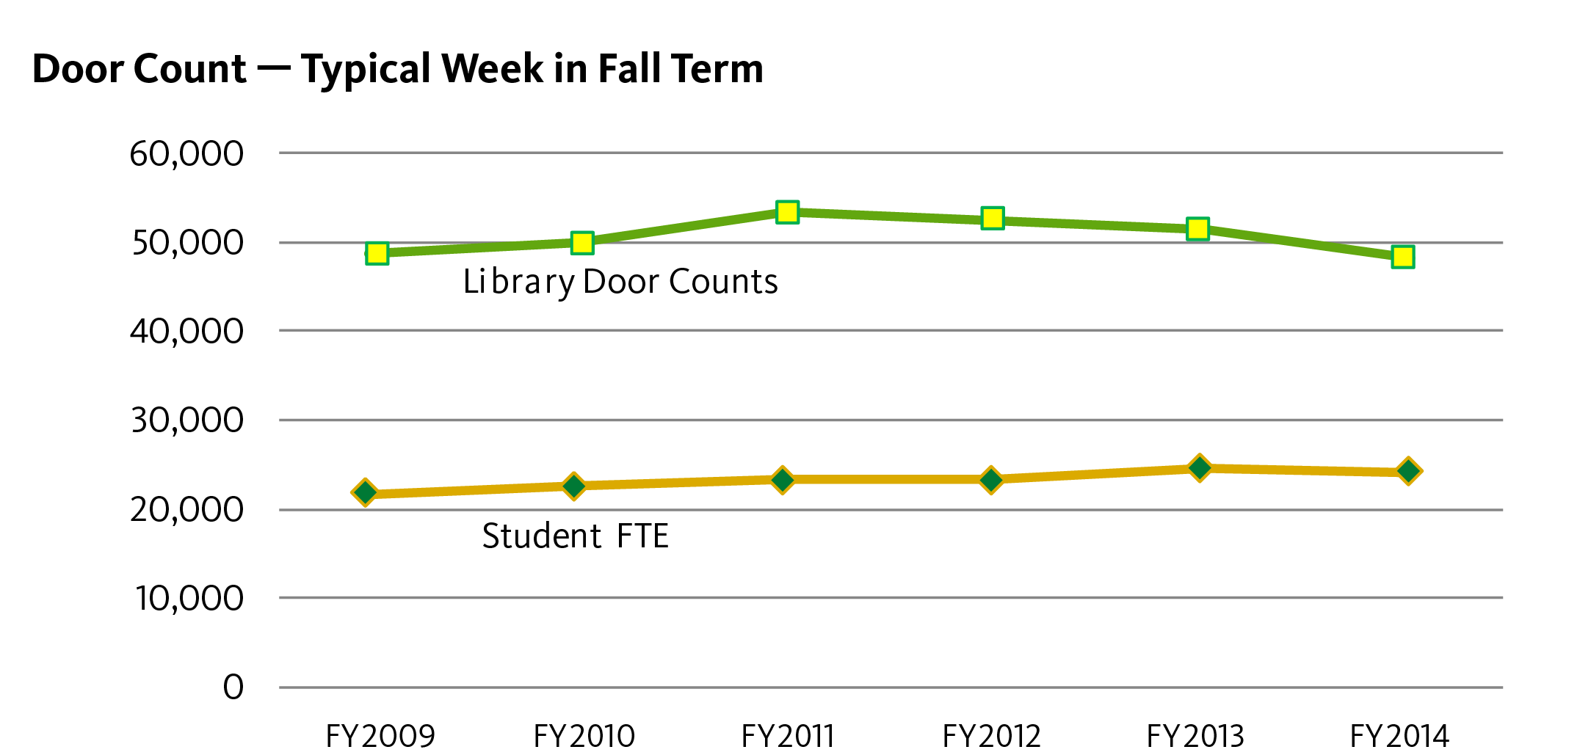

Fig. 15 Door Count

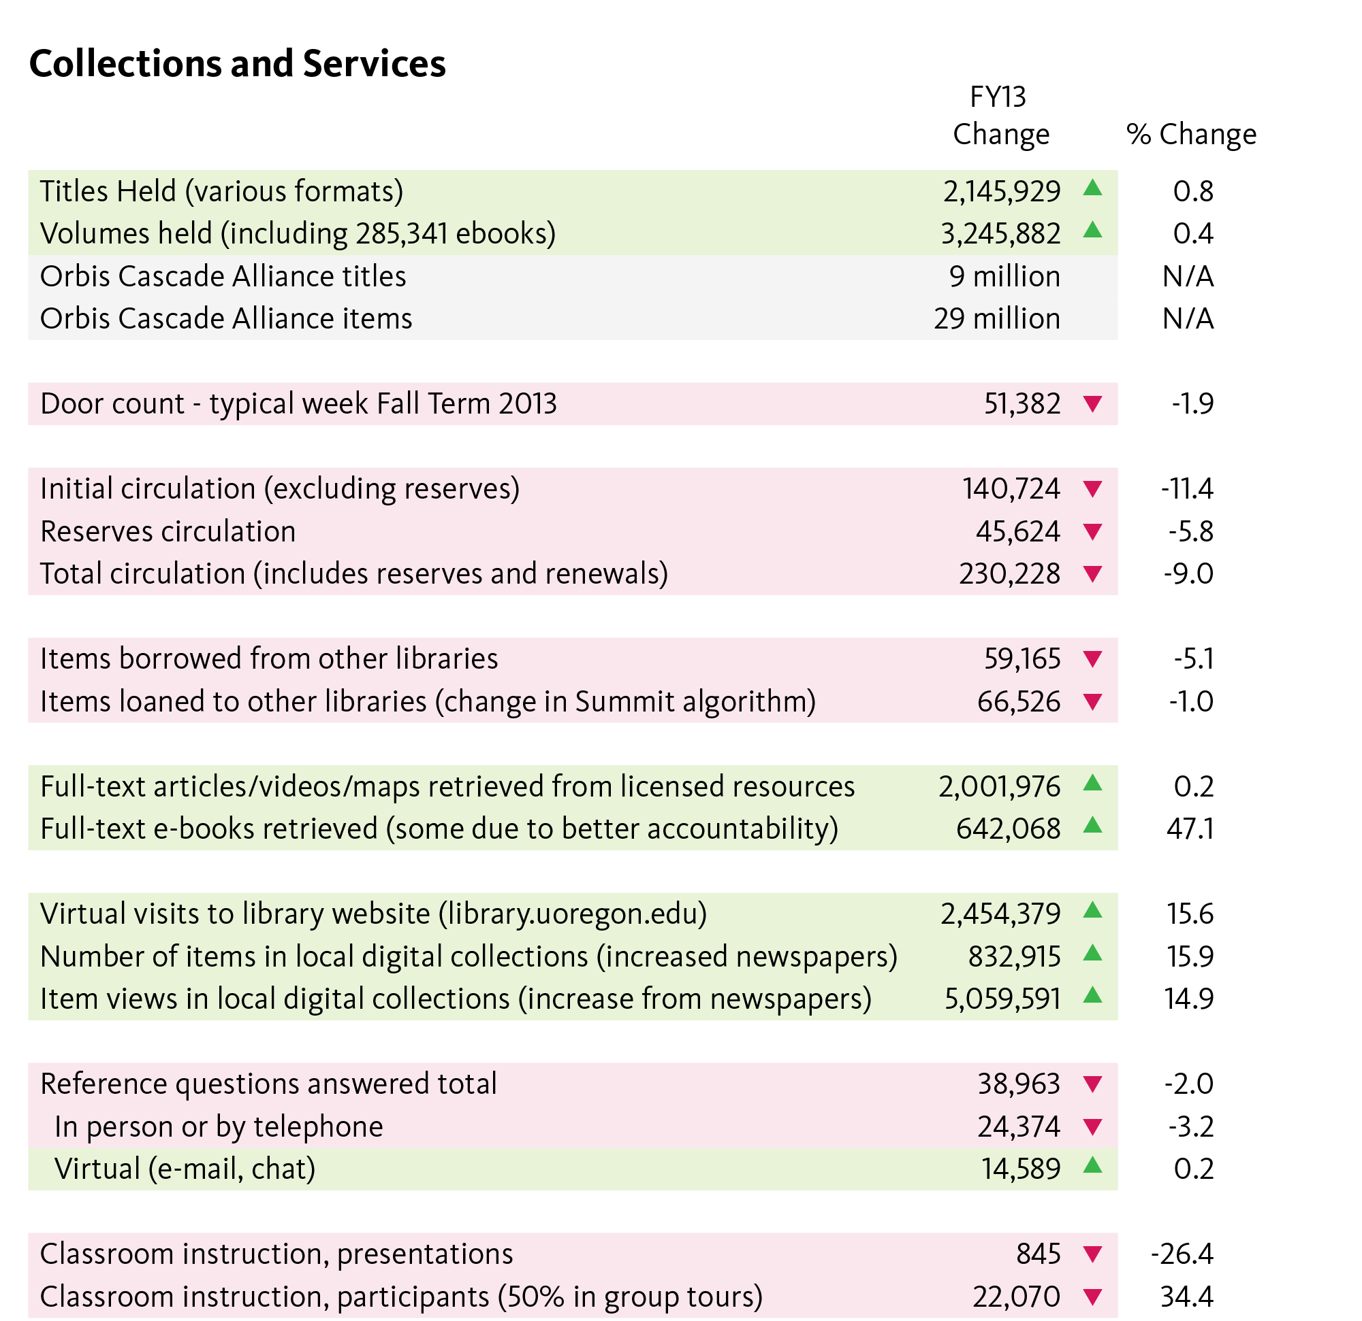

Fig. 16 Collections and Services

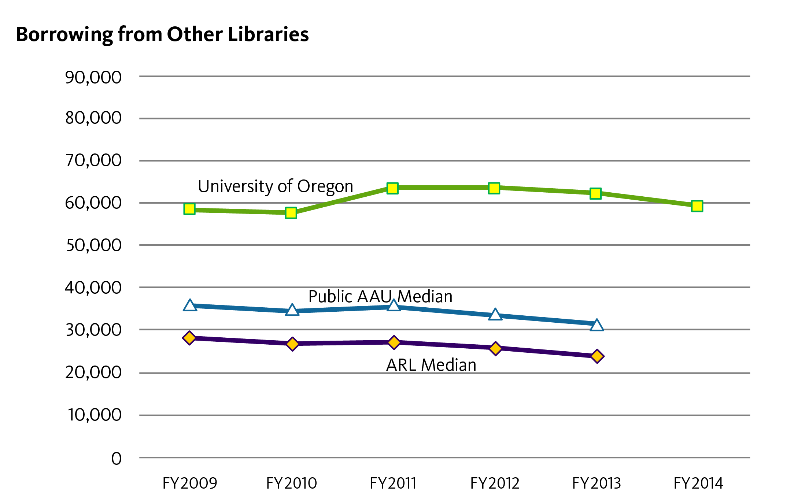

Fig. 17 Borrowing from Other Expenses

Resource sharing is a signature service of the UO Libraries reflecting our commitment to building the multi-institutional library. The lending rate is influenced by the Orbis Cascade Alliance algorithm for selecting a lender among multiple libraries that hold an item. This explains the variations in UO lending.
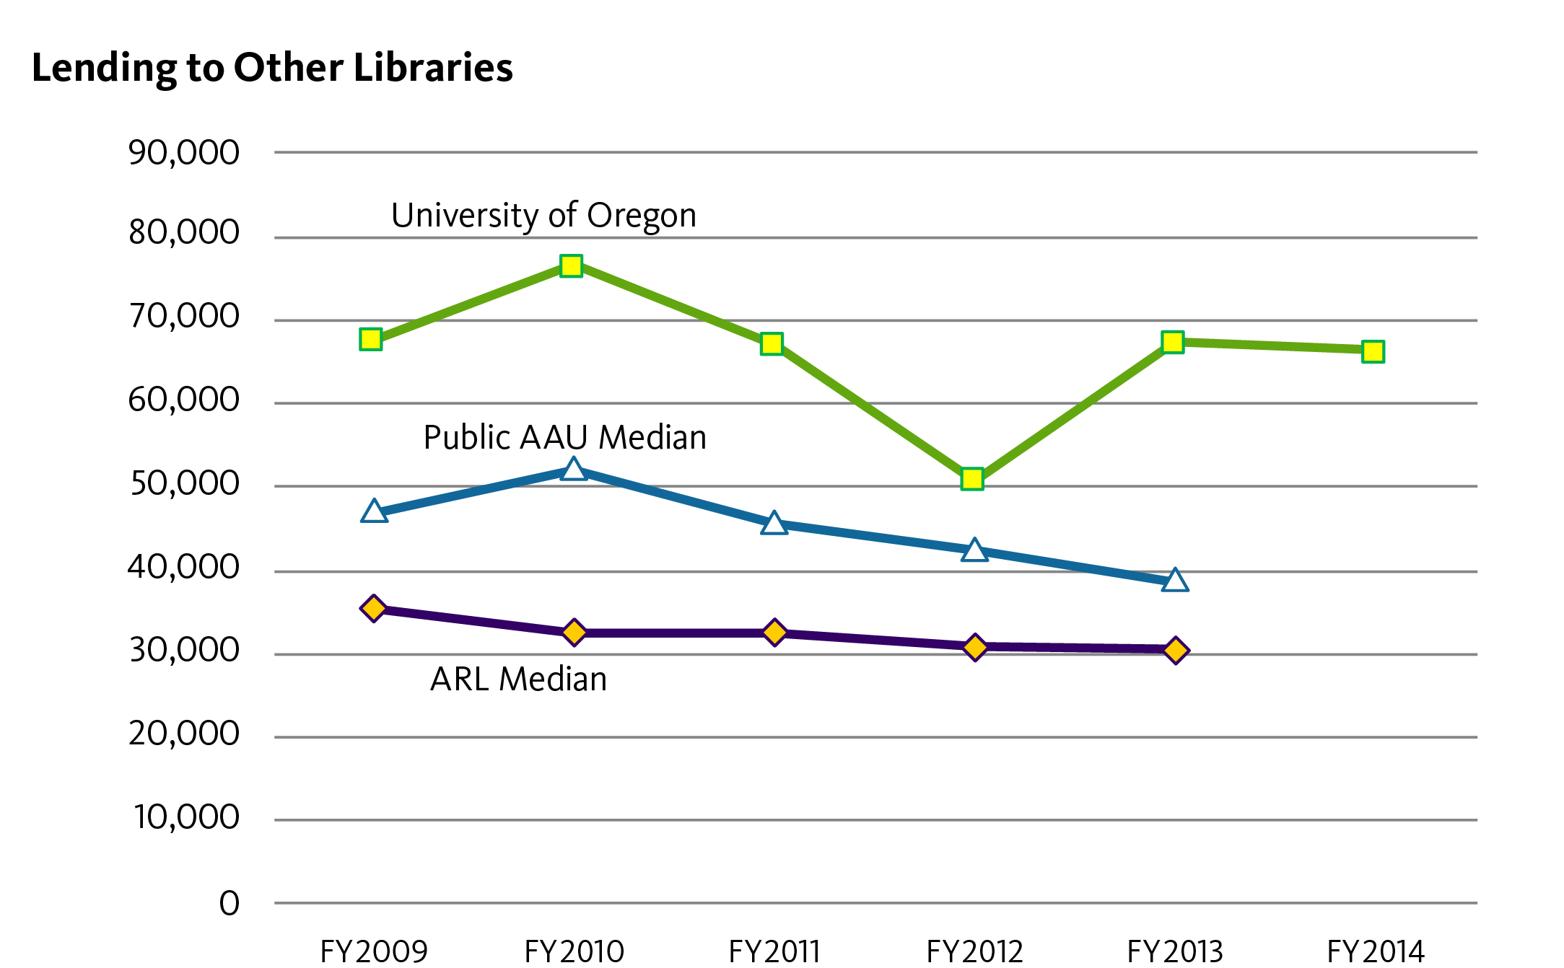

Fig. 18 Lending to Other Libraries

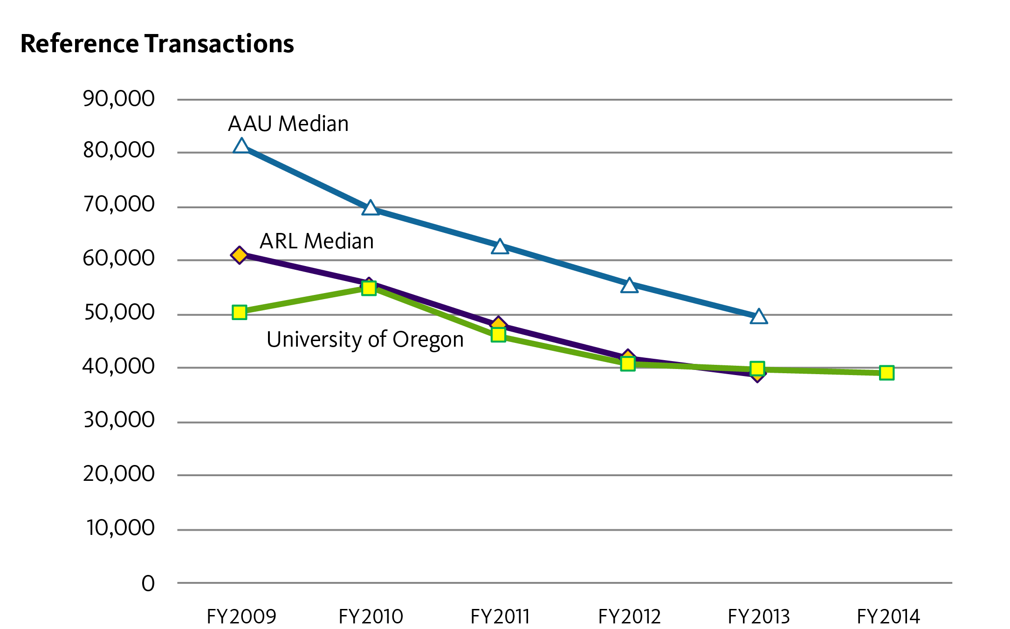

Fig. 19 Reference Transactions

Although the total number of reference transactions (one-on-one instruction) continues to decline both locally and nationally, most of the decline is with in-person visits. Virtual interactions via the web, chat, and e-mail have increased significantly.
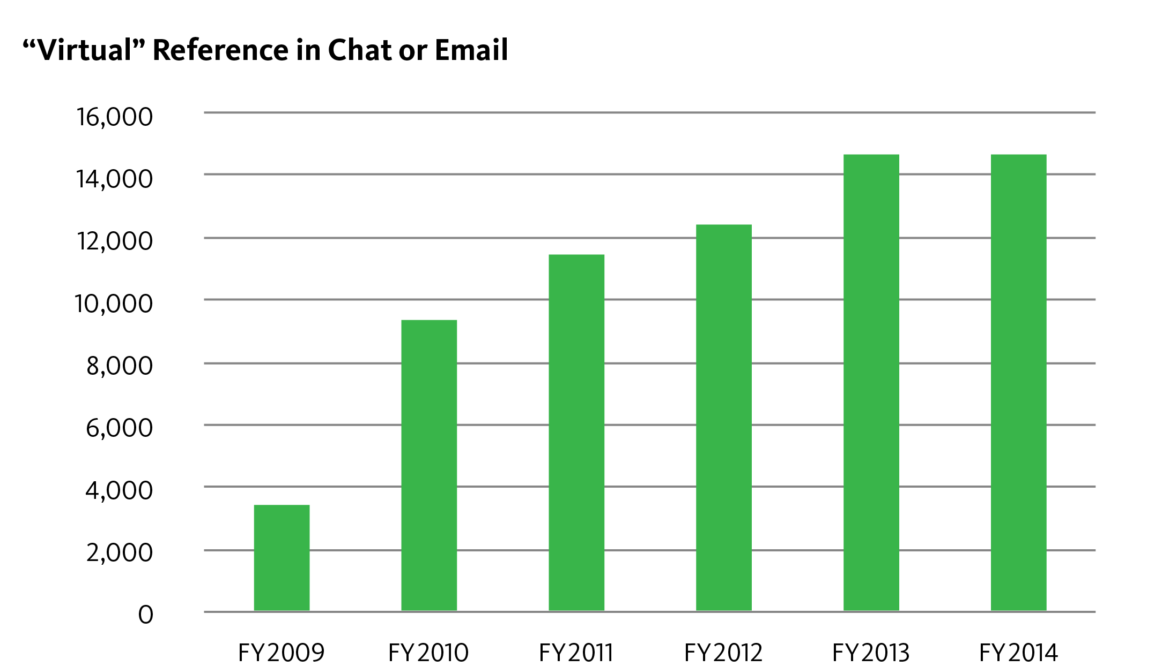

Fig. 20 ”Virtual” Reference in Chat or Email

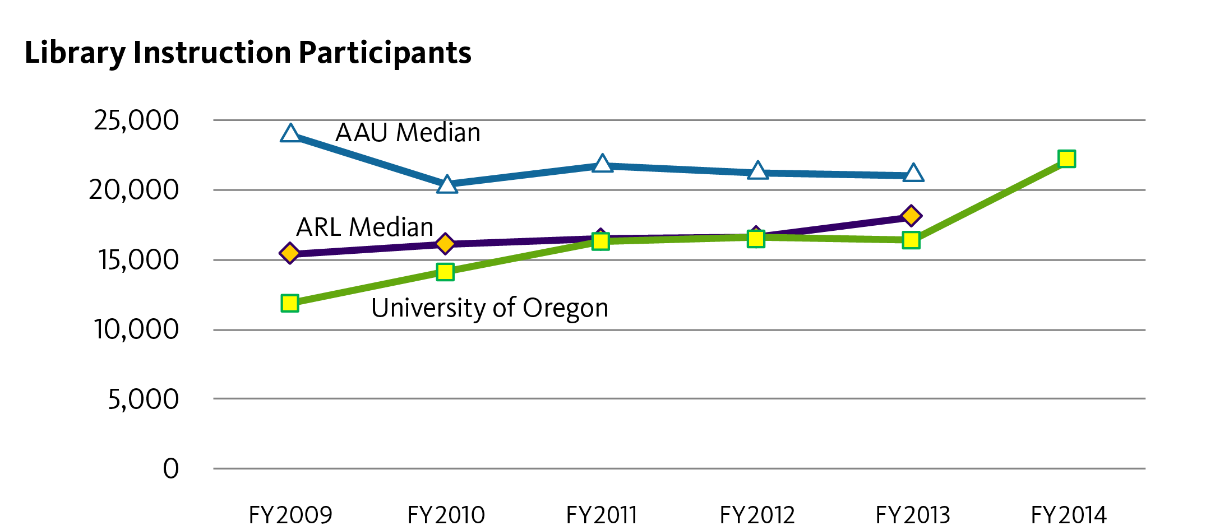

Fig. 21 Library Instruction Participants

The library’s involvement in UO first-year programs, campus partnerships, and credit classes demonstrates a diversified instruction program that has grown with campus enrollment. These numbers in include group tours, guest classroom presentations, and librarian-taught credit classes. This past year half the participation was in group tours, which accounts for the greater number of participants even with fewer presentation offered.
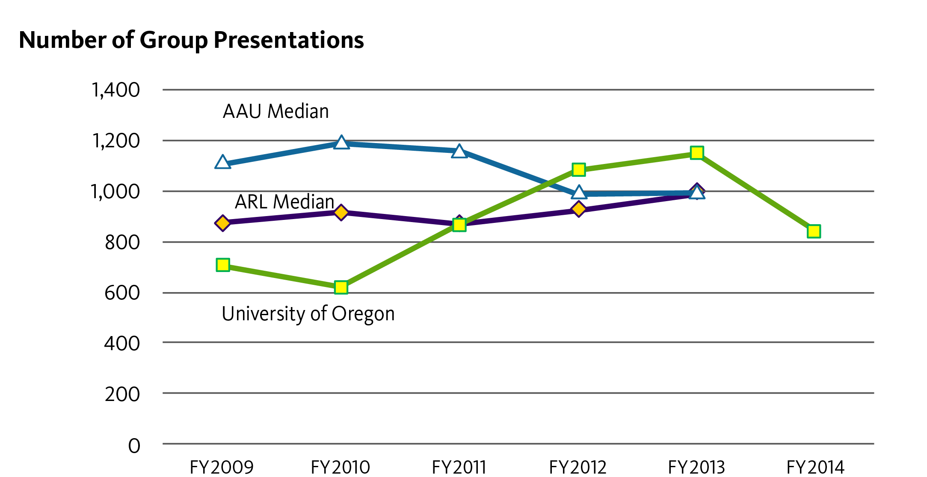

Fig. 22 Number of Group Presentations

Assessment: Learning From and About Library Users

Usability Studies/Assessing Learning Management System Options
The LMS review process is noted in detail later in this document. It included extensive pilot testing, surveys, focus groups, and usability testing.

Surveying User Satisfaction/LibQual+
The Assessment Team’s major project for the last academic year was conducting the LibQual+ survey. The survey was previously conducted in 2005 and 2010. We had an overall response rate of just 7%, in spite of multiple reminder messages. (The response rate was 11% in 2010.) The faculty response rate was 9%, graduate students 15%, and undergraduates 5%. We conducted a representativeness check comparing respondents with the overall campus population by discipline.

In this round the perceived level of service improved slightly along all three major dimensions:
- Affect of Service (how users feel they are treated)
- Information Control (library collections, website, and discovery tools)
- Library as Place (physical facilities)
Additional findings are reported in the summary online at https://library.uoregon.edu/sites/default/files/node156/libqual_summary_report.docx, with the full report from the Association of Research Libraries in Scholars’ Bank.
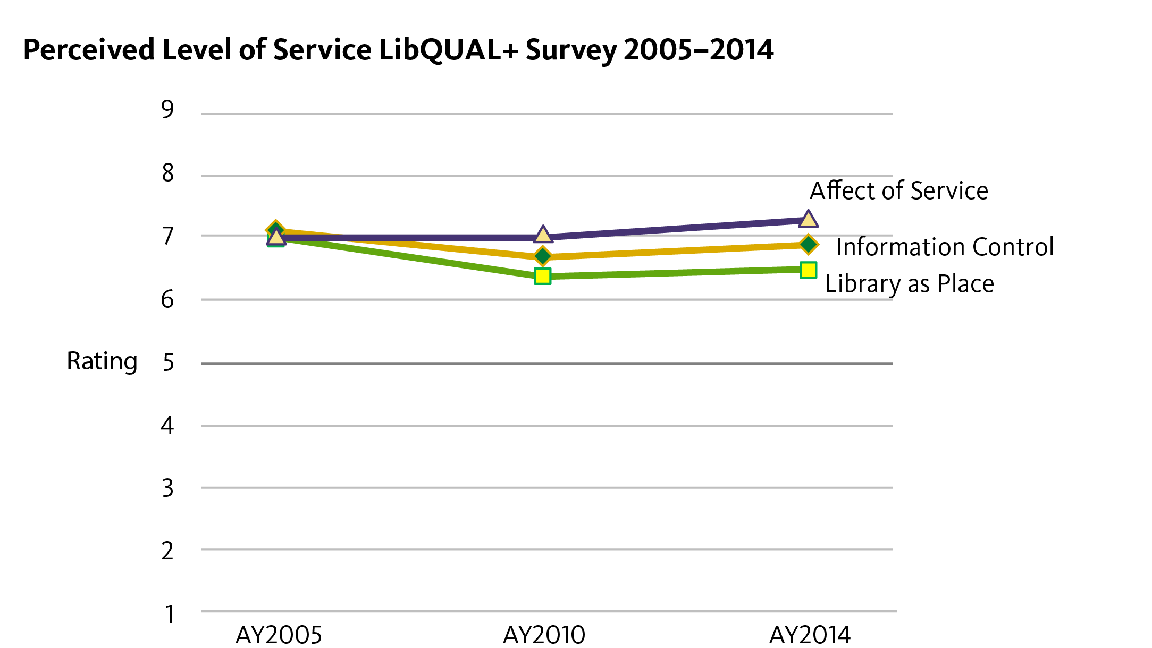

Fig. 23 Perceived Level of Service LibQUAL+ Survey 2005-2014

Library Systems and Campus Computer Labs
The Library Systems Department supports information technology used throughout the UO Libraries, both by library staff and library patrons. In addition, the Library Systems Department supports several campus computing labs.
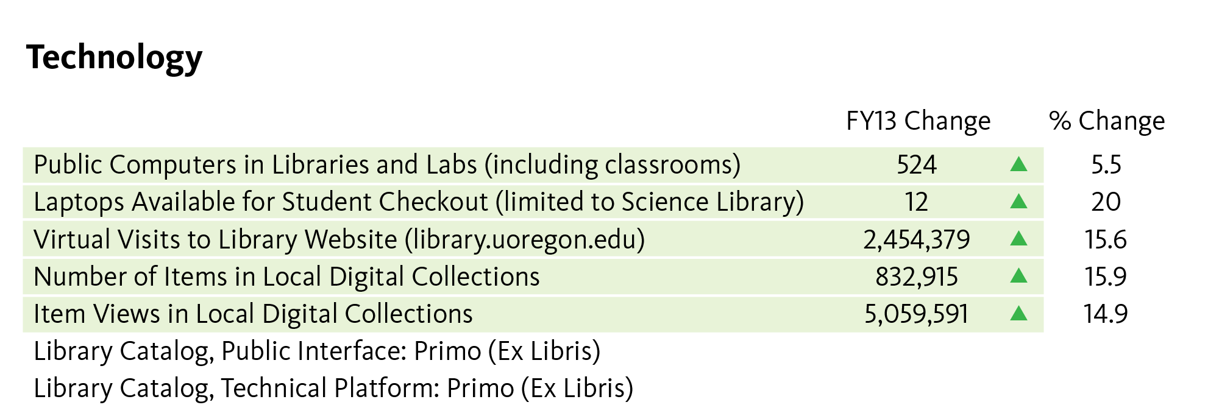

Fig. 24 Library Systems Technology

Academic Technology Support: CMET
The Center for Media and Educational Technology (CMET) is a central provider of academic technology support for faculty, GTFs and students. CMET design, installs, and manages audio visual, presentation and classroom technologies in over nearly 160 general pool and joint control classrooms on campus. CMET supports faculty and GTFs in using these technologies, checks out audio visual production equipment to faculty, staff and students, provides video production, live and on-demand streaming services, video conferencing services, as well as manages and supports the enterprise learning management system (LMS) for the University of Oregon. In Fiscal Year 2013-2014, CMET responded to 5920 support requests: 686 in classroom technology support and training sessions for faculty and GTFs, 1,188 audio visual production equipment circulation requests, 1,845 LMS (Blackboard, Canvas and Sakai) support requests, and 2,201 faculty and GTF instructional technology support and consultation requests.

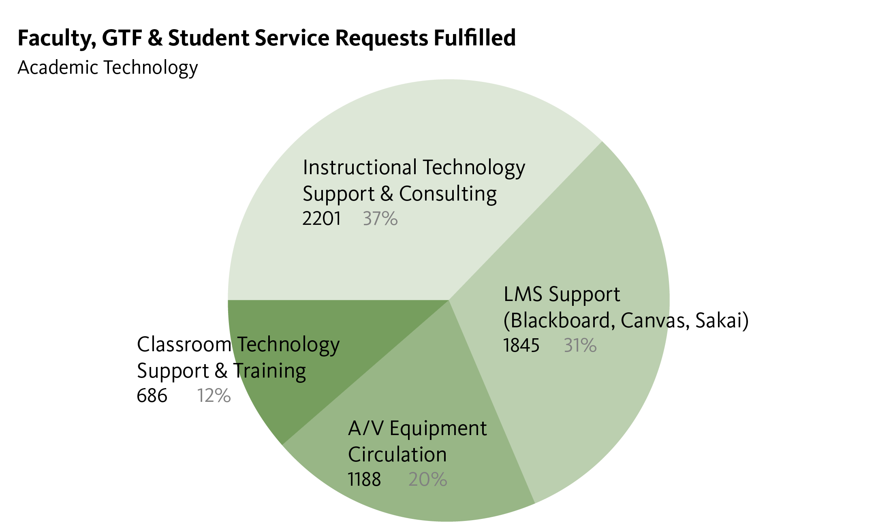

Fig. 25 Faculty, GTF & Student Service Requests Fulfilled

Learning Management System
Course and Enrollments Statistics for Blackboard, the University of Oregon’s enterprise Learning Management System, as well as Canvas and Sakai which were piloted during Spring term 2014 as part of the LMS review process.
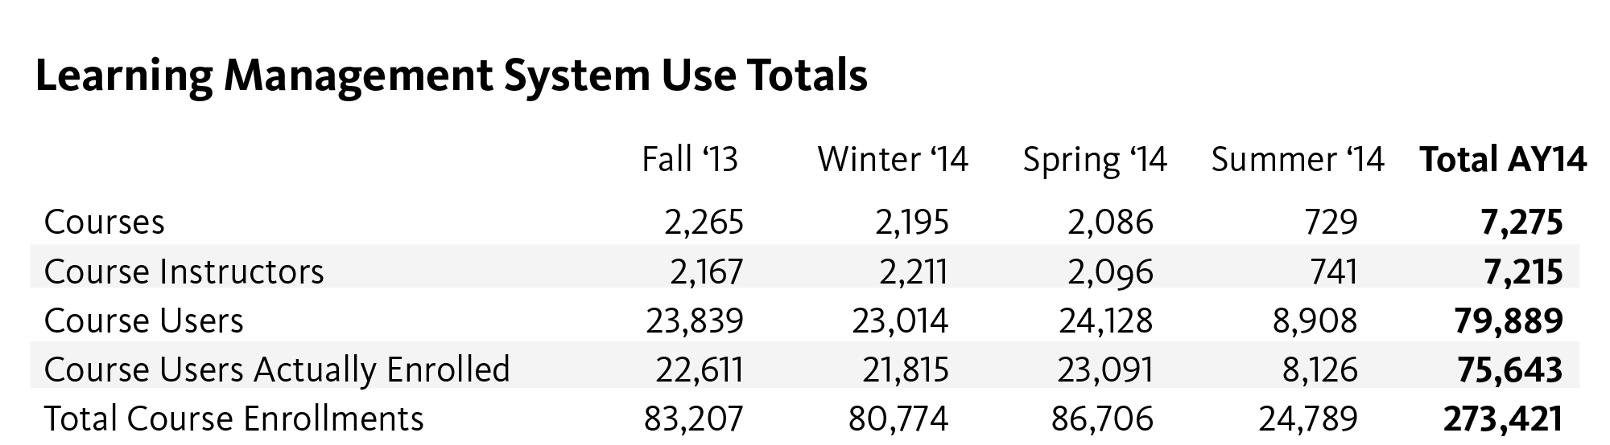

Fig. 26 Learning Management System Use Totals

Usage and Access Statistics
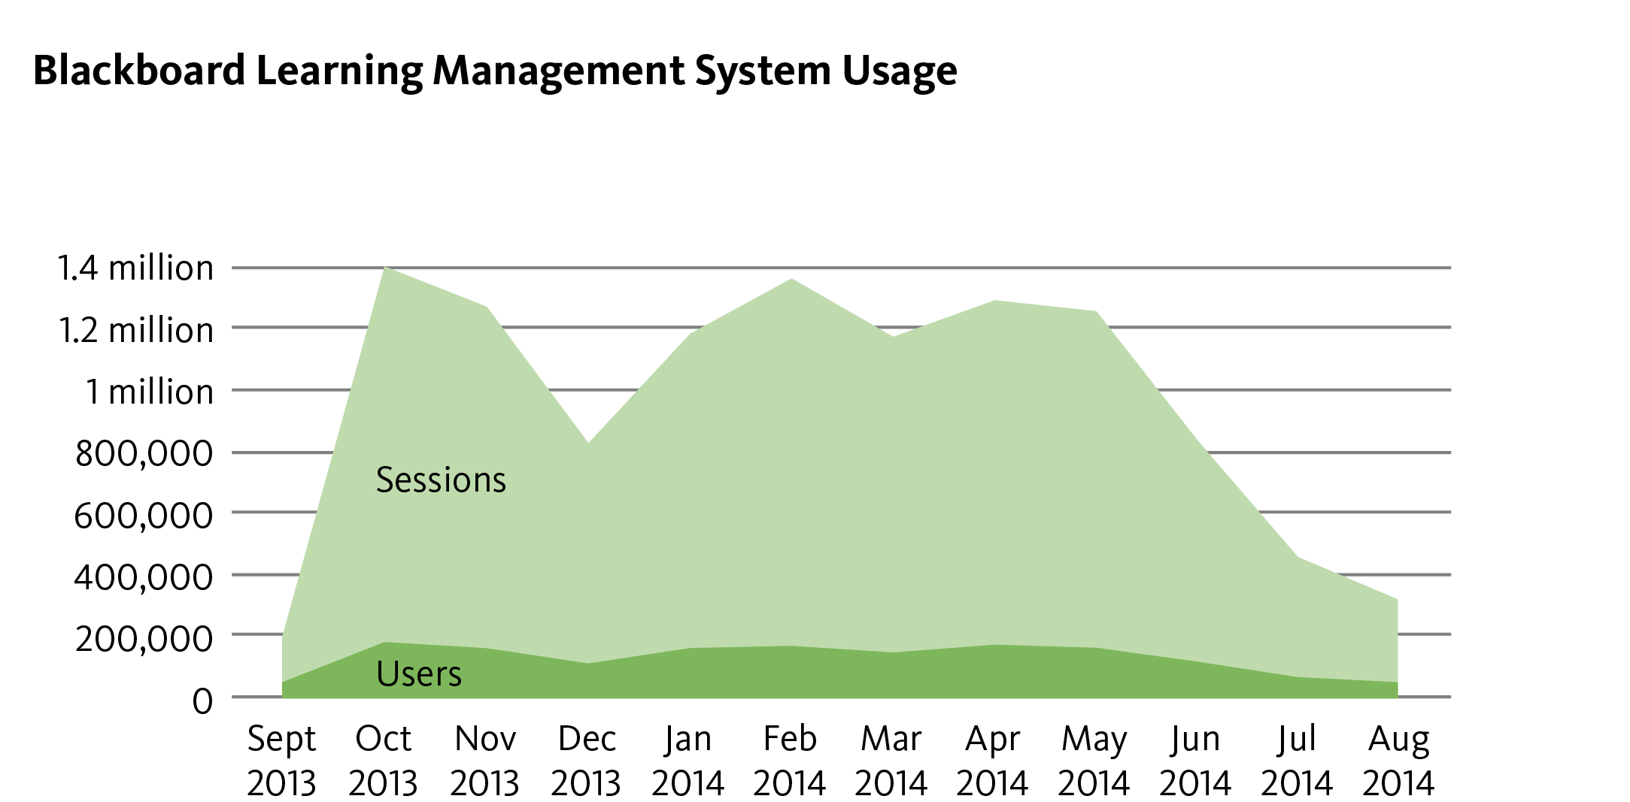

Fig. 27 Blackboard Learning Management System Usage

The LMS Review Process
The UO has been a Blackboard campus since 1999; usage and adoption has grown tremendously since, with Blackboard (Bb) becoming the UO’s enterprise learning management system (LMS). During this time, the number of LMS platforms, both proprietary and open source, has expanded. The campus community is also more experienced in using technology, and faculty, GTFs and students have new requirements and expectations. Well in advance of the expiration of the current Bb contract, the UO began a formal Request for Proposals process to determine our requirements, test various products, and competitively select an LMS.

The LMS Review process began last year with focused interviews with faculty. The UO invited several vendors to campus for open presentations and issued a formal “Request for Proposals,” to which we received multiple responses. Five products (Blackboard, Desire2Learn, Canvas by Instructure, Oba by the University of Oregon, and Sakai by Longsight) were advanced to the competitive range.

After extensive testing by dozens of faculty, GTFs and technical support staff during Winter 2014, two products were selected for further pilot testing. During Spring 2014, Canvas and Sakai were tested in 24 credit courses from across the curriculum. We gathered feedback from nearly 2,000 students, 24 faculty, 38 GTFs, and dozens of technical staff. In addition, the UO conducted focus groups and usability studies. Based on all these data, the UO LMS Task Force selected Canvas by Instructure as the university’s new enterprise Learning Management System (LMS).

Extensive pilot testing indicates that Canvas will save faculty, GTFs, and students time and enhance student engagement that may lead to improved learning outcomes. Faculty, GTFs, and student pilot testers awarded Canvas very high ratings for its friendly and easy-to-learn user interface, grade book feature, e-mail communications and notifications system, overall navigation structure, and speed grader functionality. Canvas also provides a free mobile interface.

Broadcasting, Video Production, and Distance Education
The CMET video production team in conjunction with the Oregon Humanities Center has recorded, edited and broadcast 594 episodes of OHC’s campus interview show, UO Today. Since 2007, CMET Video has produced 367 UO Today episodes, an average of 52 episodes a year.

CMET Classroom Technologies
During Fiscal year 2013-2014, CMET Classroom Technologies pioneered a new way of refreshing classroom audio-visual equipment and technologies. As a result, CMET installed new instructor podiums equipped with touchpanel control systems, DVD players, document cameras, wireless microphones and other presentation and instructional technologies in 35 of the nearly 160 general pool and joint control classrooms. This innovation paves the way for a new refresh cycle with consistently user-friendly controls.

CMET supports faculty and Graduate Teaching Fellows who teach in the general pool and joint control classrooms. During fiscal year 2013-2014, CMET responded to 686 support tickets.

When the UO migrated to a new library management system during Summer 2014, CMET implemented a new equipment reservation and checkout system. During summer and fall terms 2014, CMET served 504 patrons for a total of 1,188 separate transactions.

Library Administration Organization Chart
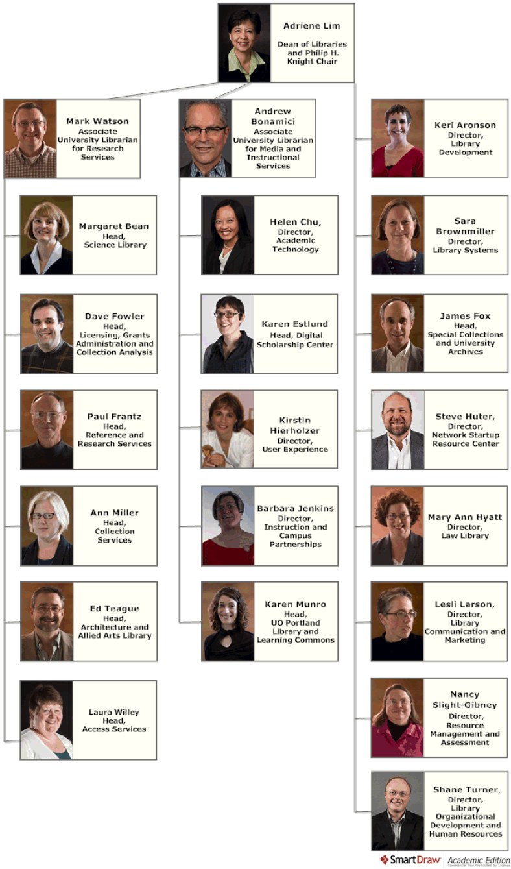

Fig. 28 Administrative Organization Chart

