



Creating Geo-Referenced Bibliographies
using a combination of Google Earth and GeoCommons

Guide to accompany the
IODE OceanTeacher Instructional Video, Nr. 1
http://vimeo.com/74282844

Barbara Butler
Oregon Institute of Marine Biology
PO Box 5389, Charleston, OR 97420, USA
butler@uoregon.edu

01 Oct 2013

Introduction:
- This document will be perpetually updated, so please send changes and suggestions to: butler@uoregon.edu, Barbara Butler, Oregon Inst. of Marine Biology, PO Box 5389, Charleston, OR 97420, USA
- This screencast is a joint project between IAMSLIC and IODE for the OceanTeacher instructional video collection: http://vimeo.com/iode, and the video can be accessed at: http://vimeo.com/74282844
- URLs, captions, and citations are available in this document at http://hdl.handle.net/1794/12859 so you won’t have to copy anything during this presentation except this one link.

Navigating through this video:
- The presentation is divided into several sections so you can skip forward or repeat sections of interest. You could even pause and work along with the screencast to create your own geo-referenced bibliography.
- Overview of what we will cover (approximate time into the video):
  - Background: why geo-referenced bibliographies(1:52)
  - Software required (3:50)
  - Geo-locating citations with Google Earth(4:44)
  - Exporting data from Google Earth (18:56)
  - Importing data into GeoCommons (22:39)
  - Keeping your bibliography current—replacing an existing dataset layer (29:37)
  - Additional information and resources (32:49)

Background:
- Given that you are watching this video it is clear you have an interest in geo-referenced bibliographies.
- Why? In our case at OIMB we wanted a resource that would be of use to new students and visiting faculty members.
- There are options for creating geo-referenced bibliographies, but they require hosting geographic information system (GIS) software.
- Two examples described by IAMSLIC colleagues include using the 651 field in MARC records (Haas et al. 2003), or using defined geographic names to link publications with a physical location as in the Yaquina Bay Bibliography (Webster and Hiveley 2006).
- We wanted to create a geo-referenced bibliography for Coos Bay, but without needing to host via GIS. I’ll be showing you how we did this using a combination of Google Earth and GeoCommons (Schmitt and Butler 2012).

Software required:
- Google Earth: http://www.google.com/earth/index.html; click on “Download Google Earth” and run the executable file.
- GeoCommons: http://geocommons.com/; click on “Sign up for Free” and create your account.
- Excel or other spreadsheet software to produce and manipulate comma-separated values (CSV) output.

Geo-locating citations with Google Earth (GE):
- Log into the Google Earth installation on your computer (not the website).
- Create a folder into which you save your citations—that will make exporting easier, but you can always just save these in the “My Places” folder as long as you aren’t using that for any other data. Depending on your work flow you may want to create multiple folders (for instance we have layers in our database for theses, agency reports, peer-reviewed journal articles and books). If you don’t want multiple data layers in your final GeoCommons bibliography a single folder will suffice.
- If you have coordinates, enter them into the “search” box (Latitude first, Longitude second). If not, navigate and zoom in to the general location where you want to add a citation.
- Press the yellow pushpin icon on top of screen to add a placemark (Figure 1) 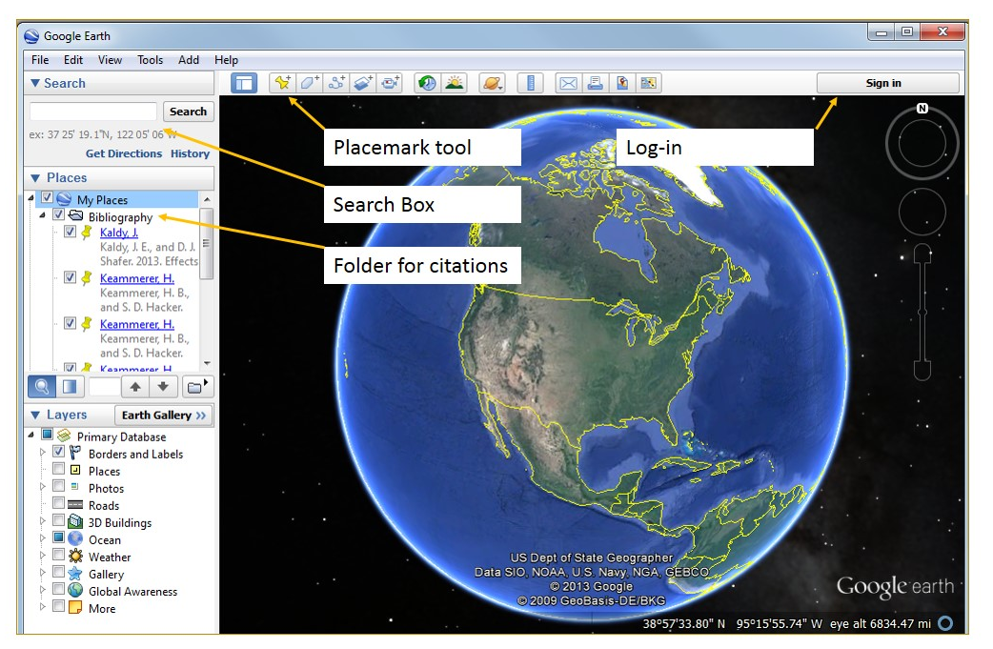
Figure 1

- A “New Placemark” screen will appear (Fig 2).
- Place your citation in the description field and customize the placemark:
  - We add links to electronic copies of the resource if available. If you have housed information on a website, in your own digital repository, OceanDocs (http://www.oceandocs.org/) or Aquatic Commons (http://aquaticcommons.org/) then you could include those handles.
  - Hint, click on “Add Link”. Paste in the URL for the link then hit “OK” or it won’t save the link.
  - If you have used specific coordinates from the item you are citing then your placemark is already in the correct place. If you have navigated to the approximate site you should click and drag the entire “new placemark” screen out of the way so you can position your icon in the exact place you want it (click and drag the blinking icon).
  - Click OK at bottom of the “New Placemark” screen to save all information.
- A note on geo-referencing: for our bibliography we looked at the methods section of each item to determine the study site involved. This was the most time-consuming part of the process. If there were multiple study sites we created multiple links.
- You will want to consider how you are going to geo-locate your references. In this day of hand-held global positioning systems (GPS) articles often include specific coordinates in their methods section.
- There could also be items with no specific geographic location (i.e. research projects without any in-field research component) and in our case we chose to specify the location for those as our marine laboratory.
- Some citations may reference a broad geographic region. You have the option of using polygons to describe an item. We didn’t use polygons for our project, but you may find them useful.
- Hint, don’t worry about the points of interest inserted by Google Earth, when you export your file of citations that is all that will appear in the .KML file.
- Why not stop here and just use Google Earth?
  - “Share with Google Earth Community” doesn’t allow updating of the bibliography. However, this would work if you are sharing a static source you don’t intend to update.
  - “View in Google Maps” does not show the geo-referenced citations.
  - Google Earth Pro may bypass some of these problems and allow more flexibility, but we found that GeoCommons offered a nice way of hosting our geo-referenced citations.

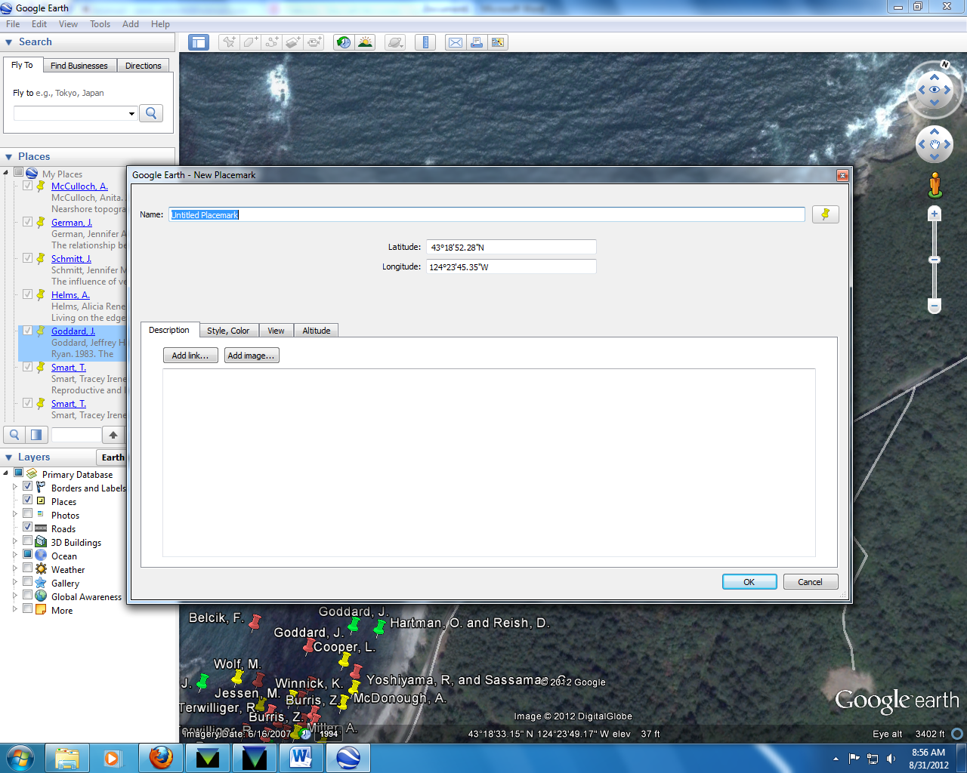
Figure 2

Exporting data from Google Earth:
- In Google Earth, save “My Places” (or whatever folder you used to store your bibliography) as a .KML file.
- Use the following website to convert that to a tab delimited text file: http://www.gpsvisualizer.com/convert_input
  - Click on “Convert a File”
  - Browse to .KML file of interest and click “Convert”
  - You will be presented with some data on your screen, but you are after the downloadable file
- Download the text file from the website (no need to open it).
  - Open Excel and import the text file into Excel.
  - For example, in Excel 2012:
    - Click on the “Data” tab on top of screen, and then click on “From Text” under the “Get External Data” subheading on the left hand side of the toolbar (Figure 3). Leave all the settings as is in the Import Wizard.
    - Once you have your data in Excel, get rid of unnecessary headings and rename usable headings to something easy to understand. For example, we used: Latitude, Longitude, Document Type, Lead Author, and Bibliography (Figure 4).
    - Hint—we save the CSV files for future updates.
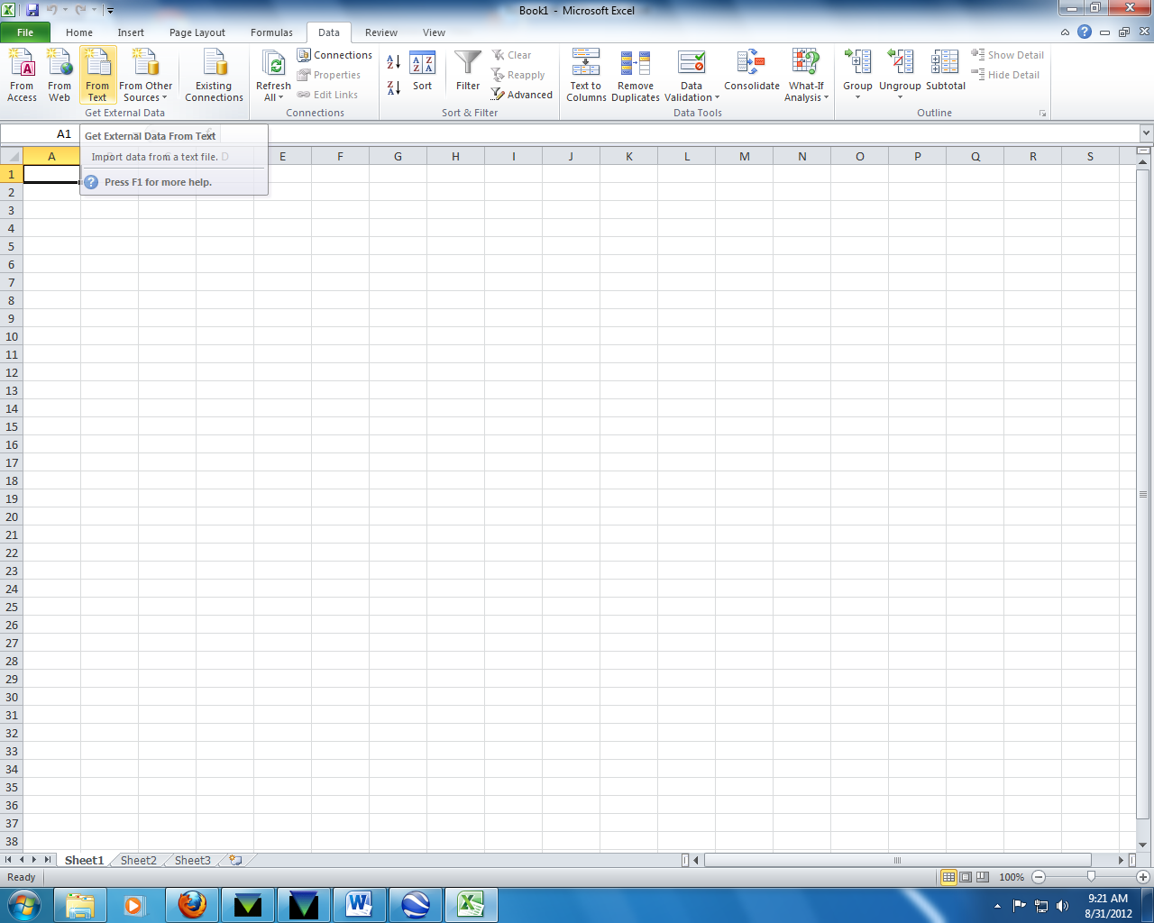
Figure 3

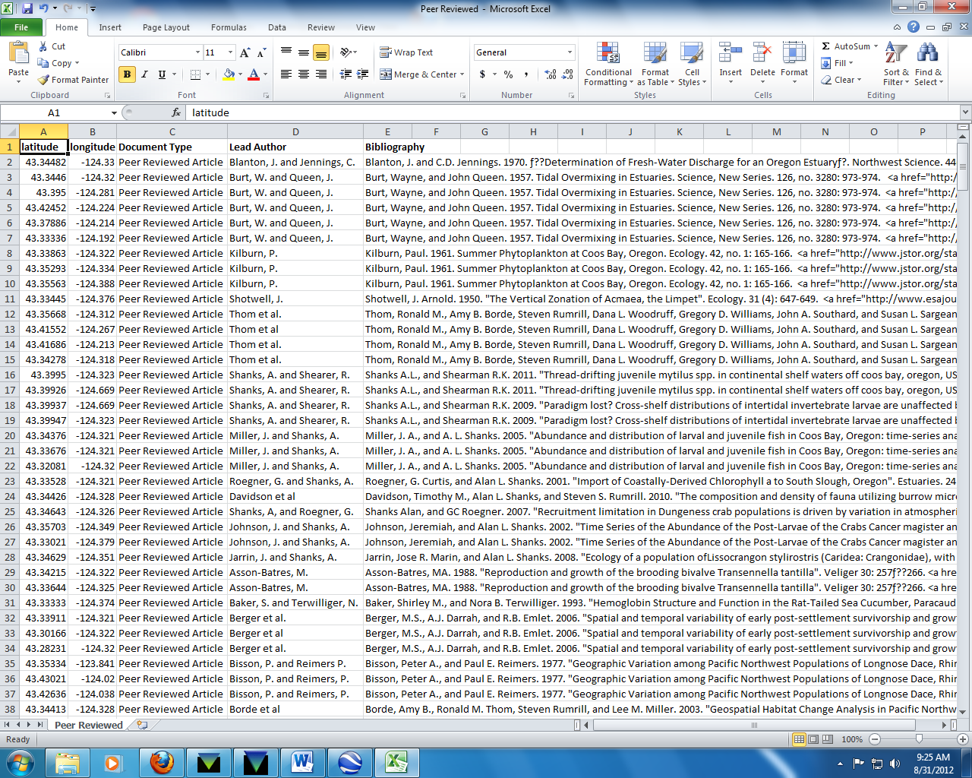
Figure 4

Importing data into GeoCommons:
- Log in to GeoCommons at: http://geocommons.com.
- Click on “Upload Data” tab on top of screen.
- Choose “Upload Files from your computer”.
- Browse and select files to upload and when you have selected them all click “Next”.
- This will place files in your “Pending Datasets” folder in Your Library.
- You still need to geo-reference your data to make it usable. To do this, click “Next Step” on your dataset.
- You now have the option to geo-reference based on the latitude/longitude from you data. Click on this option.
- Hint-- If it doesn’t offer you that option, click on the option “Geocode based on address or place name”
- A screen will then pop up with a list of your attributes (Figure 5). Click “Edit: for the latitude attribute and select the “Geographic” tab to rename the “Data Format” to “Latitude”.
- Repeat above process for the longitude number and click “Continue” to save.
- On the “Review Your Geodata” screen, make sure you only have the columns that you want then click “Continue”.
- Our bibliography contains multiple layers and just as with Google Earth you can zoom in or out to see the map in finer detail (Figure 6). On the “Describe your Dataset” screen, click “Save”. 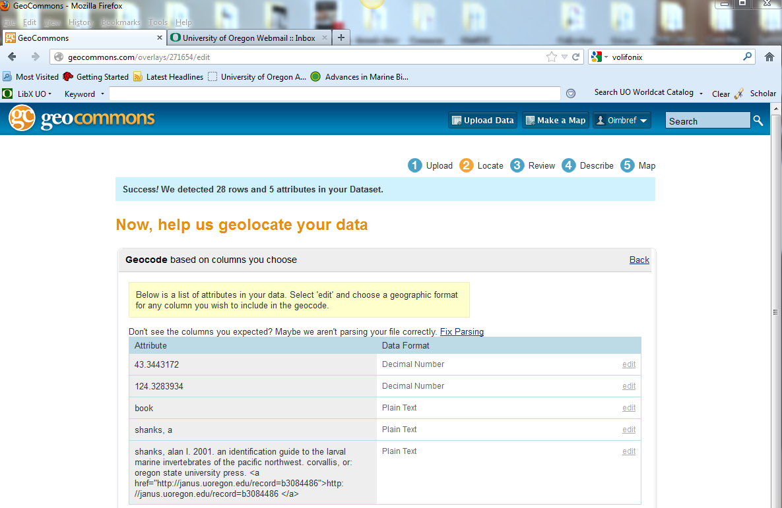
Figure 5

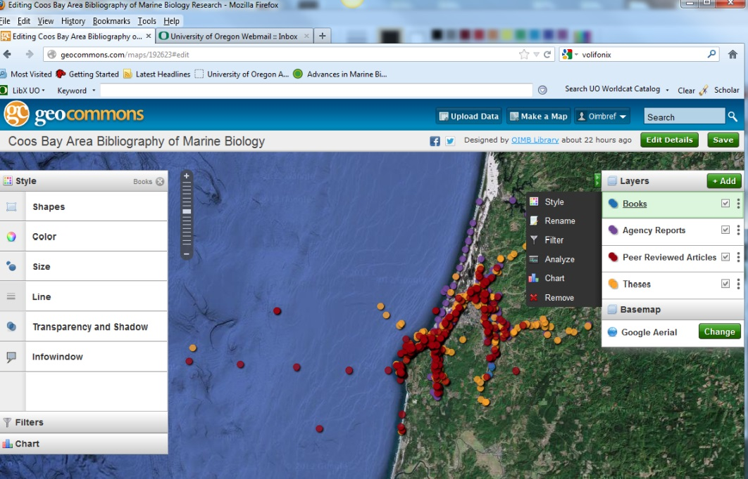
Figure 6

Keeping your bibliography current—replacing an existing dataset layer:
- We maintain our bibliography in EndNote and host a searchable text version on our institutional repository (http://hdl.handle.net/1794/12309) and update this resource quarterly.
- Think about how you plan to keep your bibliography current.
- The easiest way may be to keep your existing CSV files and add new citations as necessary.
- If you opt to go this route and not geo-locate using Google Earth you should know that GeoCommons requires latitude/longitude files to be expressed in terms of decimal degrees rather than degrees/minutes/seconds and if you need to convert these you can do so at websites such as this: http://transition.fcc.gov/mb/audio/bickel/DDDMMSS-decimal.html.
- Paste the new information into the file you are updating and re-save the CSV file.
- If necessary, you can copy and paste tags and descriptions from the existing GeoCommons file you intend to replace using the “Edit” button.
- Go to the “Your Library” screen and click on the “Maps” tab.
- Click “Edit” and choose the layer you will replace. There will be a drop down panel next to the layers panel. Find the option for “Remove” (Figure 6).
- After deleting the existing file, click on the green “+Add” button on the top of the “Layers” panel to add your new dataset.
- You will see a list of all recently added datasets to all of GeoCommons and your will be near the top.
- Find your file and click “Add to Map”. Once it is added, you may need to change the icon style if you are using multiple files/layers:
  - Click on the name for the layer you just added and choose the “Style” option from the drop down menu. A Style screen will pop up (Figure 6). Click on “Color” to change it to the color you want. Click on “Shapes” to change it to a matching shape (for instance we have decided our standard is the 5th from left on top row, the solid filled circle). Click on green “Save” button above the Layers screen when you are finished and wait for the “Save” button on the top of your map (above the layers panel) to finish loading – you’ll see the green button option for “Edit” when you are done instead of “save”.
  - Go back to Datasets tab in Your Library and delete the old dataset layer that you have just replaced.
- Hint: don’t delete a data layer from your library thinking that will remove it from your map. Make all edits to the map layer from the map page itself or you will be left with an orphaned data layer you can’t remove and you will have to recreate your map and it will have a new URL.
- If you already have the latitude/longitude for each of your citations you can use GeoIQ to upload spreadsheets of information rather than geo-locating each citation by hand. The majority of citations we entered into our database described the sampling site in words and not in coordinates, so Google Earth was a good first step for us.

Additional information:
Use GeoCommons User Manual for any questions this guide doesn’t answer: http://geocommons.com/help/Mapping_User_Manual
References cited:
Butler, B. and Schmitt, J. Coos Bay Bibliography. [Updated 2012 Oct 17]. [Internet]. Available from: http://hdl.handle.net/1794/12309
Haas, S. et al. 2003. MARC and ARC: geospatially enabling bibliographic records. In: International Association of Aquatic and Marine Science Libraries and Information Centers. Conference Proceedings (28th: 2002: Mazatlan, Sinaloa, Mexico), pages 119-126. [Internet]. [Cited November 27, 2012]. Available from: http://hdl.handle.net/1912/692
Schmitt, J. and Butler, B. 2012. Creating a geo-referenced bibliography with Google Earth and GeoCommons: the Coos Bay Bibliography. Issues in Science and Technology Librarianship. Fall 2012. Available from: http://www.istl.org/12-fall/article1.html
Webster, J. and Hiveley, H. 2006. Yaquina Bay Bibliography. Western Ecology Division of the United States Environmental Protection Agency Oregon Sea Grant Oregon State University Libraries, 239 pages. [Internet]. [Cited November 27, 2012]. Available from: http://hdl.handle.net/1957/8310

